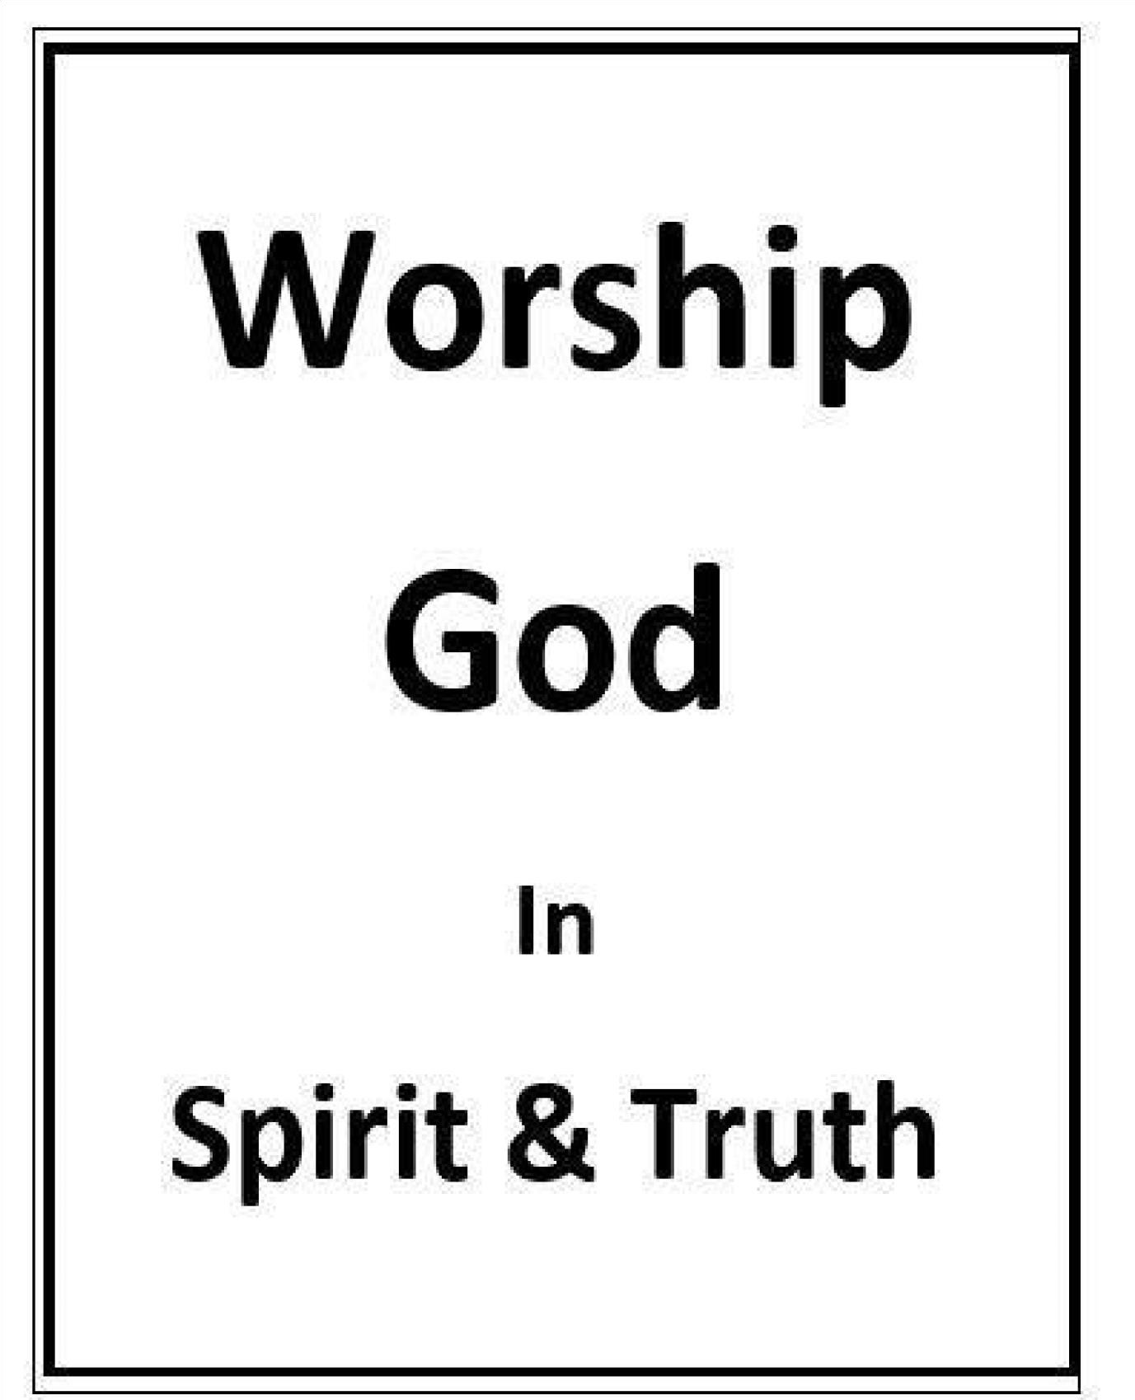
Who Is To Be Worshipped?
Randolph Dunn

Who Is To Be Worshipped?

“God is spirit [not physical], and his worshipers must worship in spirit [not a ritual act but an expression of emotion and love the inner being] and in truth [real and genuine not false and fake]" (John 4:24). One can have all knowledge (truth) but not have love then his worship is unacceptable. It is vain and means nothing (1 Corinthians 13:2).

John 4:24 declares that “‘God is a Spirit.’ These words contain one of the most simple, yet most profound, truths which ever fell upon mortal ear. Their truth is one of the great glories of revelation, and corrects the mistaken conclusion of human reason. They show that:
- God is absolutely free from all limitations of space and time, and is therefore not localized in temples (Acts 7:48).
- That God is not material, as idolaters contend.
- That He is not an abstract force, as [some] scientists think but a Being.
- That He is lifted above all need of temples, sacrifices, etc., which are a benefit to man, but not to God (Acts 17:25).”
The fourfold Gospel, p. 149, J.W. McGarvey and Philip Pendleton

The Scripture state that God’s nature is:
- Love - 1 John 4:8
- Life - John 1:4
- Truth - John 14:6
- Just (holy, righteous) - 2 Thessalonians 1:6
- Merciful - Luke 6:36
- Peace - 2 John 3 and John 14:7
- Faithful - 1 Corinthians 10:13

What is Pleasing to God?
“What does the LORD require of you but to act justly and to love mercy and to walk humbly with your God” (Micah 6:8)? Jesus did not bless but had harsh words for the religious leaders who did not follow the Lord’s requirements: “Woe to you, teachers of the law and Pharisees, you hypocrites! You give a tenth [the amount commanded, a tithe] of your spices-mint, dill and cumin [even to the smallest seed]. But you have neglected the more important matters of the law - justice, mercy and faithfulness. You should have practiced the latter, without neglecting the former” (Matthew 23:23). These leaders required the physical aspect of the law thinking they fulfilled God’s requirement but they neglected His intent, His nature.

In the Sermon on the Mount, Mathew 5, Jesus identified several actions and attitudes that are pleasing to Him, by stating “Blessed” indicating God is pleased and does the blessing of those who are:
Poor in spirit – those recognizing their own sinfulness and God’s righteousness.
Mourn – those unhappy about their spiritual weakness as opposed to those unhappy with their physical plight in life.
Gentle – those not proud, arrogant or haughty.
Hunger and thirst for righteousness, – those who are constantly seeking to know and do what is right and pleasing to God.
Merciful – Compassionate, not judgmental or condemning.
Pure in Heart – those sincere, free from what is false, free from anything that soils, adulterates, corrupts Peacemakers – those living at peace with their fellowman and helping others to do the same.

Speak and act as those who are going to be judged by the law that gives freedom, because judgment without mercy will be shown to anyone who has not been merciful [exactly as the Old Testament law prescribed without any consideration of circumstances]. Mercy triumphs over judgment (James 2:1213)! Judgment (law) demands punishment but God gives mercy to those in Christ.

Jesus asked “‘Which of these three do you think was a neighbor to the man who fell into the hands of robbers?’ The expert in the law replied, ‘The one who had compassion on him’” (Luke 10:36-37).

“Be kind and compassionate to one another, forgiving each other, just as in Christ God forgave you” (Ephesians 4:32).

“Do not judge, or you too will be judged. For in the same way you judge others, you will be judged” (Matthew
7:1-2).

Christians must be careful how they treat a) anyone who hurts someone they love; b) someone who sins, repents and returns; and c) those who fall away and have not repented and returned to Christ.

All the attributes of God must be included in the meaning of His likeness or image in which God made man. God also gave man an intellect allowing him to think, reason, analyze and choose. Man could choose to continue in God’s likeness by discerning truth, showing mercy, desiring justice and pursuing peaceful relationships, or he could choose not to do so thus remaining severed in his relationship with God, his Father and Creator.

Since all men have sinned and are in need of forgiveness, the reasoning ability given by his Creator allows man to change his ways, receive forgiveness, and begin living more like Christ. To those in Christ Paul wrote "Therefore, as God’s chosen people, holy and dearly loved, clothe yourselves with compassion, kindness, humility, gentleness and patience. Bear with each other and forgive whatever grievances you may have against one another. Forgive as the Lord forgave you. And over all these virtues put on love, which binds them all together in perfect unity" (Colossians 3:12-14). By growing in them Christians will reflect God’s image and display the fruit of the Spirit which is "love, joy, peace, patience, kindness, goodness, faithfulness, gentleness and selfcontrol" (Galatians 5:22-23).

The above characteristics of God cannot be felt, smelled, tasted, seen or heard. By observing Jesus’ actions and attitude one can know the Father which is exactly what Jesus told Philip.

We desperately need love and forgiveness. In our state of sin and rebellion, we deserve death, which justice requires. God through Jesus’ life, death, and resurrection provides the opportunity to be forgiven. When one has accepted God’s gift of forgiveness, Christ, through trust and obedience, there is an attitude of love, peace, and gratitude within their inner being, and there comes forth a desire to express that love in various ways, words, thoughts and actions.

What Does God See and Hear?
- Beautiful sound of the human voice or expressions emanating from of man’s heart.
- Money that is given or reasons why money is given.
- Words of the song or heartfelt thoughts generated by the words.
- Words of prayer or a contrite heart even if difficulty expressing his feelings.
- Sermons presented or sermons lived.
- Partaking of the Lord’s Supper or remembering Christ’s atoning sacrifice and resurrection.
- Failing to assemble together or failing to edify others when assembled.
- Reading the Bible or meditating on God’s Message.
- Living a good moral life or living a sacrificial life.

Daily living to mirror or reflect God’s image is offering “…your bodies as living sacrifices, dedicated to God and pleasing to him. This kind of worship is appropriate” (Romans 12:1).

A grateful Christian will seek ways and opportunities to express his gratitude to Christ as his savior. He will live as close to Jesus’ example as possible, and seek to understand God’s will which He gave through the apostles by the Holy Spirit. The Christian will praise Him in all his actions including the remembrance of Christ’s life, death, burial and resurrection when partaking of the “Lord’s Supper.”

Questions
- Actions that do not express the thoughts of one’s heart are ritual not spiritual.
True
False

- One can perform all things men consider worship but without love, his actions are not acceptable to God.
True
False

- A Christian’s daily living reflects the degree of his love of God.
True
False

- One should speak and act with mercy and love because of the law that gives freedom
True
False

- What does God see and hear?
Time and funds given
Contrite heart
Singing with feeling from heart
All the above

Answers to Questions
1. True
2. True
- True
- True
- Contrite heart

