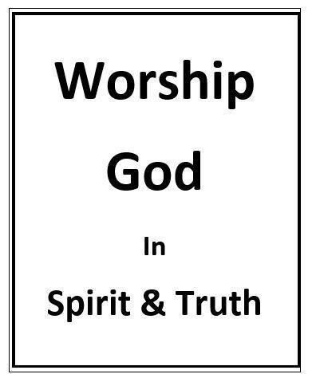

Where Is one To Worship?
Randolph Dunn
Where Is One To Worship?

When God delivered the Children of Israel from Egyptian slavery, he established a covenant with them that included a tent of meeting where His priest offered sacrifices to God. Years following their settlement in the Land of Promise, Solomon built a temple in Jerusalem for their worship and sacrifices. Years later Jesus told the Samaritan woman "Believe me, woman, a time is coming when you will worship the Father neither on this mountain (Gerizim) nor in Jerusalem” (John 4:21. In the coming New Covenant worship would not be in manmade temples or in specific locations but in the heart of man, his temple.

The New Covenant eliminated the Old Covenant Temple worship. “Jesus has now obtained a more superior ministry, since the covenant he mediates is founded on better promises. If the first covenant had been faultless, there would have been no need to look for a second one, but God found something wrong with his people when he said, "Look! The days are coming, declares the Lord, when I will establish a new covenant with the house of Israel and with the house of Judah. It will not be like the covenant that I made with their ancestors at the time when I took them by the hand and brought them out of the land of Egypt. Because they did not remain loyal to my covenant, I ignored them, declares the Lord. For this is the covenant that I will make with the house of Israel after that time, declares the Lord: I will put my laws in their minds and write them on their hearts. I will be their God, and they will be my people” (Hebrews 8:6-10).

By offering His earthly body to God as the sin-offering, atoning sacrifice, Jesus fulfilled the Old Covenant, with its Temple worship, given by God through Moses and replaced it with a New Covenant founded on better promises with redeemed man becoming God’s Temple: “Do you not know that you are God's temple and that God's Spirit dwells in you? If anyone destroys God's temple, God will destroy him. [Does one destroy God’s temple by causing or leading another away from God?] For God's temple is holy, and you are that temple.” ... “Or do you not know that your body is a temple of the Holy Spirit within you, whom you have from God? You are not your own, for you were bought with a price. So, glorify God in your body” (1 Corinthians 3:16-17 … 1 Corinthians 6:19-20).

Since Christians are His temple and the Holy Spirit dwells in them, they are to “present your bodies as a living sacrifice, holy and acceptable to God, which is your spiritual worship” (Romans 12:1).

Neither the location nor physical structure is important. But the desire, intent of mind and attitude of those in Christ are important. How one lives his life and treats others, and responds by giving his resources, money, time and abilities is what matters. Our living sacrifice, the actions in our lives, is to be done everywhere rather than a physical location, such as Mt. Gerizim, Jerusalem or a church building for God is spirit not matter, flesh and blood.

Love, purity, gentleness, justice, mercy and faithfulness – God’s very nature – are very important and are essential for Christians to be living sacrifices.

Questions
- The New Covenant eliminate Old Covenant temple worship?
True
False

- Jesus’ atoning sacrifice Destroyed the Old Covenant
Fulfilled the old Covenant

- Christians are now God’s temple since the Holy Spirit dwells within them.
True
False

- Where is one to worship God today?
Mt. Gerizim
Jerusalem
A church meeting facility
Anywhere when from their heart

- Love, purity, gentleness, justice, mercy and faithfulness are essential for a Christian to be a living sacrifice.
True
False

Answers to Questions
- True
- Fulfilled the Ols Covenant
- True
- Anywhere when from their heart
- True

