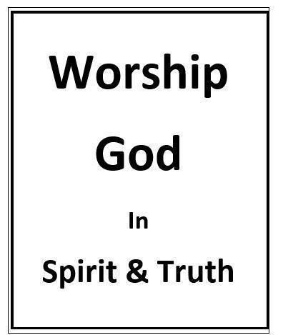
Lord’s Supper
Randolph Dunn

Lord’s Supper - Remembering Christ

“And he {Jesus} said to them, ‘I have earnestly desired to eat this Passover with you before I suffer (crucifixion)’” (Luke 22:1 7).

While the Children of Israel were still in slavery to the Egyptians the Passover was established after the ninth plague and before the death angel plague (vs. 1-7). During this feast the Israelites were to kill before twilight a lamb without blemish (vs. 5). They were to sprinkle some of its blood on the doorpost and the lintel over the door. This told God and the death angel where His people were (vs. 13). The lamb was to be roasted and eaten (Exodus 12). Therefore, the Jewish Passover was a lamb to be eaten every year on the 14th day of the first month in remembrance of God delivering them from the death of their firstborn and from, Egyptian slavery (Numbers
9).

Jesus’s Last Passover
“And when the hour was come, he sat down, and the apostles with him. And he said unto them, with desire I have desired to eat this Passover with you before I suffer: for I say unto you, I shall not eat it [the Passover ], until it [the Passover] be fulfilled in the kingdom of God” (Luke 22:14 -16).
“When it was evening, [time for the Passover meal] he (Jesus) reclined at table with the twelve . . . Now as they were eating, Jesus took bread, and after blessing (giving thanks) it broke it and gave it to the disciples, and said, ‘Take, eat; this is my body.’ And he took a cup, and when he had given thanks he gave it to them, saying, ‘Drink of it, all of you, for this is my blood of the covenant, which is poured out for many for the forgiveness of sins. I tell you I will not drink again of this fruit of the vine until that day when I drink it new with you in my Father’s kingdom.’ And when they had sung a hymn, they went out to the Mount of Olives" (Matthew 26:20 … 25-30). Then a few verses later Jesus stated “. . . ‘My soul is very sorrowful, even to death; remain here, and watch with me.’ And going a little farther he fell on his face and prayed, saying, ‘My Father, if it be possible, let this cup pass from me; nevertheless, not as I will, but as you will’” (Matthew 26:38-39).
Jesus’ plea for the removal of the cup was neither the bread nor the container and its contents. It was His sacrificial death by crucifixion, His cup of suffering. When one recalls the cup Jesus desired to have removed, one remembers, gives thanks and praises God for Christ’s blood sacrifice required for the remissions of their sins. Jesus’ act of offering Himself as the only sacrifice that could remove sin. It also established the New Covenant which is why His suffering and sacrifice could not be removed. The following is a comparison of the Old and the New Covenants.
Old Covenant New Covenant
Sacrifice Lamb without blemish Jesus - without sin
Removal from Control of Egyptians Control of Satan
Free from Physical slavery Spiritual Slavery
Promised Land Canaan - physical Heaven - spiritual
Wrath against Pharaoh Devil
Blood identifies Israelites Those in Christ

Mark 14:23-26 “And he took a cup, and when he had given thanks he gave it to them, and they all drank of it.
And he said to them, ‘This is my blood of the covenant, which is poured out for many. Truly, I say to you, I will
not drink again of the fruit of the vine until that day when I drink it new in the kingdom of God.’ And when they had sung a hymn, they went out to the Mount of Olives.”

Luke 22:17-24 “And he took a cup, and when he had given thanks he said, ‘Take this, and divide it among yourselves. For I tell you that from now on I will not drink of the fruit of the vine until the kingdom of God comes.’ And he took bread, and when he had given thanks, he broke it and gave it to them, saying, ‘This is my body, which is given for you. Do this in remembrance of me.’ And likewise the cup after they had eaten, saying, ‘This cup that is poured out for you is the new covenant in my blood.”

1 Corinthians 10:16-18 “The cup of blessing that we bless [we bless no request God to bless ], is it not a participation in the blood of Christ? The bread that we break, is it not a participation in the body of Christ? Because there is one bread, we who are many are one body, for we all partake of the one bread. Consider the people of Israel: are not those who eat the sacrifices participants in the altar?”
1 Corinthians 11:25 Paul includes another statement "For as often as you eat this bread and drink the cup, you proclaim the Lord’s death [atoning sacrifice, sin-offering, crucifixion] until he comes.”
Every time one partakes of the Lord’s Supper one must focus on Christ and His atoning sacrifice - Remember Me!
- The bread represents Jesus who as God came to earth to live among us in a body of flesh, not a phantom.
- The fruit of the vine, the contents of the cup, represents the blood of Jesus which ushered in the New Covenant by His atoning sacrifice – the sin-offering.
Questions
- What did Jesus plead to have removed?
A physical cup
The cup of suffering - crucifixion
The contents in the cup

- “Proclaim the Lord’s death” signifies the blood sacrifice, sin-offering, crucifixion
True
False

- Christians are to remember Christ sin-offering (atoning sacrifice) only on Sunday when they partake of the Lord’s Supper.
True
False

- The bread represents God in a human body being tempted and suffering as man
True
False

- The fruit of the vine represents the shedding of Jesus’ physical blood, the atoning sacrifice required for a sin-offering for an eternal life.
True
False
Answers to Questions
- The cup of suffering – crucifixion
- True
- False
- True
- True

