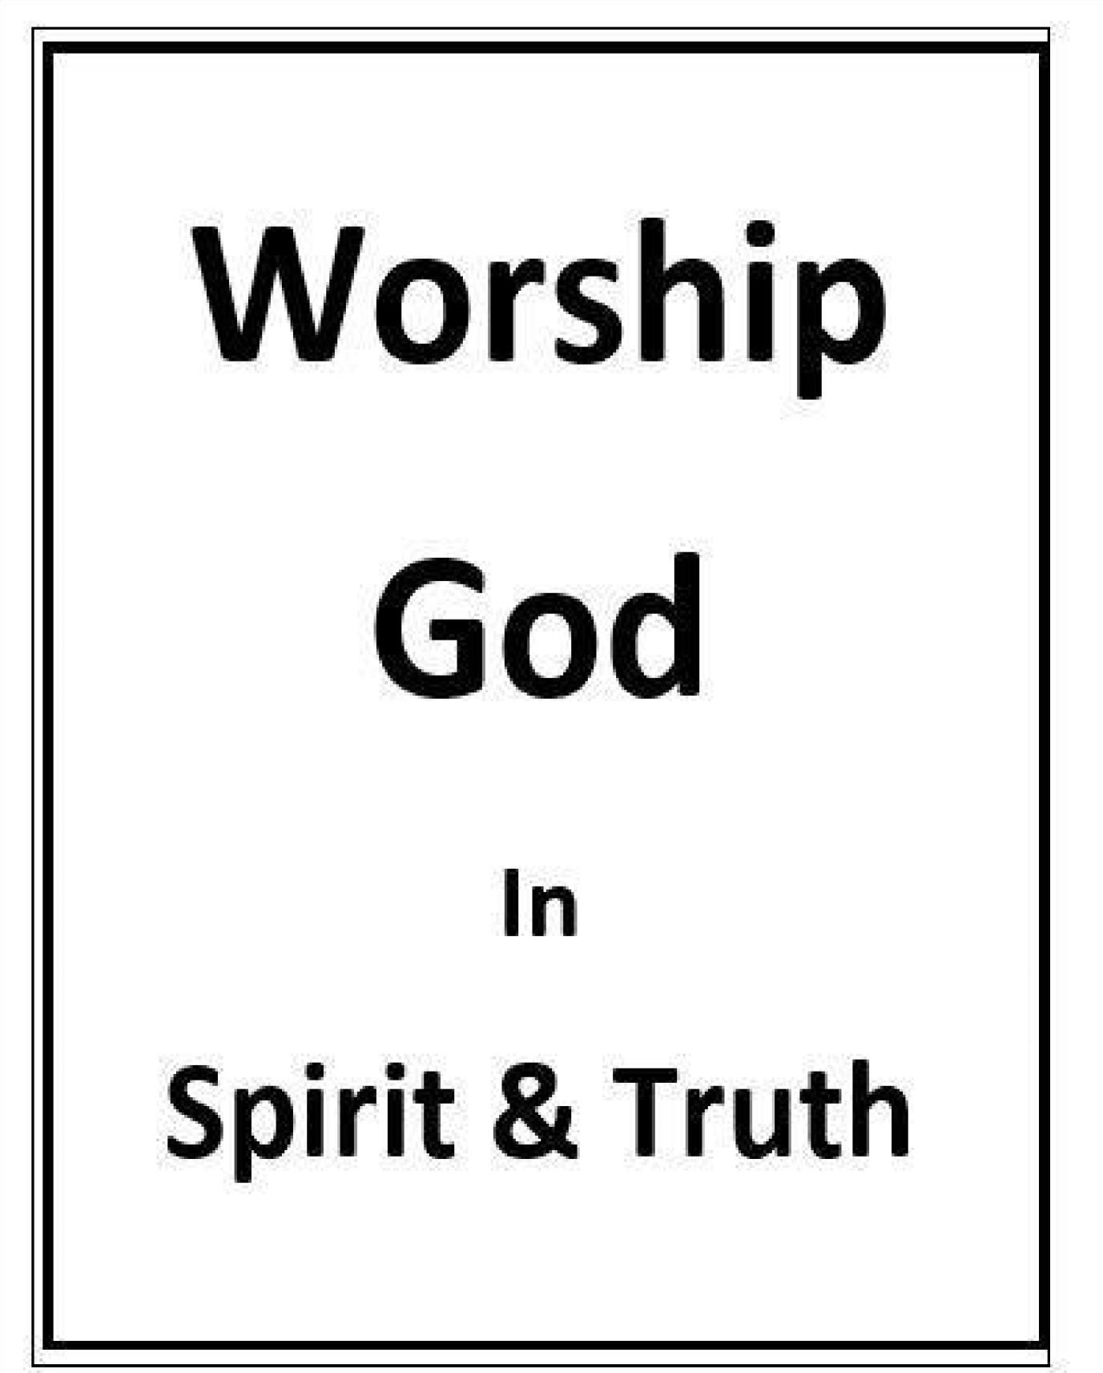
Worship From Heart
Randolph Dunn
Worship From Heart

Lesson 1
Worship in General
Most people, if not all, now and throughout antiquity have worshipped an entity. “Primitive man feared all manifestations of power; he worshiped every natural phenomenon he could not comprehend. The observation of powerful natural forces, such as storms, floods, earthquakes, landslides, volcanoes, fire, heat, and cold, greatly impressed the expanding mind of man. The inexplicable things of life are still termed ‘acts of God’ and ‘mysterious dispensations of Providence.’”

“It is known that between five hundred to six hundred such tribal units had their own independent history of social and religious development … in complete isolation from each other except for occasional marginal contacts at the boundaries of their territories. … In all the tribes of Australia, without exception, there exists a belief in one Supreme Power, who is the first cause of all creation.”

Ancient Egyptians had Ra, their sun god, and Osiris, the god of the underworld, while Babylon, Greece, and Rome worshipped mythological gods.

Today a significant portion of the world’s population consists of Christians, Jews, and Muslims who worship God or Jehovah, the God of Moses and Abraham, or Allah, the God worshipped by the Muslims. There are colossal disagreements between and within each of them. Another significant portion of the world adheres to beliefs such as Buddhism and Hinduism. Still, there are others as in primitive nations that have their time-honored
‘spiritual’ beliefs.

These examples point to a fundamental trait of man that existed from creation, a desire to pay homage and to worship some entity.
The attitude of man’s heart is most important for Jesus stated "You shall love the Lord your God with all your heart and with all your soul and with all your mind. This is the great first commandment. And a second is like it: You shall love your neighbor as yourself. On these two commandments depend all the Law and the Prophets" (Matthew 22:37-40). Later Jesus stated a new commandment: “I give to you, that you love one another: just as I have loved you, you also are to love one another. By this all people will know that you are my disciples if you have love for one another" (John 13:35).

“It [the heart] was considered to be the seat of the emotions and passions and appetites and embraced likewise the intellectual and moral faculties-though these are necessarily ascribed to the soul (The International Standard Bible Dictionary).

One is to love the Lord God with all your heart and with all your soul and with all your mind, the whole man, therefore a living sacrifice. But as Jesus showed us true worship is directed to God from love and adoration that goes beyond performing some outward act or ritual.

Questions
1. Historical records reveal that from the beginning mankind has worshipped some entity.



2.

There are colossal differences between and within all the various religions.

True

False

True

False

- The greatest commands are
Love God

Love neighbor

Love one another

All the above

- Man’s heart is his seat of emotions, moral facility, his inner being.
True

False

- Worship is love, adoration, reverence, and not some action performed with little or no thought.
True

False

Heart Worship

"And God saw that the wickedness of man was great in the earth and that every imagination of the thoughts of his heart was only evil continually. And it repented the Lord that he had made man on the earth, and it grieved him at his heart" (Genesis 6:6).

Micah wrote to the Children of Israel asking “With what shall I come before the Lord?” and then gave several possibilities in the form of other questions. He concluded, “He has shown you, O man, what is good. And what does the LORD require of you but to do justly, to love mercy, and to walk humbly with your God” (Micah 6:8)?

Jesus stated to Satan “Worship the Lord your God, and serve him only” (Matthew 4:10 referring to Deuteronomy 6:13). To some of the tradition-keeping Pharisees Jesus quoted Isaiah 29:13: “These people honor me with their lips [outward], but their hearts [inward ] are far from me. They worship me in vain; their teachings are but rules taught by men” (Matthew 15:8). Other vain worship includes angel, idol, people, ignorant and devil worship.

Jesus offered his fleshly body as the only sacrifice that could remove sin from man. God accepted his offering raising Him from the grave thereby achieving victory over death and Satan’s hold over man. The opportunity for forgiveness and reconciliation became available to all who chose to put their trust and obedience in Christ. Those reconciled to God by the forgiveness of sin express their love in reverence, homage and worship to Him.

One is devoted or religious when from within his inner being, soul, and heart, he serves God by his good works and renders homage or reverence to his God. Man may perceive someone as very religious a devout Christian, by observing all the good works he performs but be totally unaware of his motives for doing the deeds. For example, his desire for recognition of man, or to earn God’s reward by obeying His commands is not true worship as there is no reverence, honor, or homage present. A deed is not worship, although it may benefit someone unless it originates within the inner man motivated by love. God alone knows the intent of man’s “heart.” Love, faith, and action are needed for worship.

Questions
- One’s worship can be in vain and unacceptable to God.
True
False
- By doing God’s will in offering Himself as the only sacrifice acceptable to God, Jesus worshiped God.
True
False
- What was the victory over death?
Crucifixion of Jesus
Christ the sin offering
Resurrection of Christ

- People do not know if a man’s good works are worship or actions to receive praise from others.
True
False
- 5Since God knows man’s heart he knows if one’s worship is real and genuine or vain. True
False

Answers to Questions
- True
- True
- Resurrection of Christ
- True
- True

Student Information

Name __________________________________________________________________
Address ________________________________________________________________
City ____________________________________ State _______________Zip _________
Email address __________________________________________Phone ____________
Enter your understanding of the lesson message and your questions or comments. Send them to the instructor listed below.

__________________________________________________________________________________
_
__________________________________________________________________________________
_
__________________________________________________________________________________
_
__________________________________________________________________________________ _ ________________

Instructor Information
Name ________________________________________________________________________
Address _______________________________________________________________________
City ____________________________________________State _______________Zip ________ Email address _______________________________________

urantia.org/en/urantia-book-standardized/paper-85-origins-worship
alislam.org/library/books/revelation/part_3_section_2.html

