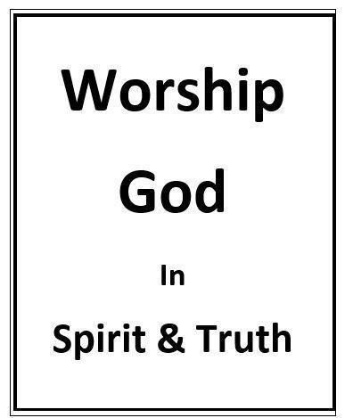

How Is One To Worship?
Randolph Dunn

How Is One To Worship?

Understanding the what, who, when and where of worship should help in understanding the how of worshipping. If giving ourselves as a living sacrifice is a lifestyle of service then there are many acts one can and should do that would be considered worship. But, they must be motivated out of a desire to be more like Christ by following His examples while giving God glory, honor, praise and adoration.

Man is to worship in his spiritual being and in truth [from the heart not ritual ], which requires knowledge. Worship is not some physical act, a ritual, but something coming from within, from love and desire to honor, praise and please. One totally incapable of performing a physical act can still worship and serve God.

The outpouring of love, adoration and praise from within man’s inner being, his heart and seat of emotion, feelings and attitude is service, true worship. This can be done alone or with a group. Similar actions absent emotions and feelings of love, adoration and praise done for the purpose of complying with a command or those centered on self are vain worship. Jesus stated “these people honor me with their lips, [the voice is heard], but their hearts [no thought ] are far from me. They worship me in vain” (Matthew 15:8-9, Mark 7:6 quoting from Isaiah 29:13).

If one’s thoughts and emotions are based upon a knowledge of God and they have an intimate relationship with Him, then they have trained their whole being to love, adore, praise, serve and worship God with a real and genuine desire to please him [Spirit and truth - not fake or some ritual]. He is now prepared to serve God in spirit and truth. But what is one to do when serving or worshipping God?
One can read in Genesis that while God was delivering Abraham’s descendants from bondage in Egypt, He established a Covenant with them. In this covenant, He selected a group of people to serve Him as priests to offer animal sacrifices for themselves and all the people. God through Moses gave very specific instructions on how their service of offering sacrifices was to be done.
Many years later God came to earth in the form of the man referred to as Jesus of Nazareth, the Christ. He lived as one of His creations facing the same type of temptations as man but without sin thus becoming the perfect sacrifice for sin by offering Himself up to the Father as the blood sacrifice required to remove man’s sins. The apostle John in Revelation 1:6 states “He has made us a Kingdom of priests for God his Father.”
God’s instructions to the New Covenant priests were also specific although very different than those of the Old Covenant. The New Covenant priests, those men, and women in Christ, are to be living sacrifices (Romans 12:1) as they daily serve God by doing good deeds, encouraging others toward faithfulness, and offering thanks, praises, and adoration to Him from the heart.

Questions
- As a Christian giving yourself to Christ as a living sacrifice is a lifestyle of worship and service.
True
False

- Worship in spirit and truth comes from the inner man requiring
Knowledge
Some physical act
Adesire to honor and praise God

- Worship occurs only in group gatherings True

False

- God through Moses gave specific instructions on how people today are to worship Him.
True
False

- God’s instruction to His New Covenant people is to daily serve God by doing good deeds and by offering thanks, praises, and adoration to Him from the heart.
True
False

Answers to Questions
- True
- A desire to honor and praise God
- False
- True
- True

