Christ's Message of Redemption
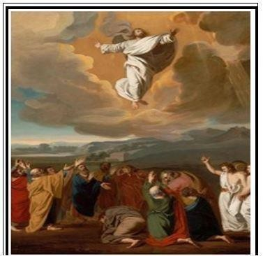
Benefits of Being In Christ
Randolph Dunn

Being In Christ
Previous studies have shown we must change our lifestyle from rebellion to righteousness. We must believe the Gospel message - the crucified and resurrected Christ. We must obey that message to be in Him because it is in Him and through Him, we have redemption and are reconciled to God.
"He predestined us to be adopted as his sons through Jesus Christ, in accordance with his pleasure and will to the praise of his glorious grace, which he has freely given us in the One he loves. In him we have redemption through his blood, the forgiveness of sins, in accordance with the riches of God's grace that he lavished on us with all wisdom and understanding. And he made known to us the mystery of his will according to his good pleasure, which he purposed in Christ, to be put into effect when the times will have reached their fulfillment to bring all things in heaven and on earth together under one head, even Christ." (Ephesians 1:5-10)
"For Christ's love compels us, because we are convinced that one died for all, and therefore all died. And he died for all, that those who live should no longer live for themselves but for him who died for them and was raised again. So, from now on we regard no one from a worldly point of view. Though we once regarded Christ in this way, we do so no longer. Therefore, if anyone is in Christ, he is a new creation; the old has gone, the new has come! All this is from God, who reconciled us to himself through Christ and gave us the ministry of reconciliation: that God was reconciling the world to himself in Christ, not counting men's sins against them. And he has committed to us the message of reconciliation." (2 Corinthians 5:14-19)
"What shall we say, then? Shall we go on sinning so that grace may increase? By no means! We died to sin; how can we live in it any longer? Or don't you know that all of us who were baptized into Christ Jesus were baptized into his death? We were therefore buried with him through baptism into death in order that, just as Christ was raised from the dead through the glory of the Father, we too may live a new life. If we have been united with him like this in his death, we will certainly also be united with him in his resurrection. For we know that our old self was crucified with him so that the body of sin might be done away with, that we should no longer be slaves to sin because anyone who has died has been freed from sin." (Romans 6:1-7)
”See to it that no one takes you captive through hollow and deceptive philosophy, which depends on human tradition and the basic principles of this world rather than on Christ. For in Christ all the fullness of the Deity lives in bodily form, and you have been given fullness in Christ, who is the head over every power and authority. In him you were also circumcised, in the putting off of the sinful nature, not with a circumcision done by the hands of men but with the circumcision done by Christ, having been buried with him in baptism and raised with him through your faith in the power of God, who raised him from the dead." (Colossians 2:8-12)
Perhaps the best benefit of being with Christ is when all stand before the judgment seat of God, the righteous have Jesus as their advocate!

Questions
- When someone crucifies his old self with Christ, he is united with Him by death of his sin, having the assurance of eternal life and being united with Him in His resurrection.
True

False

- Where is redemption found? Only faith in Christ

Prayer asking for forgiveness and redemption

The blood sacrifice of Christ

- How does one become a new creation?
When one believes in Christ

When on gets into the Body of Christ by the burial of baptism

- People who have died to sin, been buried in water baptism and resurrected to a new spiritual life are united with Christ.
True

False

- Where does the fullness of Deity dwell?
Bible

Christ

Apostles

Answers to Questions
- True
- Blood Sacrifice of Christ
- When he gets into the Body of Christ by the burial of baptism
- True
- Christ

Student Information
Name __________________________________________________________________
Address ________________________________________________________________
City ____________________________________ State _______________Zip _________
Email address __________________________________________Phone ____________
Enter your understanding of the lesson message and your questions or comments. Send them to the instructor listed below.

________________________________________________________________________________ ________________________________________________________________________________ ________________________________________________________________________________ ________________________________________________________________________________ ____________________________

Instructor Information
Name ________________________________________________________________________
Address _______________________________________________________________________
City ____________________________________________State _______________Zip ________ Email address _______________________________________

