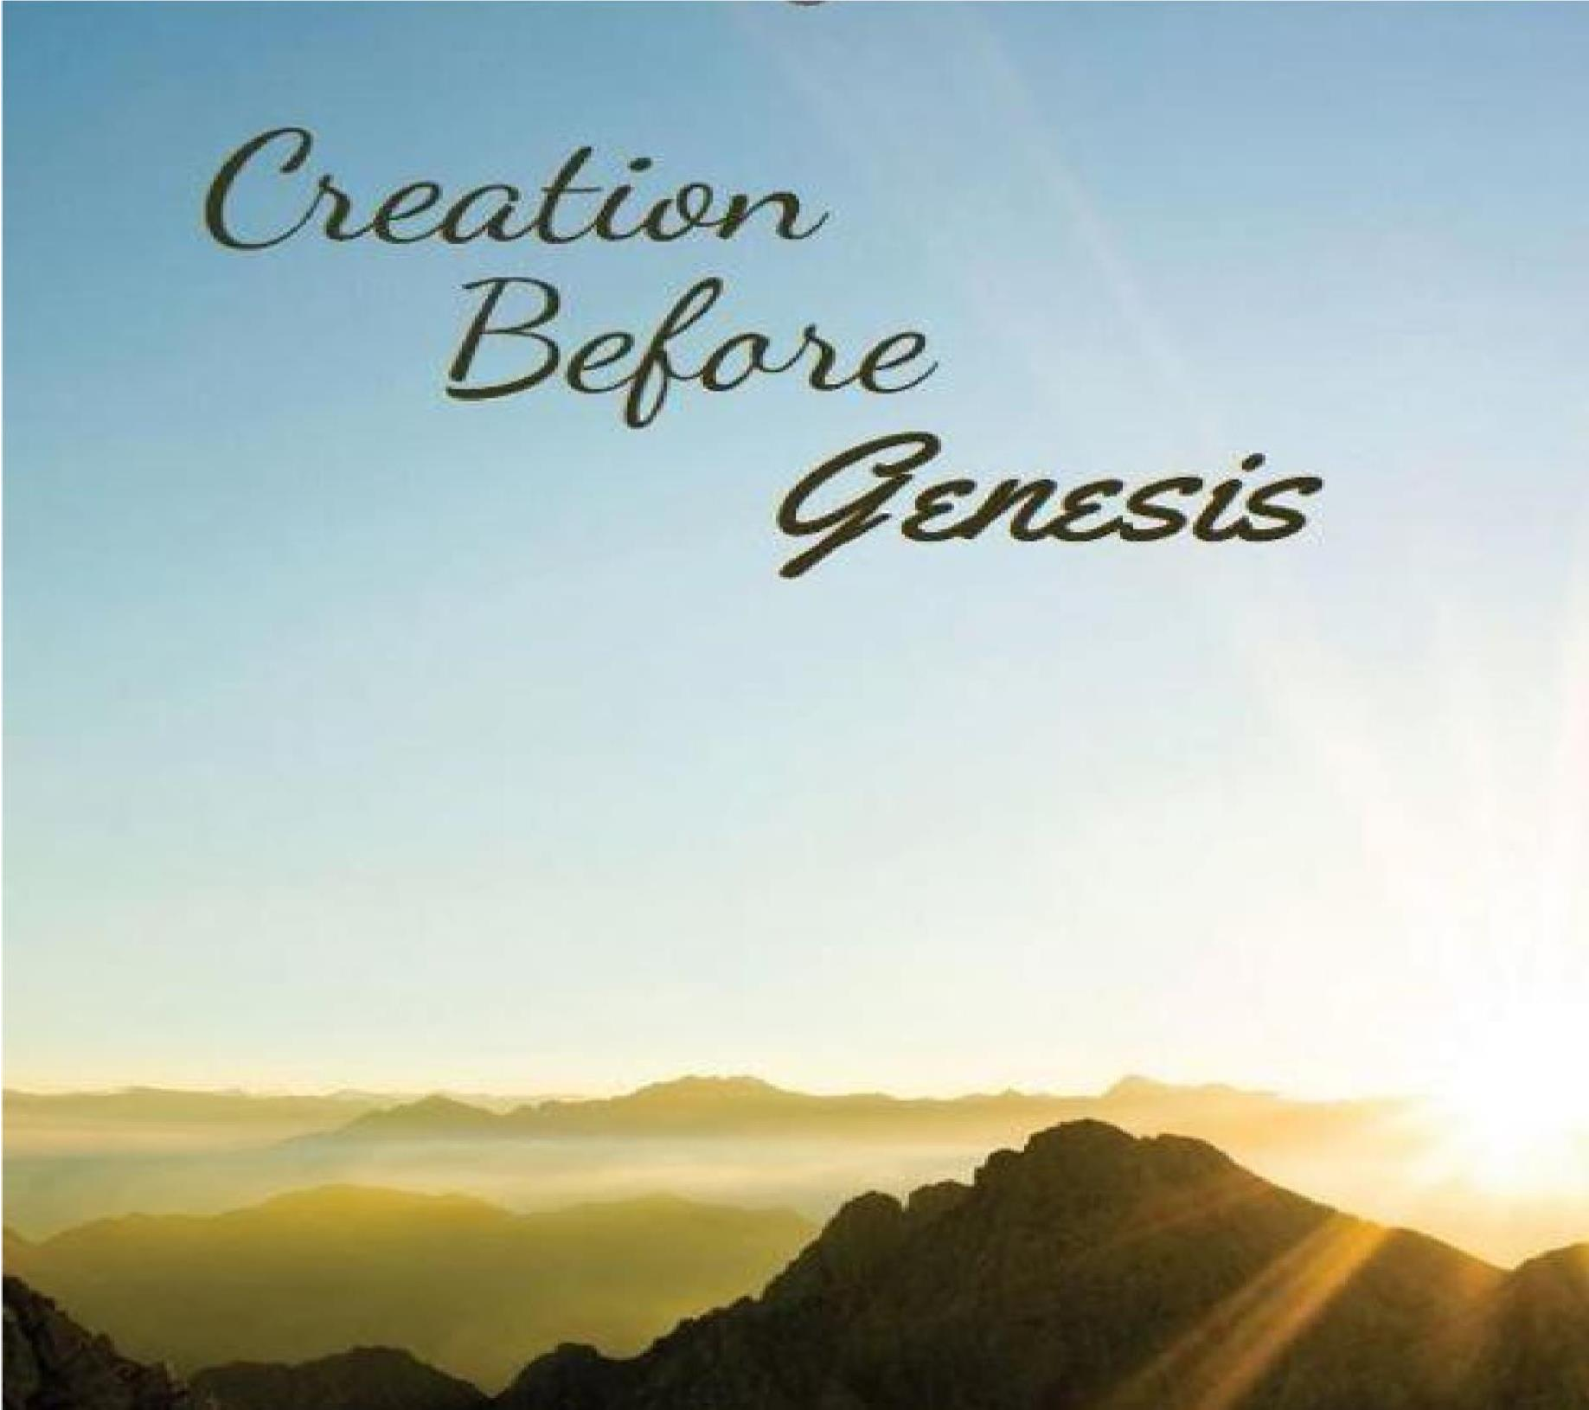
Heaven and Hell
Cecil N. Wright

Heaven and Hell

Was Heaven created or has it always existed?
The celestial Heaven is the abode of God. Since God is omnipresent, always present, and since Heaven is His abode, then Heaven must have always existed. This is the heaven where the righteous will live eternally. But angels were present when “God created the non-celestial heavens and the earth” as indicated by the question God asked Job. “Where were you when I made the earth's foundation? … cornerstone in place while the morning stars sang together and all the angels shouted with joy?” (Job 38:4-7)
Comment: Therefore, the morning stars and angels were present at creation. It is uncertain when God created them.
Heaven as the abode of God should not be confused with the:
- Aerial heaven referring to the atmospheric heavens, as "birds of heaven" or "clouds of heaven."
(Matthew
6:26; 8:20; Acts 10:12; 11:6; James 5:18)
- Sidereal heavens, the region of the "sun," "moon," and "stars." (Genesis 1:14-16; Psalm 8:3-4; Matthew 24:29,35; Mark 13:15,31; Hebrews 11:12; Revelation 6:14; 20:11)

What about Hell, has it always been in existence or was it created?
With the heavenly creation of righteous spirit beings, angels, there was no need for Hell until Satan, and his angels rebelled. “For if God did not spare angels when they sinned, but cast them into hell and committed them to chains of gloomy darkness to be kept until the judgment.” (2 Peter 2:4-5)
Comment: The word “Hell” is translated from the Greek words Tartaroósas and tartaroo which Strong’s
Concordance gives its meaning as “the deepest abyss of Hades; to incarcerate in eternal torment.” Therefore, it appears the rebellious angels are sent to the Tartarus side of Hades, a temporary abode until they are sent to everlasting torment, Hell.
“The angels who did not stay within their own position of authority, but left their proper dwelling, he has kept in eternal chains under gloomy darkness until the judgment of the great day.” (Jude 6)
Comment: Whenever Hell was created, it was established and reserved for the rebellious and wicked at their second death. Some other descriptions are:
- "furnace of fire; [where] there shall be weeping and gnashing of teeth." (Matthew 13:42)
- "the eternal fire which is prepared for the devil and his angels." (Matthew 25:41)
- "perdition," (destruction) not of the unrighteous. (Philippians 3:19)
- "eternal destruction from the face of the Lord and from the glory of his might." (2 Thessalonians
1:9)
- "the second death." (Revelation 2:11)
- "cast alive into the lake of fire and brimstone, … tormented day and night forever and ever." (Revelation 20:10)
"lake that burns with fire and brimstone, sulfur." (Revelation 21:8

