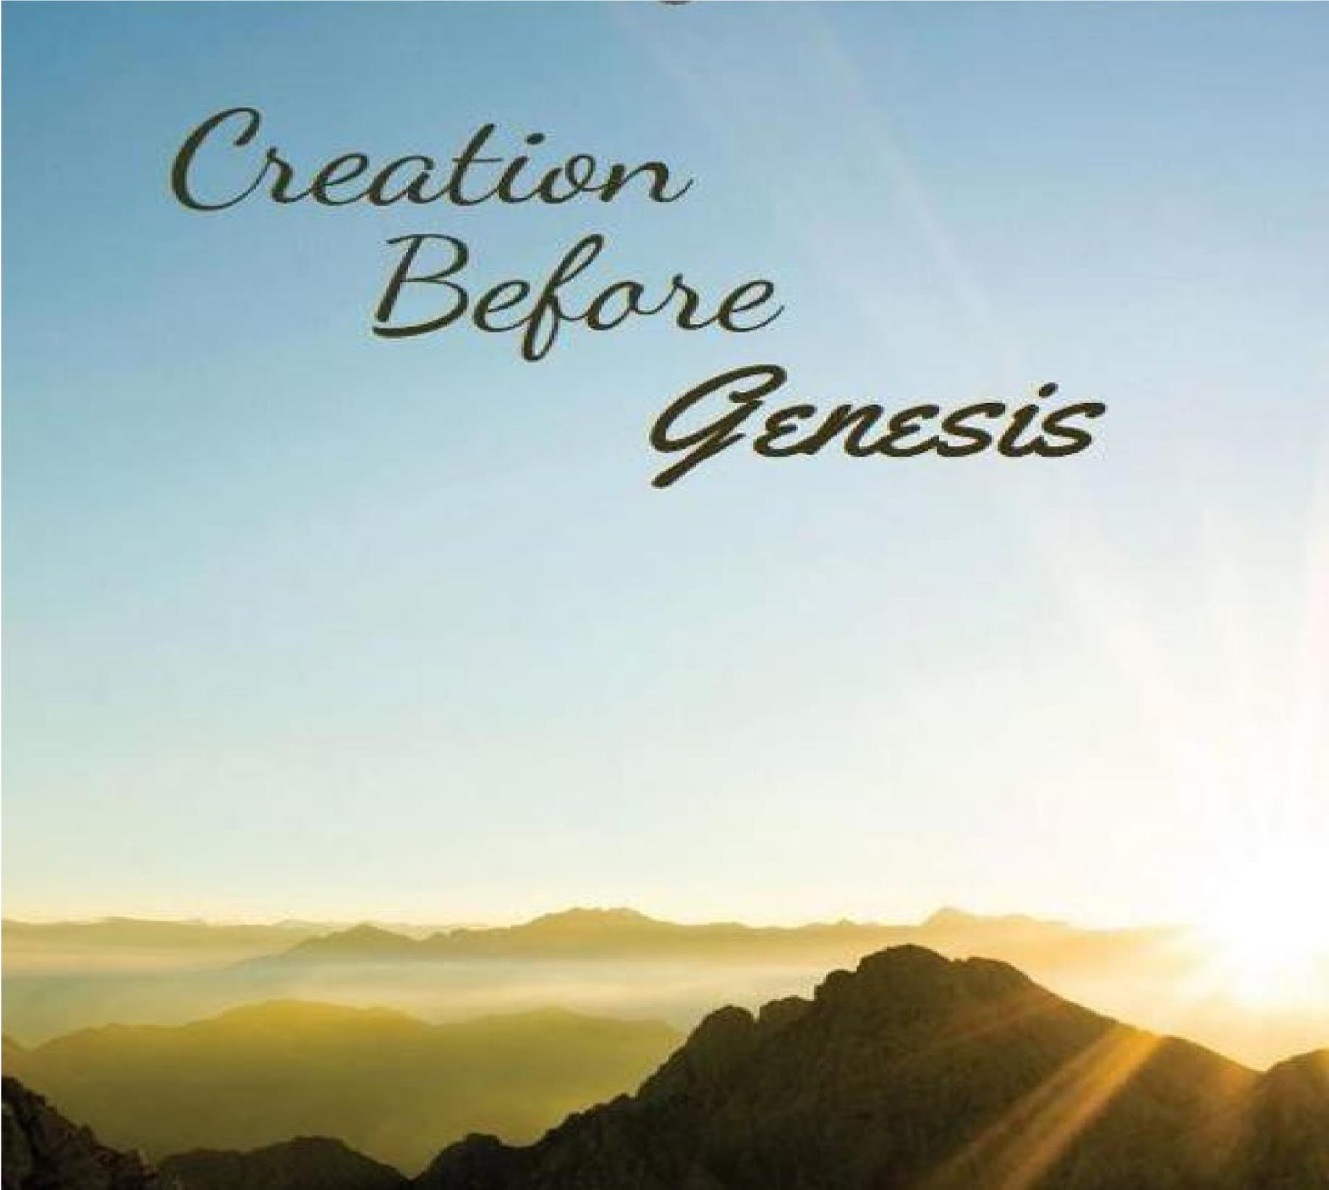
The Angel Of Jehovah
Cecil N. Wright

The Angel Of Jehovah

When Moses wanted to know God’s name so that he could tell his Hebrew brethren in Egypt, God said he was “I AM THAT I AM”, and in shortened form when He spoke of himself as I AM. (Exodus 3:14) Then he said to tell the elders of Israel that Jehovah, the God of their fathers had appeared unto him. The difference is that God spoke of himself subjectively, in the first person (I AM), whereas Moses would speak of him objectively, in the third person (HE [WHO] IS = Jehovah).
While there are multitudes of angels of God, "the angel of Jehovah" or "of God" seems to be (a) distinct from the other angels, and (b) much of the time is equated with God himself, as if one of the members of the Godhead and likely is the one called "the angel of his presence" (literally, "of his face") in Isaiah 63:9.
“The angel of Jehovah" or "of God" in the Old Testament could well have been the member of the Godhead that later became incarnate as Jesus Christ (John 1:1-3,14

Old Testament references
- Genesis 16:7-14: "The angel of Jehovah" appeared to Hagar, the handmaid of Sarai, when she was fleeing from her mistress, and instructed her to return. "and she called the name of Jehovah that spake unto her, Thou art a God that seeth."
- Genesis 18:1 - 19:28: Three "men" appeared to Abraham, one of whom is identified as "Jehovah" (18:13-33; 19:27) – a member of the Godhead; and the other two, called "angels" (19:1,15), went into Sodom and visited Abraham’s nephew, Lot, delivering him and his family from the destruction of that city.
- Genesis 21:8-20: "and the angel of God called to Hagar out of heaven [on a later occasion], and said unto her, What aileth thee, Hagar? For God has heard the voice of the lad where he is. Arise, lift up the lad, and hold him in thy hand; for I will make him a great nation.” (vs. 17-18)
- Genesis 22:1-19: "And the angel of Jehovah called unto him out of heaven, and said, Abraham, Abraham: and he said, Lay not thy hand on the lad, … for now I know thou fearest God, seeing thou hast not withheld thy son, thine only son, from me. … and the angel of Jehovah called Abraham a second time out of heaven, and said, By myself have I sworn, saith Jehovah, because thou hast done this thing, and hast not withheld thy son, thine only son, that in blessing I will bless thee," etc. (vs.11-17)
- Genesis 24: 1-67: Abraham’s language to his servant whom he was sending to the city of Nahor in Mesopotamia to obtain a wife for his son Isaac: "Jehovah, the God of heaven, who took me from my father’s house, and from the land of my nativity, and who spake unto me, and who sware unto me, saying, unto thy seed will I give this land; he will send his angel before thee, and thou shalt take a wife for my son from thence." (v.7; cf. v.40)
Comment: The writer (Moses) is using a figure of speech called prolepsis, in which a thing is spoken of before its time, as in speaking of Nero when he was a boy, though he was not emperor when a boy. In like manner, Abraham at the time referred to in the narrative under consideration did not know God by the name Jehovah, but as God almighty (Heb. El Shadddai) (Exodus 6:2-3) – though the writer did know it.
- Genesis 31: 3-16: "and Jehovah spake unto Jacob, Return unto the land of thy fathers, and to thy kindred; and I will be with thee … And the angel of God said unto me in a dream Jacob: … and he said [according to Jacob’s report to his wives], … I am the God of Bethel [28:10-22], where thou anointedst a pillar, where thou vow a vow unto me: now arise, get thee out from this land, and return unto the land of thy nativity." (vs.3-13)
- Genesis 48:15-16: "And he blessed Joseph, and said, the God before whom my fathers Abraham and Isaac did walk, the God who hath fed me all my life long unto this day, the angel who hath redeemed me from all evil, bless the lads; and let my name be named on them, and the name of my fathers Abraham and Isaac; and let them grow into a multitude in the midst of the earth." (vs.15-16)
Comment: Jacob (Israel) blessed his son Joseph and his grandsons Ephraim and Manasseh. The "angel" here is the "angel of God" in (f) above, and is equated with God himself, hence as being a member of the Godhead.
- Exodus 3:1-22: "And the angel of Jehovah appeared unto him [Moses] in a flame of fire out of the midst of a bush: and he looked, and behold, the bush burned with fire, and the bush was not consumed. And Moses said, I will turn aside now, and see this great sight, why the bush is not burnt. And when Jehovah saw that he turned aside to see, God called unto him out of the midst of the bush, and said, Moses, Moses. And he said, Here am I … Moreover, he said, I am the God of thy father, the God of Abraham, the God of Isaac, and the God of Jacob. And Moses hid his face; for he was afraid to look upon God. And Jehovah said, I have surely seen the affliction of my people that are in Egypt," etc.
(vs.2-7a)
Comment: The "angel of Jehovah," "Jehovah," and "God," are equated in this passage.
- Exodus 13: 21-22: "And Jehovah went before them [the Israelites in their journey from Egypt to the land of Canaan] by day in a pillar of cloud, to lead them by the way, and by night in a pillar of fire, to give them light; that they might go by day and by night: the pillar of cloud by day, and the pillar of fire by night, departed not from before the people."
- Exodus 23:20-23: "Behold, I [Jehovah] send an angel before thee, to keep thee by the way, and to bring thee into the place which I have prepared. Take ye heed before him, and harken unto his voice; provoke him not; for he will not pardon you transgression: for my name is in him. But if thou shalt indeed hearken unto his voice, and do all that I speak; then I will be an enemy unto thine enemies, and an adversary unto thine adversaries. For mine angel shall go before thee." Comment on Exodus 32 -33:
After a sinful episode at Mount Sinai on the way to Canaan (Exodus 32-33), God severely punished Israel and threatened to consume them and make a great nation of Moses in their stead. Moses interceded and God agreed to let them live and go on to Canaan, promising to send "mine angel" before them and drive out the inhabitants of the land (Exodus 32:34) but not without first saying, "I will not go up in the midst of thee; for thou art a stiff-necked people; lest I consume thee in the way." (Exodus 33:3b)
"When the people heard these evil tidings [of 33:1-3], they mourned: and no man did put on him ornaments. And Jehovah said unto Moses, say unto the children of Israel, Ye are a stiff-necked people; if I go up in the midst of thee for one moment, I shall consume thee; therefore. now put off thy ornaments from thee, that I may know what to do unto thee." They mourned, and stripped themselves of their ornaments, never wearing them again, and God did not "consume" them. He also further reversed himself, promising Moses, "My presence shall go with thee, and I will give thee rest." Moses replied, "If thy presence go not with me, carry us not up hence." And he asked that God show him His glory as assurance that he and the people had found favor in His sight and would have his presence on their journey. In response, God had Moses to go into the cleft of a rock while his glory passed by, and then to see his back but not his face. (33:423)
As a sequel, we note in the book of Deuteronomy that after Israel had arrived nearly 40 years later east of the Jordan River, Moses in his farewell address shortly before his death and Joshua’s leading them westward across Jordan into Canaan, recounted various outstanding incidents that occurred along the way, showing how Jehovah had indeed been with them all the while notwithstanding their intransigence time after time after time and his punishing them in various ways. And in 1:32-33, Moses was recounting how he had said to them at Kadesh-Barnea, "Jehovah your God … went before you in the way, to seek you out a place to pitch your tents in, in fire by night, to show you by what way ye should go, and in the cloud by day" – which was the very thing God had promised before the above-mentioned sinful episode at Sinai (and verifies our analysis above of Exodus 32-33). But the adult generation had so rebelled at Kadesh, near the border of Canaan, that God punished them by postponing entrance into Canaan until 40 years after their leaving Egypt when all the rebels would have died in the wilderness.

End Comment on Exodus 32-33
- While Israel was encamped in the plains of Moab east of the Jordan opposite Jericho, "the angel of Jehovah" was involved in preventing the greedy prophet Balaam from cursing the Israelites for the Moabite king Balak. (Numbers 22:22-38) And in vs.35-38 "the angel of Jehovah" and "God" seem to be equated.
- After Israel was settled in Canaan, "the angel of Jehovah" appeared from time to time to different persons for special purposes:
  - To Israel at Bochim, to rebuke them for not having driven out the inhabitants of Canaan to the extent commanded them – and identified himself as the one who had brought them out of Egypt. (Judges 2:1-5)
  - to Gideon in Ophrah, to appoint him to deliver Israel from the Midianite oppression – and is identified as
Jehovah. (Judges 6"11-14)
  - to the wife of Manoah, and later to Manoah, to foretell their becoming the parents of Samson – and they came to realize that they had seen God. (Judges 13:2-25)
  - to David by the threshing floor of Araunah, after staying a pestilence brought on by David’s numbering the people as for war without divine authorization, and where David confessed to him his sin. (2 Samuel 24:15- 17; cf. 1 Chronicles 21:18-27)
  - to Elijah, in the wilderness south of Beer-sheba while fleeing to Horeb from wicked Jezebel in Jezreel after slaying the false prophets she had been supporting. (1 Kings 19:1-8)
  - to Elijah again later, regarding a mission to king Ahaziah in Samaria, who was seeking information of Baalzebub, the god of Ekron. (2 Kings 1:1-16)
  - to the camp of the Assyrians just outside Jerusalem, to smite it and save the city from attack and destruction. (2 Kings 19:35-36)
  - it the prophet Zachariah, near the end of Judah’s exile in Babylonia, to apprise him of it and make known pertinent information, as related in the first six chapters of the Book of Zachariah. He is called "the angel that talked with me" and "the angel of Jehovah." (the latter in 1:11, 12: 3:1, 5, 6)
Comment: While (4) through (8) do not identify "the angel of Jehovah" any further as in prior references, there is nothing in their contexts to prohibit them from likewise referring to a member of the Godhead rather than a created angel sent by Jehovah. And the same is true in regard to the remaining three scriptures that mention "the angel of Jehovah" without reference to any specific occasion of service – namely, Psalm 34:7; 35:5,6 – but do have reference to their ministry in behalf of God’s saints, as do the others.

New Testament references
Speaking of Moses, Acts 7:30-32 states: "And when forty years were fulfilled, an angel appeared to him in the wilderness of Mount Sinai, in the flame in the bush. …: and as he drew near to behold, there came a voice of the Lord, I am the God of thy fathers, the God of Abraham, and of Isaac, and of Jacob." And 7:38 says, "This is he that was in the church (assembly) in the wilderness with the angel that spake to him in the mount Sinai, and with our fathers" – described in the Pentateuch as "the angel of Jehovah" and identified as Jehovah, that is, as a member of the Godhead. But these verses in Acts identify said angel as the same one in all these instances.
Next we have 1 Corinthians 10:1-4, as follows: "For I would not, brethren have you to be ignorant, that our fathers were all under the cloud, and all passed through the sea; and were all baptized unto [Gr. into] Moses in the cloud and in the sea; and did all eat of the same spiritual food [manna]; and did all drink the same spiritual drink [water supplied from a rock at Horeb and at Kadeshbarnea]: for they drank of the spiritual rock that followed them: and the rock was Christ."
The actual source of that drink was a Spirit Being, not the inanimate physical rock from which it flowed. That
Being was "Christ," a "spiritual rock." AND "HE FOLLOWED THEM." That must mean he was the member of the Godhead who accompanied Israel from Egypt to Canaan and still rendered miraculous service on various occasions in the land of Canaan also, as well as being the one who had appeared unto their earlier fathers, Abraham, Isaac, and Jacob, as narrated above from the outset. But when he "became flesh, and dwelt among us … as … the only begotten from the Father" (John 1:14), there were still angels of God that ministered on various occasions, but none called "the angel of the Lord" or "of God," which he, and seemingly he alone, had been called.
Comment: The Israelites were immersed in Moses, a physical redemption from Egyptian bondage. Christians are immersed in Christ’s blood, their spiritual redemption from the bondage of sin.

