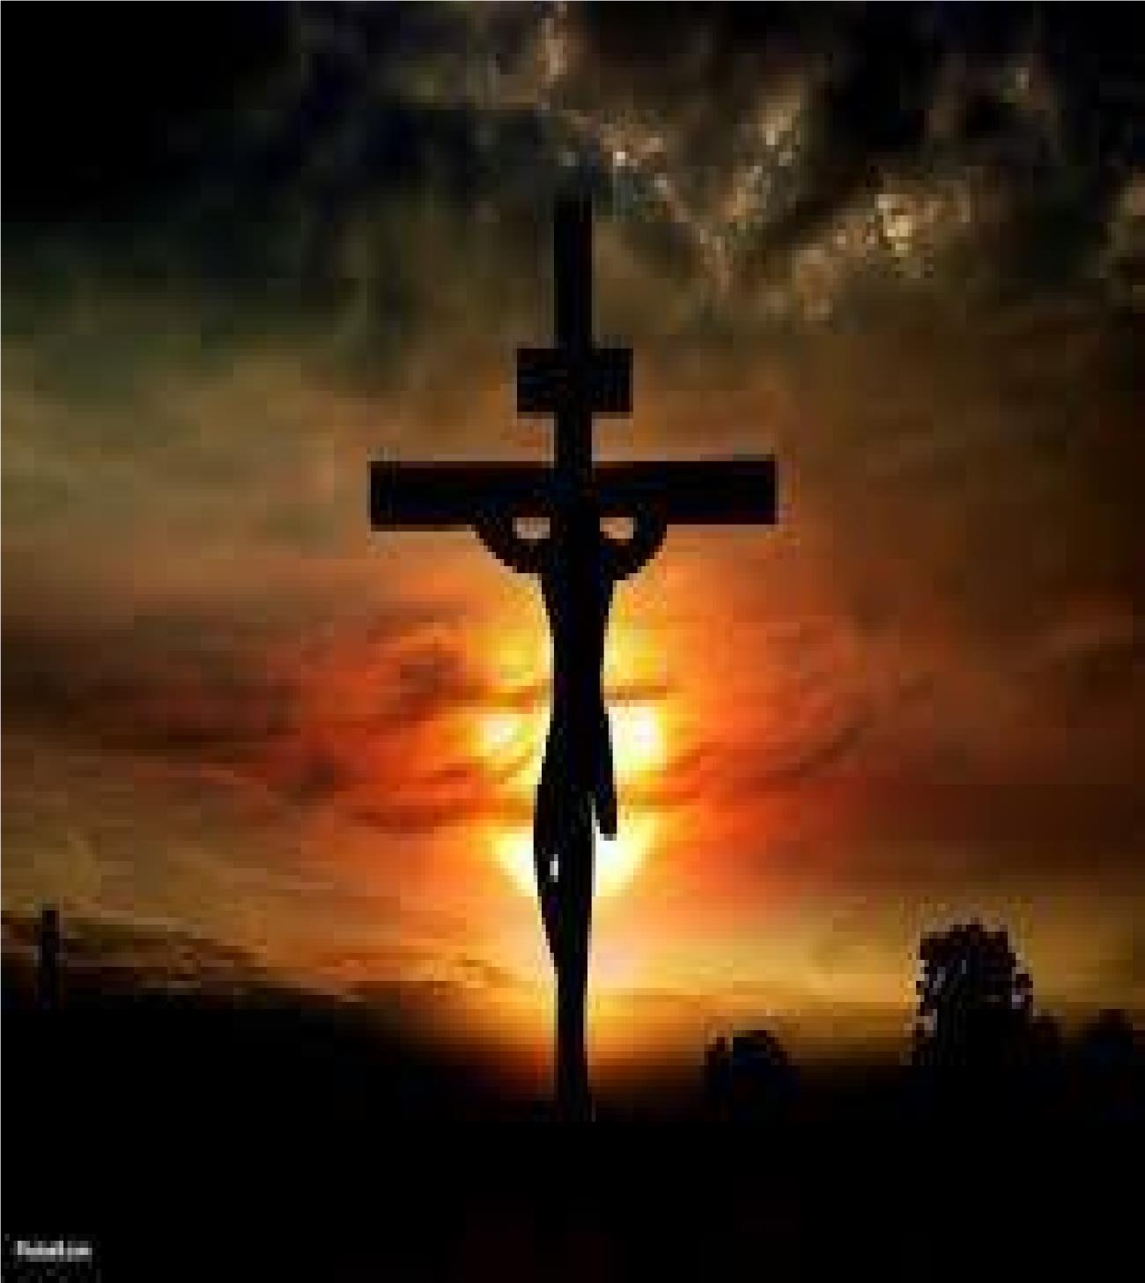
Christ - Witnesses
Randolph Dunn

Christ’s - Witnesses

During Jesus' earthly ministry, it was important that the people would come to believe that He was the Messiah, the Christ, the Son of God. There were several witnesses who proved this to be the truth.

John the Baptist
John preached a baptism (baptizo, a Greek word meaning immersion) for repentance and it was said all Judah came to John to be baptized. “Now some Pharisees who had been sent questioned him, ‘Why then do you baptize if you are not the Christ, nor Elijah, nor the Prophet?’ ‘I baptize with water,’ John replied, ‘but among you stands one you do not know. He is the one who comes after me, the thongs of whose sandals I am not worthy to untie.’” (John 1:24-27) ... “The next day John saw Jesus coming toward him and said, 'Look, the Lamb of God, who takes away the sin of the world! This is the one I meant when I said, ‘A man who comes after me has surpassed me because he was before me.’ I myself did not know him, but the reason I came baptizing with water was that he might be revealed to Israel.’ Then John gave this testimony: ‘I saw the Spirit come down from heaven as a dove and remain on him. I would not have known him, except that the one who sent me to baptize with water told me, 'The man on whom you see the Spirit come down and remain is he who will baptize with the Holy Spirit.’ I have seen and I testify that this is the Son of God.” (John 1:29-34) “Then Jesus came from Galilee to the Jordan to be baptized by John. But John tried to deter him, saying, ‘I need to be baptized by you, and do you come to me?’ Jesus replied, ‘Let it be so now; it is proper for us to do this to fulfill all righteousness.' Then John consented.” (Matthew 3:13-15)

Holy Spirit
“As soon as Jesus was baptized, he went up out of the water. At that moment heaven was opened, and he saw the Spirit of God descending like a dove and lighting on him.” (Matthew 3:16-17a) God
“And a voice from heaven said, ‘This is my Son, whom I love; with him I am well pleased.’” (Matthew 3:17b) Jesus then fasted forty days prior to publicly beginning His work. It was at the end of the forty days the Devil seized the opportunity to tempt Jesus in his physically weakened condition. Although he failed in this attempt, he continued to look for opportunities. Jesus then began His ministry. One of the first things He did was to select twelve men to train and to be witnesses of all He said and did, which was mostly public. He performed many miracles proving that God was with Him.

Miracles, Signs, and Wonders
He received no training in the Law and Prophets but people recognized he spoke with authority; not like the learned men, the rabbis, priests, Pharisees, Scribes, and other religious leaders. To these learned men He was very pointed in His remarks calling them hypocrites, and blind guides as their hearts, minds, and attitude, were so prideful, arrogant, haughty, jealous, and willing to stop at nothing to maintain their place in society. They even attributed His many miracles to the Devil rather than giving glory to God. Matthew records the following about them in chapter 23: vv.
- 3 – "For they do not practice what they preach."
- 5 – "Everything they do is done for men to see."
- 6 – They love the place of honor at banquets and the most important seats in the synagogues.”
- 13 – "Woe to you, teachers of the law and Pharisees, you hypocrites!"
- 16 – "Woe to you, blind guides! You say ..."
- 33 – "You snakes! You brood of vipers! How will you escape being condemned to hell?"
Luke adds another charge in 20:47 … You devour, eat up, consume, exploit, prey upon widows’ and rob them of their resources. They tried many things to trap Him into contradictions but failed. They challenged his authority but failed. See Luke 20 and Mark 12.

Crucifixion
Events during His Crucifixion witnessed the fact He was the Christ, the Son of God. (Refer to Matthew 27:5052)
- Jesus cried out with a loud voice and yielded up His spirit • The curtain of the temple was torn in two from top to bottom.
- The earth shook and the rocks split.
- The tombs were opened and the bodies of many holy people who had died were raised to life and they went into the holy city and appeared to many people.

Roman Soldiers
“When the centurion and those with him who were guarding Jesus saw the earthquake and all that had happened, they were terrified, and exclaimed, ‘Surely, he was the Son of God!’” (Matthew 27:54)

Those Closest to Him - Apostles
“Therefore, it is necessary to choose one of the men who have been with us the whole time the Lord Jesus went in and out among us, beginning from John's baptism to the time when Jesus was taken up from us. For one of these must become a witness with us of his resurrection.” (Acts 1:21-22)

“That which was from the beginning, which we have heard, which we have seen with our eyes, which we have looked at and our hands have touched-this we proclaim concerning the Word of life. The life appeared; we have seen it and testify to it, and we proclaim to you the eternal life, which was with the Father and has appeared to us. We proclaim to you what we have seen and heard, so that you also may have fellowship with us. And our fellowship is with the Father and with his Son, Jesus Christ.” (1 John 1:1-3)

Questions
- Immediately when Jesus came up out of the water following his baptism a voice from Heaven said that Jesus was God’s Son and God was well pleased with Him.
True

False

- Jesus spoke as one having authority because He was one of the learned men having been schooled in the rabbinical schools of the Jews.
True

False

- Jesus referred to the Pharisees and Scribes as blind guides

hypocrites

thieves

All the above

- Jesus' closest friends testified as eyewitnesses of His miracles, death, burial, and especially His resurrection.
True

False

- Why was Jesus baptized in water by John the Baptist?
To comply with the law of Moses

To be forgiven of His sins

To be obedient and to fulfill all righteousness

None of the above

Answers to Questions
  - True
  - False
  - All the Above
  - True
  - To be obedient and to fulfill all righteousness

