Time Christ On Earth

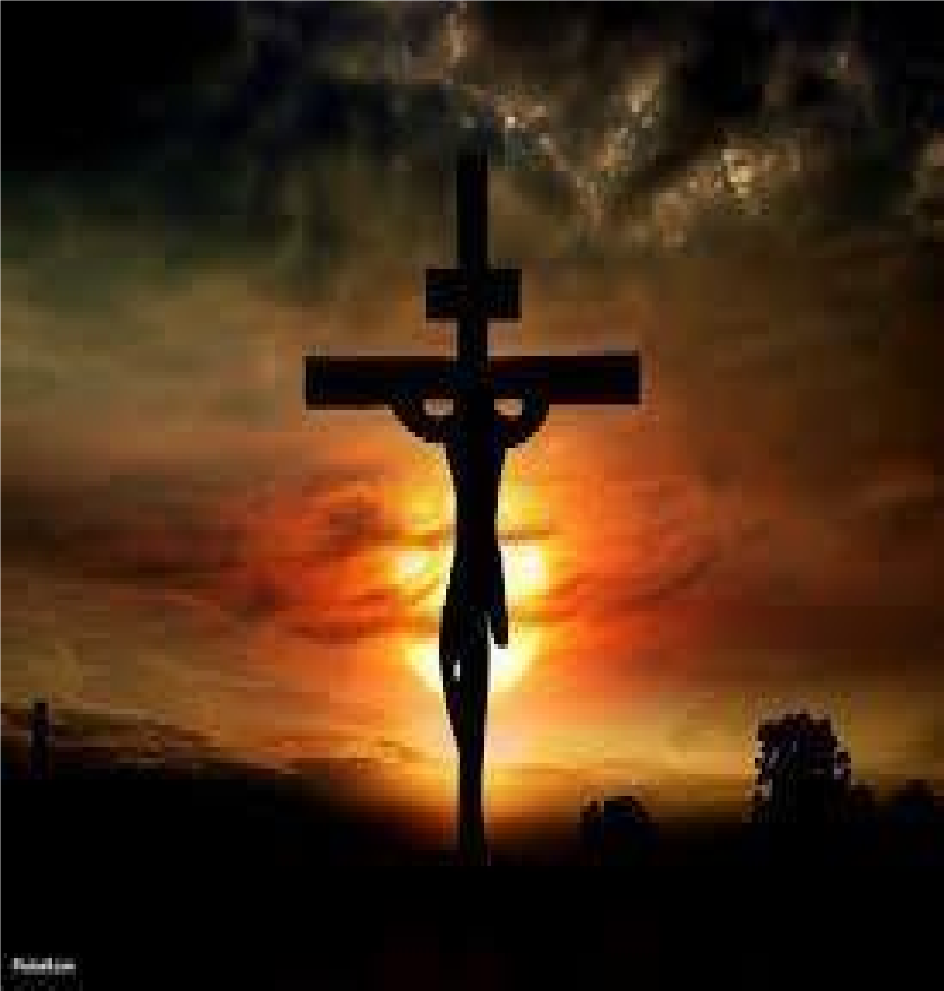
Christ’s Church
Randolph Dunn

Christ’s Church

“Because it is impossible for the blood of bulls and goats to take away sins. Therefore, when Christ came into the world, he said: ‘Sacrifice and offering you did not desire, but a body you prepared for me; … “then he said, ‘Here I am, I have come to do your will.’ He sets aside the first to establish the second. And by that will, we have been made holy through the sacrifice of the body of Jesus Christ once for all.” … “Then hath he said, Lo, I am come to do thy will. He taketh away the first, that he may establish the second. By which will we have been sanctified through the offering of the body of Jesus Christ once for all.” … “But when this priest had offered for all time one sacrifice for sins, he sat down at the right hand of God. Since that time, he waits for his enemies to be made his footstool, because by one sacrifice he has made perfect forever those who are being made holy.” (Hebrews 10:4-5, 9-10, 12-14) This is the atoning sacrifice to destroy the sting of death caused by sin and to cleanse man of his sins.

During His ministry, Jesus asked His disciples “‘But what about you?’ he asked. ‘Who do you say I am?’ Simon Peter answered, ‘You are the Christ, the Son of the living God.’ – ‘And I tell you, you are Peter, and on this rock, I will build my church (His called-out people), and the powers of death shall not prevail against it.’” (Matthew 16:15-16-18) Therefore, the foundation of “my church” is the person Jesus, the Son of God.
Before “my church” could become reality, death needed to be conquered and the sacrifice for sin had to be made. Following the mockery of a trial with its perverted justice, the Romans crucified the innocent Son of God. The judicial charge against Him, JESUS OF NAZARETH, KING OF THE JEWS, was fastened to the cross.

The hypocritical Jewish religious leaders mocked Him and looked upon his crucifixion with great pleasure, but that was soon interrupted as darkness fell over Jerusalem for three hours just before His death. John tells us in John 19:30 that just, before He died, Jesus said, "It is finished”. He had completed His mission for the redemption of mankind by His atoning sacrifice. The way was open for man to be reconciled to God.

Jews
On Pentecost Day 10 days after Christ ascended back to heaven His Spirit was poured out to all men. Then Peter and the other apostles proclaimed to those gathered that forgiveness of sins was now available as the atoning sacrifice had been made when Christ was crucified, resurrected by God and returned to be with the Father having conquered death, Satan’s hold over man. Some 3,000 heard this message, repented asking “what shall we do,” and were immersed into Christ death (Acts 2:14-38). Then God added them to Christ’s church also referred to as Body of Christ. (Acts 2:41)

Gentiles
“I delivered to you as of first importance what I also received: that Christ died for our sins in accordance with the Scriptures, that he was buried, that he was raised on the third day in accordance with the Scriptures.” (1 Corinthians 15:3-5) “Do you not know that all of us who have been baptized into Christ Jesus were baptized
(immersed) into his death? We were buried therefore with him by baptism into death, in order that, just as Christ was raised from the dead by the glory of the Father, we too might walk in newness of life. For if we have been united with him in a death like his, we shall certainly be united with him in a resurrection like his.” (Romans 6:3-5)
Summary
“The Lamb of God who takes away the sin of the world” (John 1:29-30)!
- Christ’s mission was to remove sin from man • Jesus lived among men without sin
- God made Jesus to be sin.
- Christ died with man’s sins placed upon Him
- Christ removes sins through trust and obedience when man o Dies to sin o Is buried with their sins into Christ’s death o Is raised a new creation by God free of past sins o Is put by God into Christ’s spiritual body, His Church

Christ’s church is not a building or an organization as some think. It is people called out of sin into righteousness, put into Christ’s Body to be living sacrifices by worshipping in songs, prayers, and the doing of good works, thus glorifying God daily. They assemble together to encourage each other unto faithfulness by singing, praying, disciplining, giving and evangelizing, and remembering Christ who gave Himself as the only atoning sacrifice for the forgiveness of sins known as the Lord’s Supper.

Questions
- Christ offered His sinless body to God to atone for man’s sins
True
False

- These saved people, those put into Christ’s body, are a living organism doing the will of God, not an organization.
True
False

- The church is people called out of sin into God’s righteousness.
True
False

- The foundation of Christ’s church is
The Apostles
Temples and church sanctuaries
Jesus, the Christ, the Son of God

- People are added to Christ’s Body, His church, by
Inheritance
Vote of members
God

Answers to Questions
1. True 2. True
  - True
  - Jesus, the Christ, the Son of God
  - God

