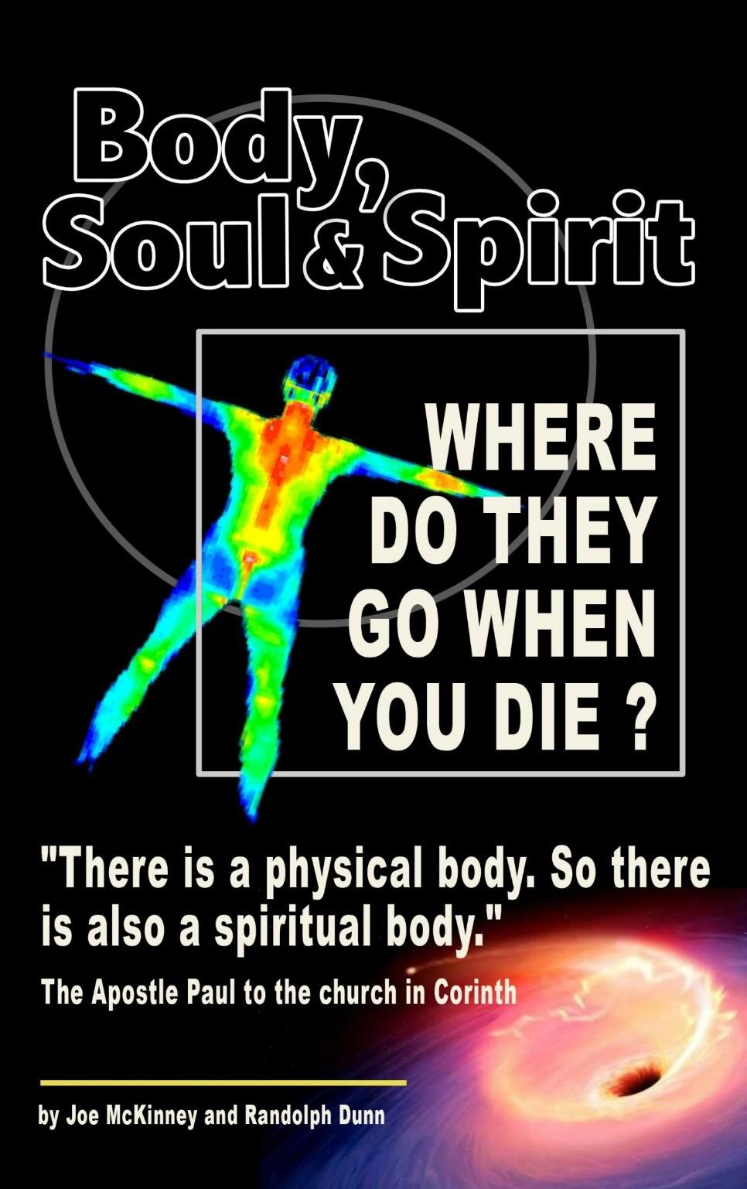

Body, Soul and Spirit
Where do They Go When You Die?
Randolph Dunn

Chapter 1
What Happens to the Body, Soul and Spirit?
In the beginning, God created the heavens and the earth. The earth was without form and void." (Genesis 1:2) "And God said, 'Let the waters under the heavens be gathered together into one place, and let the dry land appear.' And it was so. God called the dry land Earth.” (Genesis 1:9-10) “And God said, let the earth bring forth living creatures according to their kind - livestock and creeping things and beast of the earth according to their kind. And It was so.” (Genesis 1:24)
Then God created man, a physical and an eternal being in His likeness of love, righteousness, peace, and mercy. He then told Adam and Eve to take care of the place where he was placed, to be fruitful and multiply and not to eat from the tree of the knowledge of good and evil. But they sinned when they yielded to their desires and disobeyed by eating from the tree. This disobedience resulted in physical and eternal death. This applies to all men for “all have sinned and fall short of the glory of God.” (Rom 3:23)
God's desire is for all people to change from their sinful way of life, be washed and made clean by the blood of Christ bring forgiveness of sins, so they could be reconciled to God. To accomplish this, an acceptable sin offering had to be made. Jesus of Nazareth, God in human form, who offered His sinless body as the only and perfect sin-offering sacrifice for anyone who puts their faith and trust in Christ through obedience by being buried into His death, raised a new spiritual being, put in Christ's Church, and given the Holy Spirit as a gift. Then those in Christ are to grow and mature into God's likeness – love, faithful, peace, mercy, truth – by abiding in Christ's Word and living according to His will.
If those in Christ remain faithful, their destiny is eternal life with God, Christ, the Holy Spirit and others made righteous by the blood of Christ. However, the destiny of the rebellious, unfaithful and unrepentant is everlasting death with the Devil.
People like Job often question what happens after physical death asking; "If a man dies, shall he live again?" (Job 14:14)
Before addressing “If a man dies, shall he live again?", some definitions of words used in this study and a review of man's existence from the beginning is in order.
BODY – The visible and physical man – the flesh and blood part of man.
“Then the Lord God formed the man of dust from the ground and breathed into his nostrils the breath of life, and the man became a living creature.” (Genesis 2:7-8)
“Your hands fashioned and made me, and now you have destroyed me altogether. Remember that you have made me like clay; and will you return me to the dust?” (Job 10:8-9)
“For what happens to the sons of men also happens to animals; one thing befalls them: as one dies, so dies the other. Surely, they all have one breath; man has no advantage over animals, for all is vanity. All go to one place: all are from the dust, and all return to dust. Who knows the spirit of the sons of man, which goes upward …?” (Ecclesiastes 3:19-21)
DEATH - The cessation of the functioning of the heart, lungs, brain, etc. of the physical body.
In the account of the flood, it states “Everything on the dry land in whose nostrils was the breath of life died.” (Genesis 7:22)
“The body without the spirit is dead.” (James 2:26)
“And just as it is appointed for man to die once, and after that comes judgment, so Christ, having been offered once to bear the sins of many, will appear a second time, not to deal with sin but to save those who are eagerly waiting for him.” (Hebrews 9:27-38)
Comment: Man’s body was a lifeless form of dirt until God breathed into the body life and gave man a soul and a spirit.
GRAVE – The grave is anywhere the dead physical body is left or put – ocean, wilderness, a tomb, or anything that marks the last remains.
HADES – Hades is from the Hebrew word sheol and the Greek words aidos or hadou meaning the abode of the souls of the physical dead – the not seen or unseen world of the eternal souls of those who are dead physically.
Comment: Some Bibles have erroneously translated aidos and hadou as "hell." But the word for Hell is geénnee – the place reserved for the Devil. This mistranslation has caused much confusion.
“There was a rich man who was clothed in purple and fine linen and who feasted sumptuously every day. And at his gate was laid a poor man named Lazarus, covered with sores, who desired to be fed with what fell from the rich man's table. Moreover, even the dogs came and licked his sores. The poor man died and was carried by the angels to Abraham's side. The rich man also died and was buried, and in Hades, being in torment, he lifted up his eyes and saw Abraham far off and Lazarus at his side.” (Luke 16:19-23)
Comment: Hades has a paradise side for the righteous souls and a torment side for those who refuse to obey God, the rebellious, unfaithful and the wicked.
HELL – The Hebrew word geénnee originally meant the place where the idolatrous Jews burned their children alive as worship to the gods Moloch and Baal. After the Babylonian Exile this valley became the city dump and a fire was kept constantly burning. It came to signify Hell, the everlasting place of the wicked, the opposite of heaven. [Easton's Bible Dictionary, PC Study Bible by Biblesoft]
SOUL – The Greek word psuche means man's eternal being, his conscience awareness given to man when God breathed life into him. This is often referred to as the heart or his inner being.
“Do not put out the Spirit's fire; do not treat prophecies with contempt. Test everything. Hold on to the good. Avoid every kind of evil. May God himself, the God of peace, sanctify you through and through. May your whole spirit, soul and body be kept blameless at the coming of our Lord Jesus Christ. The one who calls you is faithful and he will do it.” (1 Thessalonians 5:19-24)
Matthew records Jesus stating “Don't be afraid of those who want to kill your body; they cannot touch your soul. Fear only God, who can destroy your soul and body in hell (geénnee not the Greek word hadou Hades).” (Matthew 10:28)
SPIRIT – The Hebrew word neshamah and Greek word pneuma refer to man's spirit God created in him which returns to God upon man's death. “The dust (body) returns to the ground it came from, and the spirit returns to God who gave it.” (Ecclesiastes 12:7)
To the Christians in Rome Paul wrote “The Spirit himself bears witness with our spirit that we are children of God.” … “The Spirit helps us in our weakness. We do not know what we ought to pray for, but the Spirit himself intercedes for us with groans that words cannot express. And he who searches our hearts knows the mind of the Spirit, because the Spirit intercedes for the saints in accordance with God's will.” (Romans 8:16; 26-27)
Comment: “The Spirit” when ascribed to God is generally translated as Spirit of God, Spirit of Christ, Holy Spirit or just Spirit.
Comment: The Aramaic word ruwach translated “spirit”, refers to life-breathing animals including man.
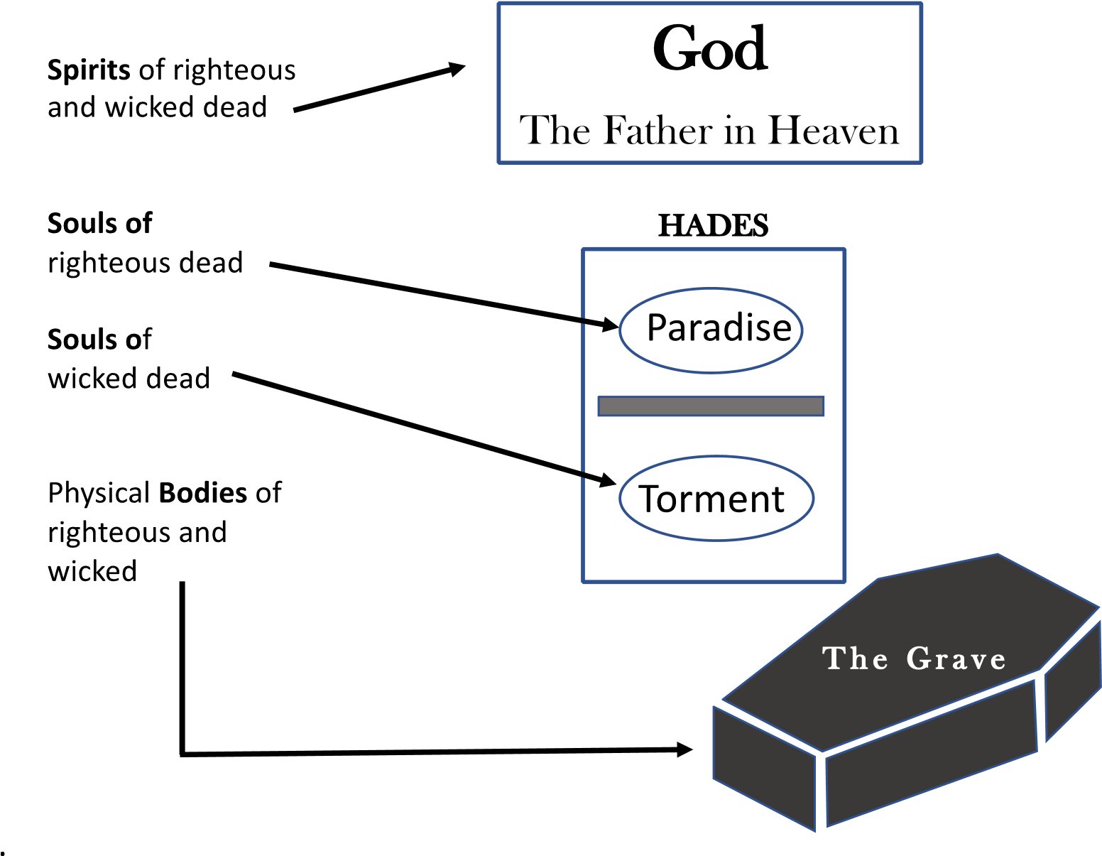

Chapter 2 Time While Christ Was on Earth

“An angel of the Lord appeared to him [Joseph] in a dream, saying, ‘Joseph, son of David, do not fear to take Mary as your wife, for that which is conceived in her is from the Holy Spirit. She will bear a son, and you shall call his name Jesus, for he will save His people from their sins.’” (Matthew 1:21-22)
Comment: Jesus saves “His people” NOT ALL people.
The apostle John wrote “The next day he (John, the baptizer) saw Jesus coming toward him, and said, ‘Behold, the Lamb of God, who takes away the sin of the world.’” (John 1:29)
“Thus, it is written, that the Christ should suffer death (by crucifixion) and on the third day rise from the dead, and that repentance and forgiveness of sins should be proclaimed in his name to all nations (Jews and Gentile), beginning from Jerusalem.” (Luke 24:46-47)
Comment: Some people claim at death all people will go to Heaven. If this were true then proclaiming “repentance and forgiveness” of sins s not necessary.
Jesus said to him, “I am the way, and the truth, and the life. No one comes to the Father except through me.” (John 14:6-7)
“In him (Christ) we have redemption through his blood, the forgiveness of our trespasses, according to the riches of his grace.” (Ephesians 1:7)
Shortly before His crucifixion, Jesus told His disciples: “I left the Father and came into the world. Now I am leaving the world and going back to the Father.” (John 16:28)
Comment: But first Jesus must complete the purpose for which He descended from Heaven.
The Lamb of God must offer Himself to God as the atoning sacrifice as He bore man's sins in His body while on the cross.” (2 Peter 2:24)
He himself (Christ) bore our sins in his body on the tree, so that we might die to sins and live for righteousness; by his wounds you have been healed. (1 Peter 2:24)
Jesus told the thief being crucified with Him “Truly, I say to you, today you will be with me in Paradise.” (Luke 23:43)
At the ninth hour just short of dying Jesus felt forsaken by God crying out “My God, my God, why have you forsaken me?” (Matthew 27:26)
Christ's Spirit then “went and proclaimed (Greek word kerusso – meaning herald, proclaim, preach) to the spirits in prison, because they formerly did not obey.” (1Peter 3:19-20)
Comment: The Bible is silent regarding the content of His proclamation. Jesus could have proclaimed to those in Paradise that their sins are now forgiven as the perfect atoning sacrifice has been made.
Something dramatically changed when Jesus ascended back to The Father. He moved Paradise and all the souls therein to Heaven. “When he ascended up on high, he led a host of captives, and gave gifts to men.” (Ephesians 4:8)
Comment: The “host of captives” righteous souls held in Paradise have been cleansed, forgiven, and taken up on high, heaven, with Jesus. The souls remaining in the Torment side of Hades await the Day of Judgment.

Chapter 3

Time After Christ Returned to God
Jesus promised: “I will build my (Christ’s) church and the gates of Hades will not prevail against it.” (Matthew 16:18)
Comment: “Christ’s Church” is not a building, temple or sanctuary but a body of forgiven sinners made righteous by the blood of Christ.
Comment: The gates or entrance to Hades is death, Satan’s hold over man. Since death will not prevail over Christ’s church, then those in in His kingdom who die after Christ's resurrection and ascension are not held captive in Hades.

Comment: The wicked remain in Hades, a prison housing the souls of the unforgiven until Christ returns.
Paul desired:
“To depart and be with Christ.” (Philippians 1:23)
“Therefore, we are always confident and know that as long as we are at home in the body we are away from the Lord. We live by faith, not by sight. We are confident, I say, and would prefer to be away from the body and at home with the Lord.” (Corinthians 5:6-8)
“For God did not appoint us to suffer wrath (everlasting torment) but to receive salvation through our Lord Jesus Christ. He died for us so that, whether we are awake (living) or asleep (dead), we (those in Christ) may live together with him. Therefore encourage one another and build each other up, just as in fact you are doing.” (1 Thessalonians 5:9-11)
Comment: All this agrees with the desire of Paul. His hope, upon dying, was not to go to Hades where Jesus is no longer to be found but go to Heaven, to be with Christ.
“When he opened the fifth seal, I saw under the altar the souls of those who had been slain because of the word of God and the testimony they had maintained.” (Revelation 6:9)
“Another angel, who had a golden censer, came and stood at the altar. He was given much incense to offer, with the prayers of all the saints, on the golden altar before the throne.” (Revelation 8:3)

Comment: In the fifth seal of Revelation 6:9 John saw the souls of martyred Christians that were under the altar and that altar was in front of God's throne in heaven. So, the martyrs were not in Hades but in heaven.
“Jesus said to her, ‘I am the resurrection and the life. He who believes in me will live, even though he dies; and whoever lives and believes in me will never die. Do you believe this?’” (John 11:2526)
Comment: Jesus promised that those who live and believe, have faith and trust in Him, would never die. Even though their physical bodies quit working and must be discarded, their souls are eternal and go directly to the Paradise part in Heaven to be with the Christ who declared, “I am the way, the truth and the life.” (John 14:6)
“We believe that Jesus died and rose again and so we believe that God will bring with Jesus those who have fallen asleep in him.” (1 Thessalonians 4:14)
Comment: The souls of Christians, when their physical bodies die, go to be with Jesus in Paradise in Heaven where they will remain until His return, the Second Coming. Since the souls of the saved are in heaven, then it makes sense they will be with Him when He returns.
“I know a man in Christ who fourteen years ago was caught up to the third heaven. Whether it was in the body or out of the body I do not know-God knows. And I know that this man-whether in the body or apart from the body I do not know, but God knows was caught up to paradise. He heard inexpressible things; things that man is not permitted to tell.” (2 Corinthians 12:2-4)
Comment: Paul was caught up in the Third Heaven, the celestial heaven, the abode of God and Paradise, where Christ instructed him, so, paradise was in Heaven not Hades, shortly after Christ’s ascension.
Comment: To the Jews the first heaven meant the atmosphere (aerial heavens), the second heaven meant outer space (sidereal heavens) and the “third heaven” was God's dwelling place
“When they heard this, they were furious and gnashed their teeth at him. But Stephen, full of the Holy Spirit, looked up to heaven and saw the glory of God, and Jesus standing at the right hand of God. 'Look,' he said, 'I see heaven open and the Son of Man standing at the right hand of God.' At this they covered their ears and, yelling at the top of their voices, they all rushed at him, dragged him out of the city and began to stone him. Meanwhile, the witnesses laid their clothes at the feet of a young man named Saul. While they were stoning him, Stephen prayed, 'Lord Jesus, receive my spirit.' Then he fell on his knees and cried out, 'Lord, do not hold this sin against them.'
When he had said this, he fell asleep.” (Acts 7:54-60)
Their destiny after Christ’s ascension
Obedient to God | Wicked and rebellious
The Spirit returns to God | The Spirit returns to God
The body returns to dust | The Body returns to dust
The soul goes to Paradise In Heaven awaiting the 2nd Coming. | The soul goes to Torment in Hades awaiting judgment.

The most critical question, then, has to be "What must I do to be saved eternally?" He who finds the answer to that question will be faced with a serious choice to make.
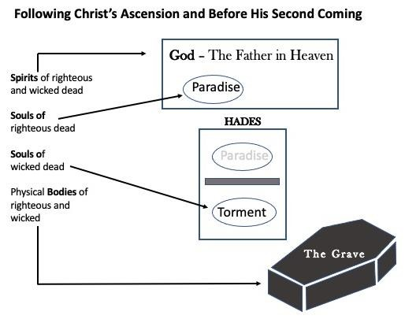

Chapter 4 The Second Coming of Christ
“After he said this, he was taken up before their very eyes, and a cloud hid him from their sight. They were looking intently up into the sky as he was going, when suddenly two men dressed in white stood beside them. ‘Men of Galilee,’ they said, ‘why do you stand here looking into the sky?
This same Jesus, who has been taken from you into heaven, will come back in the same way you have seen him go into heaven.’” (Act 1:9-11)
“To him who loves us and has freed us from our sins by his blood, and has made us to be a kingdom and priests to serve his God and Father — to him be glory and power for ever and ever! Amen. Look, he is coming with the clouds, and every eye will see him, even those who pierced him; and all the peoples of the earth will mourn because of him. So, shall it be!” (Revelation 1:5-7)
“The Lord is not slow in keeping his promise, as some understand slowness. He is patient with you, not wanting anyone to perish, but everyone to come to repentance.” (2 Peter 3:9)
“Come to me, all you who are weary and burdened, and I will give you rest. Take my yoke upon you and learn from me, for I am gentle and humble in heart, and you will find rest for your souls. For my yoke is easy and my burden is light.” (Matt 11:28-30)
“In my Father's house are many rooms. If it were not so, would I have told you that I go to prepare a place for you? And if I go and prepare a place for you, I will come again and will take you to myself, that where I am you may be also.” (John 14:2-3)
“We who are alive, who are left until the coming of the Lord, will not precede those who have fallen asleep. For the Lord himself will descend from heaven with a cry of command, with the voice of an archangel, and with the sound of the trumpet of God. And the dead in Christ will rise first. Then we who are alive, who are left, will be caught up together with them in the clouds to meet the Lord in the air, and so we will always be with the Lord.” (1Thessalonians 4:15-17)
“The sea gave up the dead that were in it, and Death and Hades gave up the dead that were in them, and all were judged according to their actions.” (Revelation 20:13)
Comment: “Death” or the grave gave up the physical body that had been turned to dust being transformed. “The dead in Christ,” the bodies of all the righteous, will be changed to immortal bodies to be with God while the bodies of all the rebellious and wicked will be changed to imperishable bodies to be with Satan.
Comment: “Hades” not Hell gave up the souls of the wicked for judgment has come.
Comment: The Bible states that Christ will return but it provides no indication when His Second Coming will occur.
“I tell you this, brothers: flesh and blood cannot inherit the kingdom of God, nor does the perishable inherit the imperishable. Behold! I tell you a mystery. We shall not all sleep, but we shall all be changed, in a moment, in the twinkling of an eye, at the last trumpet. For the trumpet will sound, and the dead will be raised imperishable, and we shall be changed. For this perishable body must put on the imperishable, and this mortal body must put on immortality. When the perishable puts on the imperishable, and the mortal puts on immortality, then shall come to pass the saying that is written: ‘Death is swallowed up in victory.’” (1Cointhians 15:50-54)
“When the Lord Jesus is revealed from heaven with his mighty angels in flaming fire, inflicting vengeance on those who do not know God and on those who do not obey the gospel of our Lord Jesus. They will suffer the punishment of eternal away from the presence of the Lord and from the glory of his might.” (2 Thessalonians 1:7-9)
“And I saw the dead, great and small, standing before the throne, and books were opened. Then another book was opened, which is the book of life. And the dead were judged by what was written in the books, according to what they had done. And the sea gave up the dead who were in it, Death and Hades gave up the dead who were in them, and they were judged, each one of them, according to what they had done. Then Death and Hades were thrown into the lake of fire. This is the second death, the lake of fire. And if anyone's name was not found written in the book of life, he was thrown into the lake of fire.” (Revelation 20:12-15)
Comment: The result of physical death is the same for the wicked and the righteous. Their physical body goes to the grave and returns to earth's elements while their spirit returns to God who gave it, but not so for their soul. The souls of the righteous go to Paradise in Heaven with Christ. The souls of those whose names are not written in the “Book of Life” go to Torment in Hades awaiting the Second Coming of Christ and then the Judgment.

The Physical Body
“Remember also thy Creator … before the silver cord is broken and the golden bowl is crushed, the pitcher by the well is shattered and the wheel at the cistern is crushed; then the dust will return to the earth as it was.” (Ecclesiastes 12:1; 6-7a)
“Our bodies are buried in brokenness, but they will be raised in glory. They are buried in weakness, but they will be raised in strength. They are buried as natural human bodies, but they will be raised as spiritual bodies. For just as there are natural bodies, there are also spiritual bodies.” (1 Corinthians 15:43-44)
“I declare to you, brothers, that flesh and blood cannot inherit the kingdom of God, nor does the perishable inherit the imperishable. Listen, I tell you a mystery: We will not all sleep, but we will all be changed— in a flash, in the twinkling of an eye, at the last trumpet. For the trumpet will sound, the dead will be raised imperishable, and we will be changed. For the perishable must clothe itself with the imperishable, and the mortal with immortality. When the perishable has been clothed with the imperishable, and the mortal with immortality, then the saying that is written will come true: "Death has been swallowed up in victory.” (1 Corinthians 15:50-54) “Don't be surprised at this; because the time is coming when all who are in the grave (the dead) will hear his (Christ's) voice and come out - those who have done good to a resurrection of life, and those who have done evil to a resurrection of judgment.” (John 5:28-29)

The Soul
The souls of the living who are in Christ are growing into the likeness and nature of God, their Father - love, faithful, merciful, truthful and peaceful. The souls of the dead in Christ are in Heaven with Christ. Both are waiting for the return of Christ and the Second Coming.
The souls of the living not in Christ are developing into the likeness of the Devil, their father - liars, murderers, rebellious, God-haters, lovers of self and the sexually immoral. The souls of the dead wicked and rebellious remain in the torment side of Hades awaiting the Second Coming of Christ and Judgment.
“And do not fear those who kill the body but cannot kill the soul. Rather fear him who can destroy both soul and body in hell.” (Matthew 10:28)
Comment: “Hell” is from the Greek word geénnee meaning the abode of Satan not hades the Greek word aidos (hadou )– the abode of departed souls.
Comment: The soul stays with the imperishable body even in Hell.
“Moses said, ‘The Lord God will raise up for you a prophet like me from your brothers. You shall listen to him in whatever he tells you. And it shall be that every soul who does not listen to that prophet shall be destroyed from the people.’” (Acts 3:22-23)
“My brothers, if anyone among you wanders from the truth and someone brings him back, let him know that whoever brings back a sinner from his wandering will save his soul from death and will cover a multitude of sins.” (James 5:19-20)
Comment: The physical body and man's soul are not the same. The souls of the righteous dead whether in the grave, buried at sea or cremated went to Paradise (in Hades until Christ's ascension and now in Heaven). Whereas, the soul of the wicked go to Torment in Hades awaiting Judgment. The Spirit
The Bible is silent regarding to what happens to man's spirit at Christ's Second Coming.
The writer of Ecclesiastes states that the body will decay and return to back to the earth from which it came and “the spirit returns to God who gave it.” (Ecclesiastes 12:6-7)
“The body without the spirit is dead.” (James 2:26)
“Jesus said ‘Father, into your hands I commit my spirit. When he had said this, he breathed his last.’” (Luke 23:46)
At his stoning Stephen called on the Lord and said, “Lord Jesus, receive my spirit! … When he had said this, he fell asleep (died).” (Acts 7:59; 60)
Comment: Studies of generations, cultures and races, including the isolated American Indians, African tribes and Aborigines of Australia, reveal that mankind has worshipped some object or being. One can only speculate if it is man's spirit, his soul or both that has this yearning to worship. That yearning or feeling is not sufficient for forgiveness. But those in Christ also have the Spirit of God given to them when God put them into Christ's Kingdom.

The Spirit of God Given to Those In Christ
“And Peter said to them, ‘Repent and be baptized every one of you in the name of Jesus Christ for the forgiveness of your sins, and you will receive the gift of the Holy Spirit.’” (Acts 2:38)
“And we are witnesses to these things, and so is the Holy Spirit, whom God has given to those who obey him.” (Acts 5:32)
“Do you not know that you are God's temple and that God's Spirit dwells in you?” (1 Corinthians 3:16)
“In him you also, when you heard the word of truth, the gospel of your salvation, and believed in him, were sealed with the promised Holy Spirit.” (Ephesians 1:13)
“Those who are in the flesh cannot please God. You, however, are not in the flesh but in the Spirit, if in fact the Spirit of God dwells in you. Anyone who does not have the Spirit of Christ does not belong to him.” (Romans 8:8-9)
“The Spirit helps us in our weakness; for we don't know how to pray the way we should. But the Spirit himself pleads on our behalf with groanings too deep for words; and the one who searches hearts knows exactly what the Spirit is thinking, because his pleadings for God's people accord with God's will.” (Romans 8:26-27)
“Follow the pattern of the sound words that you have heard from me, in the faith and love that are in Christ Jesus. By the Holy Spirit who dwells within us, guard the good deposit entrusted to you.” (2 Timothy 1:13-14)
Comment: The Spirit of God is given by God to the obedient when they are raised a new spiritual being following his death to sin and burial by being immersed (baptized) into Christ's death. The Spirit of God within man communicates with man's spirit feelings he is unable to verbalize in prayer.
What Occurs at Christ’s Second Coming?

The Dead in Christ
- The Soul comes with Christ in the cloud.
- The Body is transformed to be like Christ’s glorious body, immortality, to meet Christ in the cloud.

Those alive in Christ –the righteous.
- The Soul meets Christ in the cloud.
- The Body is transformed to be like Christ’s glorious body, immortality to meet Christ in the cloud.

The dead not in Christ – wicked and rebellious
- The Spirit remains with God
- The Body is transformed into an indestructible body.
- The Soul and body await judgment to be sent to everlasting death with the Devil and his angels.

Those alive not in Christ – wicked and rebellious await judgment
- The Spirit returns to God.
- The Body is transformed into an indestructible body.
- The Soul and body await judgment to be sent to everlasting death with the Devil and his angels.

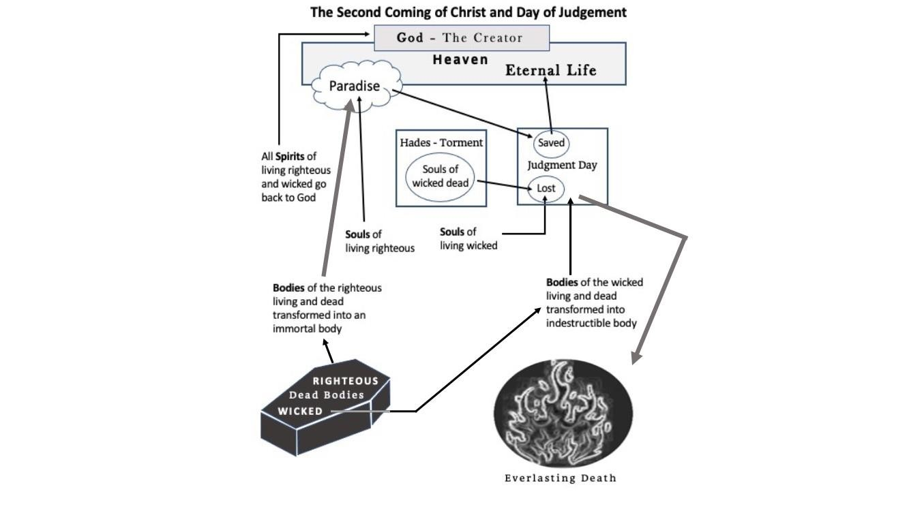

Another Interpretation
There are several ideas from different theological perceptions based upon personal reasoning and interpretation or lack thereof. Many people, if not most, believe all souls go to Hades when they die and remain there until Christ’s Second Coming. They believe Christ did not release the righteous held captive in the Paradise side of Hades or take them with Him when He ascended back to the Father.
At the Second Coming of Christ, there will not be any righteous souls with Him. Their bodies of the righteous will be transformed into immortal bodies and their souls in Paradise of Hades will meet Christ in the Cloud. Then they stand before God to be ushered into Heaven to be with God, Christ and all the Heavenly Host.
The wicked and rebellious bodies will be transformed into indestructible bodies. Their transformed indestructible bodies with their souls in Torment of Hades will answer to God at the Judgment to receive things done in the flesh before being sent to Hell to be with The Devil and his angels.

Chapter 5
What Happens on the Day of Judgment?
"… it is appointed for man to die ONCE, and after that comes judgment" (Hebrews 9:27).
Comment: “Once to die” then the judgment, no second chance or reincarnation.
“And after six days Jesus took with him Peter and James, and John his brother, and led them up a high mountain by themselves. And he (Jesus) was transfigured before them, and his face shone like the sun, and his clothes became white as light. And behold, there appeared to them Moses and Elijah, talking with him.” (Matthew 17:1-3)
Comment: So, Moses and Elijah were still in existence as only the flesh had died. They had the same identity as when in the physical body. Therefore, there could not be any reincarnation as their souls were still alive in the Hadean world because the atoning sacrifice required for forgiveness of sin had not been offered up to God.
“For all of us will stand before the judgment seat of God. For it is written, ‘As certainly as I live, declares the Lord, every knee will bow to me, and every tongue will praise God.’ Consequently, each of us will give an account of himself to God.” (Romans 14:10-12)

“For we must all appear before the judgment seat of Christ, that each one may receive what is due him for the things done while in the body, whether good or bad.” (2 Corinthians 5:10)
“When the Son of Man comes in his glory, and all the angels with him, he will sit on his throne in heavenly glory. All the nations will be gathered before him, and he will separate the people one from another as a shepherd separates the sheep from the goats. He will put the sheep on his right and the goats on his left. Then the King will say to those on his right, ‘Come, you who are blessed by my Father; take your inheritance, the kingdom prepared for you since the creation of the world’ … ‘to those on his left, 'Depart from me, you who are cursed, into the eternal fire prepared for the devil and his angels.’” (Matt 25:31-34 … 42)

The Righteous
“For the Lord himself will descend from heaven with a cry of command, with the voice of an archangel, and with the sound of the trumpet of God. And the dead in Christ will rise first. Then we who are alive, who are left, will be caught up together with them in the clouds to meet the
Lord in the air, and so we will always be with the Lord.” (1 Thessalonians 4:15-17)

The Wicked
“When the Son of Man comes in his glory, and all the angels with him, then he will sit on his glorious throne. Before him will be gathered all the nations, and he will separate people one from another as a shepherd separates the sheep from the goats. And he will place the sheep on his right, but the goats on the left. … "Then he will say to those on his left, 'Depart from me, you cursed, into the eternal fire prepared for the devil and his angels.” (Matthew 25:31-33 … 41)
“But the cowardly, the unbelieving, the vile, the murderers, the sexually immoral, those who practice magic arts, the idolaters and all liars — their place will be in the fiery lake of burning sulfur. This is the second death.” (Revelation 21:8)

The authors’ opinion
The righteous souls and their immortal bodies will be reunited to live eternally with God in Heaven. Not so for the rebellious and wicked for God’s Word will separate their soul and spirit. God’s Spirit will return to Him. Their soul and imperishable body will be cast into everlasting torment, Hell, with Satan and his angels. “For the word of God is living and active. Sharper than any double-edged sword, it penetrates even to dividing soul and spirit, joints and marrow; it judges the thoughts and attitudes of the heart.” (Hebrews 4:12-13)
Are you living for eternal life or everlasting death? It will either be in Heaven with God or in Hell with the Devil and His angels.

Chapter 6

Eternal Life
People who believe there is an eternal life and an eternal death attempt to follow some interpretation of God’s principles, precepts, and commands.
God requires a person to be “In Christ” to be acceptable. “Therefore, if anyone is in Christ, he is a new creation; old things have passed away; behold, all things have become new.” (2 Corinthians 5:17)
Comment: The lifestyle of these people will include:
- Loving, honoring, glorifying, praising and worshiping God as He has directed in His Word.
- Desiring the best for everyone, even their enemies.
- Providing for the needs of widows, orphans and especially Christians.
Since it is “In Him (Christ) we have redemption, the forgiveness of our sins,” (Ephesians 1:7) then our primary concern should be learning how Christ desires us to live and then live accordingly.
Christ’s commands and teachings are to be found in His Word, the Bible.
“On one occasion an expert in the law stood up to test Jesus. ‘Teacher,’ he asked, ‘what must I do to inherit eternal life?’ ‘What is written in the Law?’ he replied. ‘How do you read it?’ He answered: ‘Love the Lord your God with all your heart and with all your soul and with all your strength and with all your mind'; and, 'Love your neighbor as yourself.’ ‘You have answered correctly,’ Jesus replied. ‘Do this and you will live.’ But he wanted to justify himself, so he asked Jesus, ‘And who is my neighbor?’” (Luke 10:25-29)
After relating the parable known as “the Parable of the Good Samaritan,” Jesus asked which of the three – the Levite, priest or the Samaritan – was the injured man’s neighbor. “The expert in the law replied, ‘The one who had mercy on him.’ Jesus told him ‘Go and do likewise.’” (Luke 10:37)
We are also told to “Be imitators of God, therefore, as dearly loved children and live a life of love, just as Christ loved us and gave himself up for us as a fragrant offering and sacrifice to God” (Ephesians 5:1-2) and
"If you love me, you will obey what I command.” (John 14:15)
There are many instructions those In Christ must follow to become imitators of God thus living in the AFTER-LIFE with God.
“Do not love the world or anything in the world. If anyone loves the world, the love of the Father is not in him. For everything in the world - the cravings of sinful man, the lust of his eyes and the boasting of what he has and does comes not from the Father but from the world. The world and its desires pass away, but the man who does the will of God lives forever.” (1 John 2:15-17)
“This is how we know that we love the children of God: by loving God and carrying out his commands. This is love for God: to obey his commands. And his commands are not burdensome.” (1 John 5:2-3)
“This is the message we have heard from him and declare to you: God is light in him there is no darkness at all. If we claim to have fellowship with him yet walk in the darkness, we lie and do not live by the truth. But if we walk in the light, as he is in the light, we have fellowship with one another, and the blood of Jesus, his Son, purifies us from all sin.” (1 John 1:5-7)
Comment: God is Light – all things good, things done in the open – love, truth, mercy, kindness, faithfulness.
Comment: Devil is Darkness – all things evil, things done in secret – hate, envy, false, vengeance, selfishness.
“We proclaim to you what we have seen and heard, so that you also may have fellowship with us.
And our fellowship is with the Father and with his Son, Jesus Christ.” (1 John 1:3)
“If we claim to be without sin, we deceive ourselves and the truth is not in us. If we confess our sins, he is faithful and just and will forgive us our sins and purify us from all unrighteousness. If we claim we have not sinned, we make him out to be a liar and his word has no place in our lives.” (1 John 1:8-10)
“Dear friends, do not believe every spirit, but test the spirits to see whether they are from God, because many false prophets have gone out into the world. This is how you can recognize the Spirit of God: Every spirit that acknowledges that Jesus Christ has come in the flesh is from God, but every spirit that does not acknowledge Jesus is not from God. This is the spirit of the antichrist, which you have heard is coming and even now is already in the world.” (1 John 4:1-3)
Comment: “Antichrists” are those who deny that Jesus of Nazareth was God in a human body of flesh and blood.
“Then we will no longer be infants, tossed back and forth by the waves, and blown here and there by every wind of teaching and by the cunning and craftiness of men in their deceitful scheming. Instead, speaking the truth in love, we will in all things grow up into him who is the Head, that is, Christ. From him the whole body, joined and held together by every supporting ligament, grows and builds itself up in love, as each part does its work. So, I tell you this, and insist on it in the Lord, that you must no longer live as the Gentiles do, in the futility of their thinking. They are darkened in their understanding and separated from the life of God because of the ignorance that is in them due to the hardening of their hearts. Having lost all sensitivity, they have given themselves over to sensuality so as to indulge in every kind of impurity, with a continual lust for more.” (Ephesians 4:14-19)
“Therefore, as God's chosen people, holy and dearly loved, clothe yourselves with compassion, kindness, humility, gentleness and patience. Bear with each other and forgive whatever grievances you may have against one another. Forgive as the Lord forgave you. Above all these put on love, which binds everything together in perfect harmony. Let the peace of Christ rule in your hearts, since as members of one body you were called to peace. And be thankful. Let the word of Christ dwell in you richly as you teach and admonish one another. Whatever you do, whether in word or deed, do it all in the name of the Lord Jesus, giving thanks to God the Father through Him.” (Colossians 3:12-17)
Comment: “Word or deed” are things spoken or things done. They can be either peace and love or strife and hatred.
“For this very reason, make every effort to add to your faith goodness; and to goodness, knowledge; and to knowledge, self-control; and to self-control, perseverance; and to perseverance, godliness, and to godliness, brotherly kindness; and to brotherly kindness, love.
For if you possess these qualities in increasing measure, they will keep you from being ineffective and unproductive in your knowledge of our Lord Jesus Christ.” (2 Peter 1:5-8)
“In the last times there will be scoffers who will follow their own ungodly desires." These are the men who divide you, who follow mere natural instincts and do not have the Spirit. But you, dear friends, build yourselves up in your most holy faith and pray in the Holy Spirit. Keep yourselves in God's love as you wait for the mercy of our Lord Jesus Christ to bring you to eternal life. Be merciful to those who doubt; snatch others from the fire and save them; to others show mercy, mixed with fear-hating even the clothing stained by corrupted flesh.” (Jude 18-23)
Comment: It is clear from the above that those in Christ must grow. Therefore, the critical question is “How do I grow in order that my life reflects God?” I can become more like God by continually reflecting a clearer likeness of His essence and nature – of love, kindness, mercy, truth and justice as I grow older.
Chapter 7

Everlasting Death
Those who believe in neither an AFTER-LIFE nor an AFTER-DEATH or believe everyone will live eternally with God live by the philosophy of:
- Eat, drink and be merry for tomorrow you may die.
- What is mine is mine. What is yours I will take if I want it.
- Whoever acquires the most things in life wins.
- I fear no one, God nor man. I AM the one with the power.
Consequently, they follow the actions of Adam and Eve, Cain, Esau and Judas by yielding to their desires and doing what they want to do rather than what God desires. God said to them in Genesis 2:16-17 “Of every tree of the garden you may freely eat; but of the tree of the knowledge of good and evil you shall not eat, for in the day that you eat of it you shall surely die.” But in Genesis 3:4-6, 13 we read “Then the serpent said to the woman, ‘You will not surely die. For God knows that in the day you eat of it your eyes will be opened, and you will be like God, knowing good and evil.’ So, when the woman saw that the tree was good for food, that it was pleasant to the eyes, and a tree desirable to make one wise, she took of its fruit and ate. She also gave to her husband with her, and he ate.” … “And the LORD God said to the woman, ‘What is this you have done?’”
Comment: Adam and Eve believed a lie. Esau yielded to their desires, while Judas, a covetous person, wanted money so bad he chose everlasting death by betraying Jesus and stealing from his “friends.”
James put it this way in James 1:12-15 “Blessed is the man who endures temptation; for when he has been approved, he will receive the crown of life which the Lord has promised to those who love Him. Let no one say when he is tempted, ‘I am tempted by God’; for God cannot be tempted by evil, nor does He Himself tempt anyone. But each one is tempted when he is drawn away by his own desires and enticed. Then, when desire has conceived, it gives birth to sin; and sin, when it is full-grown, brings forth death.”
Therefore, by the disobedience of Adam and Eve, yielding to their desires, death entered the world – the result of sin. “Therefore, just as through one-man sin entered the world, and death through sin, and thus death spread to all men, because all sinned.” (Romans 5:12)
Comment: God said, “you must not eat from the tree of the knowledge of good and evil, for when you eat of it you will surely die.” (Gen 2:17) Therefore, it was disobedience to God, sin, that death was spread to all men – NOT sin.
But there is hope “For just as you presented your members as slaves of uncleanness, and of lawlessness leading to more lawlessness, so now present your members as slaves of righteousness for holiness. For when you were slaves of sin, you were free in regard to righteousness. What fruit did you have then in the things of which you are now ashamed? For the end of those things is death. But now having been set free from sin, and having become slaves of God, you have your fruit to holiness, and the end, everlasting life. For the wages of sin is death.” (Romans 6:19-23)
The following are several references to things God considers sin, lawlessness, rebellion and disobedience. Those who practice such live for the AFTER-DEATH.
Genesis 6:5-6 – “And GOD saw that the wickedness of man was great in the earth, and that every imagination of the thoughts of his heart was only evil continually. And it repented the LORD that he had made man on the earth, and it grieved him at his heart.”
Genesis 13:13 – “But the men of Sodom were wicked and sinners before the LORD exceedingly.”
Genesis 19:4-5 – “They called to Lot, "Where are the men who came to you tonight? Bring them out to us so that we can have sex with them.”
Comment: The desire for unnatural sex – sex with the same gender.
Ephesians 5:5 – “For of this you can be sure: No immoral, impure or greedy person – such a man is an idolater-has any inheritance in the kingdom of Christ and of God.”
Hebrews 10:26-31 – “For if we sin willfully after we have received the knowledge of the truth, there no longer remains a sacrifice for sins, but a certain fearful expectation of judgment, and fiery indignation which will devour the adversaries. Anyone who has rejected Moses' law dies without mercy on the testimony of two or three witnesses. Of how much worse punishment, do you suppose, will he be thought worthy who has trampled the Son of God underfoot, counted the blood of the covenant by which he was sanctified a common thing, and insulted the Spirit of grace? For we know Him who said, ‘Vengeance is Mine, I will repay,’ says the Lord. And again, ‘The LORD will judge His people.’ It is a fearful thing to fall into the hands of the living God.”
James 1:19-21 – “So then, my beloved brethren, let every man be swift to hear, slow to speak, slow to wrath; for the wrath of man does not produce the righteousness of God. Therefore, lay aside all filthiness and overflow of wickedness, and receive with meekness the implanted word, which is able to save your souls.”
2 Peter 2:4-11 – “For if God did not spare the angels who sinned, but cast them down to hell and delivered them into chains of darkness, to be reserved for judgment; and did not spare the ancient world, but saved Noah, one of eight people, a preacher of righteousness, bringing in the flood on the world of the ungodly; and turning the cities of Sodom and Gomorrah into ashes, condemned them to destruction, making them an example to those who afterward would live ungodly; and delivered righteous Lot, who was oppressed by the filthy conduct of the wicked (for that righteous man, dwelling among them, tormented his righteous soul from day to day by seeing and hearing their lawless deeds) — then the Lord knows how to deliver the godly out of temptations and to reserve the unjust under punishment for the day of judgment, and especially those who walk according to the flesh in the lust of uncleanness and despise authority. They are presumptuous, self-willed. They are not afraid to speak evil of dignitaries, whereas angels, who are greater in power and might, do not bring a reviling accusation against them before the Lord.”
2 Peter 2:12-17 – “But these, like natural brute beasts made to be caught and destroyed, speak evil of the things they do not understand, and will utterly perish in their own corruption, and will receive the wages of unrighteousness, as those who count it pleasure to carouse in the daytime. They are spots and blemishes, carousing in their own deceptions while they feast with you, having eyes full of adultery and that cannot cease from sin, enticing unstable souls. They have a heart trained in covetous practices, and are accursed children. They have forsaken the right way and gone astray, following the way of Balaam the son of Beor, who loved the wages of unrighteousness; but he was rebuked for his iniquity: a dumb donkey speaking with a man's voice restrained the madness of the prophet. These are wells without water, clouds carried by a tempest, for whom is reserved the blackness of darkness forever.”
Comment: People assembling with Christians who professed to be Christians caroused in the daytime, had eyes full of adultery, and were covetous. They had forsaken the right way and gone astray.
2 Thessalonians 1:3-10 – “We are bound to thank God always for you, brethren, as it is fitting, because your faith grows exceedingly, and the love of every one of you all abounds toward each other, so that we ourselves boast of you among the churches of God for your patience and faith in all your persecutions and tribulations that you endure, which is manifest evidence of the righteous judgment of God, that you may be counted worthy of the kingdom of God, for which you also suffer; since it is a righteous thing with God to repay with tribulation those who trouble you, and to give you who are troubled rest with us when the Lord Jesus is revealed from heaven with His mighty angels, in flaming fire taking vengeance on those who do not know God, and on those who do not obey the gospel of our Lord Jesus Christ. These shall be punished with everlasting destruction from the presence of the Lord and from the glory of His power, when He comes, in that Day, to be glorified in His saints and to be admired among all those who believe, because our testimony among you was believed.”
Revelation 20:10 – “The devil, who deceived them, was cast into the lake of fire and brimstone where the beast and the false prophet are. And they will be tormented day and night forever and ever.”
Revelation 21:8 – “But the cowardly, unbelieving, abominable, murderers, sexually immoral, sorcerers, idolaters, and all liars shall have their part in the lake which burns with fire and brimstone, which is the second death.”
1 John 1:10 – “If we say that we have not sinned, we make Him a liar, and His word is not in us.”
Comment: Now there may be lots of debating about the nature of the AFTER-DEATH. Is it literal or figurative, never-ending torment or annihilation and on and on? Regardless of the nature of the AFTER-DEATH, it will be so terrible and so final that no one in his or her right mind would want to be sent there. The eternal residents in the after-death will be:
- Angels who rebelled
- Devil (Satan)
- Beast
- False Prophet
- Cowardly (fearful)
- Unbelieving
- Abominable
- Murderers
- Liars
- Sorcerers
- Sexually immoral (fornicators)
- Idolaters

The good news is that it is not necessary to leave the land of the dying to enter the land of the dead.
“See, I have set before you today life and good, death and evil, in that I command you today to love the LORD your God, to walk in His ways, and to keep His commandments, His statutes, and His judgments, that you may live and multiply; and the LORD your God will bless you in the land which you go to possess.”
“But if your heart turns away so that you do not hear, and are drawn away, and worship other gods and serve them, I announce to you today that you shall surely perish; you shall not prolong your days in the land which you cross over the Jordan to go in and possess. I call heaven and earth as witnesses today against you, that I have set before you life and death, blessing and cursing; therefore choose life, that both you and your descendants may live; that you may love the LORD your God, that you may obey His voice, and that you may cling to Him, for He is your life and the length of your days; and that you may dwell in the land which the LORD swore to your fathers, to Abraham, Isaac, and Jacob, to give them.” (Deut. 30:15-20)
Comment: The land of the Lord for Israel was “The Promised Land” – Canaan. Today the “land of the Lord” is “The Kingdom of God” Christ’s church, the land of the forgiven. This is discussed in the BibleWay Publishing book A Kingdom Not Made With Hands.
God’s desire is for those created in His image (His nature) to be reconciled to Him and have an intimate relationship with Him which occurs immediately following their burial in Christ’s blood, death. “The Lord is not slow about his promise, as some people understand slowness, but is being patient with you. He does not want anyone to perish, but wants everyone to repent.” (2 Peter 3:9) “You see, at just the right time, when we were still powerless, Christ died for the ungodly. …. But God demonstrates his own love for us in this: While we were still sinners, Christ died for us. Since we have now been justified by his blood, how much more shall we be saved from God's wrath through him!” (Romans 5:6-10)
Comment: “Repentance” is “Not a mere feeling; it has not the uncertainty of moods and sentiments. It is not a simple change in the weather of the soul. It is a distinct alteration of the focus of the intelligence; it carries with it a movement of the will; in short, it is a revolution in the very ground of the man's being”
(“The Pulpit Commentary”, vol. 18, p. 66 quoted in “REFLECTIONS” #515 Al Maxey, January 3, 2012)
The most critical question, then, has to be – “What must I do to be forgiven of my sins in order to be saved and receive eternal life with God? He who finds the answer to that question will be faced with a serious choice – an everlasting decision to make. Like the Israelites of old, you must choose “Life” or “Death.”

Chapter 8
What Must I Do?
I must recognize that I am a sinner who needs a savior.
Many people do not feel the need for a savior because they do not feel they are lost in need of forgiveness. Whether it comes through hearing a moving sermon; maybe a friend who shares with you the truth; maybe by reading a tract; whichever, in some way you must come to understand that “all have sinned and fall short of the glory of God” (Romans 3:23). As the prophet Isaiah had said long ago: “Our sins have hidden God's face from us so that He will not hear” (Isaiah 59:2). Our own sin separates us from God! “The wages of sin is death” (Romans 6:23). This is a spiritual death, which is a separation from God for those who are lost.
“But what about my good works?" someone may say. The answer is: "For by grace you have been saved through faith, and that not of yourselves; it is the gift of God, not of works, lest anyone should boast.” (Ephesians 2:8-9)
“But my sins are small" others say, but "For whoever shall keep the whole law, and yet stumble in one point, he is guilty of all.” (James 2:10)
Human pride and self-sufficiency are the greatest barriers to salvation. He who refuses to admit that he is a sinner in need of forgiveness is lost and cannot be saved.
Have you understood the despair of being a sinner in need of a Savior?
I must recognize that Jesus is the only hope of salvation.
There is no other way to salvation. By his death on the cross, Jesus is able to save, set free, and ransom sinners. In John 14:6, Jesus declared: “I am the way, the truth, and the life: No man comes to the Father except through Me.” The only way we can get to God is through Christ. We also read in Acts 4:12, “Nor is there salvation in any other, for there is no other name under heaven given among men by which we must be saved.” We cannot be saved by relying on Mohammed, Buddha, Judaism, Hindu gods or any religion organization. Neither can we devise our own system of “Christianity” as is being done today and expect it to save us. Only Jesus Christ can specify the conditions for our salvation because He paid our price and is our only savior. There is no other way.
Are you ready to throw yourself down at the feet of the only one who can save you - Jesus the Christ?
I must believe the good news that Jesus Christ came to earth, lived a perfect life, was crucified, (the perfect atoning sacrifice) for my sins, was buried, arose from the dead on the third day and now lives forever at God's right hand to intercede for those in Christ’s Body, His Church, a living organism, not some organization.
What Jesus did for us is called "the gospel", meaning "good news!" In Mark, Jesus tells us we must believe this gospel to be saved.
Mark 16:15-16 – “Go into all the world and preach the good news to all creation. Whoever believes and is baptized will be saved, but whoever does not believe will be condemned.”
What a story it is! God in human form, in the person of Jesus of Nazareth, passed through so many temptations but never sinned!
1 Peter 2:21 – “To this you were called, because Christ suffered for you, leaving you an example, that you should follow in his steps.”
He did so many signs and miracles to prove His divinity.
John 20:30-31 – “Jesus did many other miraculous signs in the presence of his disciples, which are not recorded in this book. But these are written that you may believe that Jesus is the Christ, the Son of God, and that by believing you may have life in his name.”
He died for us - a sacrifice to God for all our sins!
Hebrews 1:10-14 – “He also says, ‘In the beginning, O Lord, you laid the foundations of the earth, and the heavens are the work of your hands. They will perish, but you remain; they will all wear out like a garment. You will roll them up like a robe; like a garment they will be changed. But you remain the same, and your years will never end.’”
“To which of the angels did God ever say, ‘Sit at my right hand until I make your enemies a footstool for your feet? Are not all angels ministering spirits sent to serve those who will inherit salvation?’”
Finally, He was raised from the dead, proving that He is the Son of God.
Romans 1:4-5 – “Who through the Spirit of holiness was declared with power to be the Son of God by his resurrection from the dead: Jesus Christ our Lord. Through him and for his name's sake, we received grace and apostleship to call people from among all the Gentiles to the obedience that comes from faith.”
1 Corinthians 15:1 – “Now, brothers, I want to remind you of the gospel I preached to you, which you received and on which you have taken your stand.” What a wonderful story!
I must repent of my sins.
Jesus says in Luke 13:3, “... unless you repent, you will all likewise perish.” It is either repent or perish; the choice is ours. Acts 17:30 says, “Truly these times of ignorance God overlooked, but now commands all men everywhere to repent.” All people everywhere, and that includes you and me, are commanded by God to repent. Repent of what? Repent of our sins. Repent of not fully serving and following all that God says. God is pleading with us to repent. He greatly desires that we turn to him. He tells us in 2 Peter 3:9, “The Lord is not slack concerning His promise, as some men count slackness; but is longsuffering toward us, not willing that any should perish but that all should come to repentance.” God wants us to repent so we can be saved. He is patiently waiting on us. But eventually, our time will run out. The longer we put off repentance, the harder our heart gets.
Repentance is not just being sorry. 2 Corinthians 7:10 says, “For Godly sorrow produces repentance leading to salvation, not to be regretted; but the sorrow of the world produces death.” Repentance is a change of heart and a change of mind. We must make up our minds to stop living life our way and start living it God's way. It is making up our minds that we are going to serve God with all our might and do everything He says. Matthew 22:37, “Jesus said to him, You shall love the Lord your God with all your heart, and with all your soul, and with all your mind.” In other words, we must do it with all of our being.
Romans 2:4 states, “The goodness of God leads you to repentance.” God has been so good to us, and this should cause us to want to please Him in every way. God, because of His love for us, has done so much for us, and because of this we read in 1 John 4:19, “We love Him, because He first loved us." This should cause us to want to repent and do all the things that He has asked us to do, otherwise, we do not love God. Jesus said in John 14:24, "He who does not love Me, does not keep my words.”
Do you love God? If you do, you will want to do everything that He says. In John 14:15 Jesus says, “If you love Me keep My commandments.” Are you willing to show your love to God by repenting? By renouncing all your sins and disobedience? By deciding that you will give your life over to following and obeying Jesus? Jesus said: “Whoever desires to come after Me, let him deny himself, and take up his cross, and follow Me” (Mark 8:34). Have you decided that you do not want to sin anymore? If so, you are now ready to be united with Christ.

I must confess Jesus
Jesus wants us to confess Him before men. In Matthew 10:32-33 he says, “Therefore whoever confesses Me before men, him I will also confess before My Father who is in Heaven. But whoever denies Me before men, him I will also deny before my Father who is in Heaven.” If we deny Christ we are going to be lost. We must not be ashamed to confess to other people that we believe that Jesus Christ is the Son of God. Jesus says in Mark 8:38, “For whoever is ashamed of Me and My words in this adulterous and sinful generation, of him the Son of Man also will be ashamed when he comes in the glory of His Father with the holy angels.” If He is ashamed of us that means that we are going to be lost.
There are several examples of people confessing their faith in Christ in the Bible. One is found in Matthew 16:16-17, “Simon Peter answered and said, You are the Christ, the Son of the living God. Jesus answered and said to him, Blessed are you, Simon Barjona, for flesh and blood has not revealed this to you, but My Father who is in Heaven.” Christ was well pleased with Peter's confession and He will be with ours also.
In Acts 8:36-37 a man asked the question, “See here is water. What hinders me from being baptized?” Then in verse 37, “Then Philip said, ‘If you believe with all your heart you may.’ And he answered and said, ‘I believe that Jesus Christ is the Son of God.’” That is the good confession.
But there is more. We not only confess that Jesus is the Christ, the Son of God, we also confess
Him as our Lord. “... If you confess with your mouth the Lord Jesus and believe in your heart that God has raised Him from the dead, you will be saved.” Romans 10:9. We name Him as our leader, owner, ruler, chief, boss, the one who has all the authority over our lives. Someday everyone will make this confession – “…that at the name of Jesus every knee should bow, of those in heaven, and of those on earth, and of those under the earth, and that every tongue should confess that Jesus Christ is Lord, to the glory of God the Father.” (Philippians 2:10-11) But for some, it will be too late.
Are you ready to confess to others that you believe that Jesus is the Christ the Son of the living God and that He is now the lord and Master of your life?

I must be immersed
Acts 2:38 – “Repent, and let every one of you be baptized in the name of Jesus Christ for the remission of sins; and you shall receive the gift of the Holy Spirit.” We are to be baptized (immersed), in order to receive the forgiveness of all our sins.
Acts 22:16 – “And now why are you waiting? Arise and be baptized, and wash away your sins, calling on the name of the Lord.”
Comment: After declaring that Jesus was God in human form and the calling on God to forgive then through the act of immersion in water, baptism, God washes away one’s sins by the blood of Christ – NOT the water. To call on the name of the Lord means to invoke Him to action.
Calling on the name of the Lord, pleading for Him to forgive, wash away our sins and save us!
1 Peter 3:21 – “Corresponding to that (eight souls saved by water in the ark), baptism now saves you - not the removal of dirt from the flesh, but an appeal to God for a good conscience through the resurrection of Jesus Christ.” Baptism, according to Peter, is not an outer cleansing of dirt from the physical body. Rather, the baptism that saves us is an 'appeal' (plea) to God for a good conscience. Baptism is a prayer, an appeal, a pleading to God for an inner cleansing of the guilty soul. Therefore, baptism into Christ is the true biblical sinner's prayer.
What saves us from our sins? The blood of Jesus! When does the blood of Jesus save us? When we call upon God to cleanse us through baptism! So where lies the saving power? It is in the atoning blood of Christ. (The resurrection of Jesus Christ is the event that validated the worth of his death on the cross.) Faith - baptism links us with the death, burial and resurrection of Christ.
Being baptized "into his death" and being "united with him in his resurrection" (Romans 6:3-5) is how salvation comes to us in baptism.

Salvation, forgiveness of sins, which comes from being united, (reconciled), with God in Christ is given when our trusting hearts appeal to God for a good conscience. We do this when we are baptized, (immersed). Baptism is faith crying out, a prayer, to God to save us based on the death of Christ on the cross, the atoning sacrifice. Do you need to be baptized?

I must be faithful until death
Colossians 1:21-23 – “And you, who once were alienated and enemies in your mind by wicked works, yet now He has reconciled in the body of His flesh through death, to present you holy, and blameless, and above reproach in His sight; if indeed you continue in the faith, grounded and steadfast, and are not moved away from the hope of the gospel which you heard. ... .”
Revelation 2:10 – “Be faithful until death, and I will give you the crown of life."
This is only a brief outline of God's will for your life. Those who enter in the way of Christ spend their whole lives seeking his perfection, preparing for eternal life that the saved will enjoy in His presence. Now you must decide. Each one of us will choose our own eternal destiny. Which will your decision be?
Matthew 7:13-14 - "Enter by the narrow gate for wide is the gate and broad is the way that leads to destruction and there are many who go in by it. Because narrow is the gate difficult is the way which leads to life and there are few who find it."

God’s Invitation to the World
Matt 11:28-30 – “Come to Me, all you who labor and are heavy laden, and I will give you rest. Take My yoke upon you and learn from Me, for I am gentle and lowly in heart, and you will find rest for your souls. For My yoke is easy and My burden is light.”
1 Corinthians 2:9-11 – “But as it is written: ‘Eye has not seen, nor ear heard, nor have entered into the heart of man the things which God has prepared for those who love Him.’ But God has revealed them to us through His Spirit. For the Spirit searches all things, yes, the deep things of God. For what man knows the things of a man except the spirit of the man which is in him? Even so no one knows the things of God except the Spirit of God.”
Matthew 28:18-20 – “And Jesus came and spoke to them, saying, ‘All authority has been given to Me in heaven and on earth. Go therefore and make disciples of all the nations, baptizing them in the name of the Father and of the Son and of the Holy Spirit, teaching them to observe all things that I have commanded you; and lo, I am with you always, even to the end of the age.’ Amen.”
Mark 1:14-15 – Jesus came to Galilee, preaching the gospel of the kingdom of God, and saying,
“The time is fulfilled, and the kingdom of God is at hand. Repent, and believe in the gospel.”
Matthew 6:33-34 – “But seek first the kingdom of God and His righteousness, and all these things shall be added to you. Therefore, do not worry about tomorrow, for tomorrow will worry about its own things. Sufficient for the day is its own trouble.”
Romans 6:16-19 – “Do you not know that to whom you present yourselves slaves to obey, you are that one's slaves whom you obey, whether of sin leading to death, or of obedience leading to righteousness? But God be thanked that though you were slaves of sin, yet you obeyed from the heart that form of doctrine to which you were delivered. And having been set free from sin, you became slaves of righteousness. I speak in human terms because of the weakness of your flesh.”
“For just as you presented your members as slaves of uncleanness, and of lawlessness leading to more lawlessness, so now present your members as slaves of righteousness for holiness.”
Acts 4:10-12 – “Let it be known to you all, and to all the people of Israel, that by the name of
Jesus Christ of Nazareth, whom you crucified, whom God raised from the dead, by Him this man stands here before you whole. This is the 'stone which was rejected by you builders, which has
become the chief cornerstone.' Nor is there salvation in any other, for there is no other name under heaven given among men by which we must be saved.”

Conclusion
There is No Guarantee of a Tomorrow
The tragedy is that nobody must lose Heaven and gain Hell. The choice is ours. We are free to determine our own eternal destiny. If Heaven is a prepared place for a prepared people, then Hell is a place prepared for an unprepared people.
2 Corinthians 6:2 – “Behold, now is the accepted time; behold, now is the day of salvation.”
John 15:10 – “If ye keep my commandments, ye shall abide in my love; even as I have kept my Father's commandments, and abide in his love.”
Those “In Christ” living for the AFTER-LIFE must be aware of temptations constantly set before them by the Devil as there are examples in both the Old Testament and New Testament of God’s children disobeying God and going back into the ways of the world.
Those “not in Christ” need to seriously consider:
What The Bible Says About How to Get in Christ?

Hear – Study diligently and read what Christ taught for they are the Words of life.

Understand
- All people, men and women, are sinful having disobeyed God’s righteous ways and commands
- One’s unforgiven sin will result in my eternal death
- One must be forgiven to have eternal life with God
- Christ is the only way for me to be forgiven of all my sins

Believe – Jesus Was and is God
- He came to earth in human flesh as Jesus of Nazareth
- He lived among men
- He willingly gave His sinless physical life as the perfect and only sacrifice for my sins, being crucified
- He Was buried
- God raised Him from the grave on the third day
- He appeared to hundreds following His resurrection
- His ascension back to heaven to be with the Father was witnessed by His disciples

Repent – Change from sin and disobedience to trust and obedience
Confess – Acknowledge your belief that Jesus is the Son of God.
Seek – Call upon God to forgive you of your sins
Die – Put to death your old, sinful, worldly life
Be Buried – Put your dead sinful life in the grave of baptism by water immersion into His death, allowing God to raise you from the grave as a new cleansed Creation.
Receive – The Holy Spirit as a deposit guaranteeing what is to come
Become – As a new Christian, God added you, as His adopted child, to the other children into Christ’s Church.
Live – Continue to live steadfastly and obediently to Christ and the apostles’ teachings “… I urge you to live a life worthy of the calling you have received. Be completely humble and gentle; be patient, bearing with one another in love. Make every effort to keep the unity of the Spirit through the bond of peace.” (Ephesians 4:1-3) Take Action – The “Right Time” is Now.
Today is The Day of Salvation!

Questions
- God has given all men a
  - ____ Body
  - ____ Soul
  - ____ Spirit
  - ____ All the above
  - ____ Body and Soul
- Man dies only once after that comes the judgment. True ____ False ____
- The soul of man is his conscience (awareness).
True ____ False ____
- The spirit of man is given by God and will return to Him when man dies a physical death. True ____ False ____
- The covenant God made with the Children of Israel forgave their sins by the sacrifice of bulls and goats.
True ____ False ____
- In a dream Joseph was told by an angel of God that Mary, his betrothed, would have a son conceived by the Holy Spirit and He would save people from their sins.
True ____ False ____
- John the Baptizer testified that Jesus was the Lamb of God who would take away the sins of the world.
True ____ False ____
- Jesus declared "I am the Way, the Truth and the Life." True ____ False ____
- When Jesus died his soul went to Hades, the abode of souls of the physically dead. True ____ False ____
- When Christ was resurrected, He opened the gates of the Paradise side of Hades freeing all held there.
True ____ False ____
- When Christ ascended to Heaven, He led the righteous souls held captive in the Paradise side of Hades to Heaven to be with Him? True ____ False ____
- Jesus stated the Gates of Hades would not prevail against the Body of believing, trusting and obedient people, His Church. True ____ False ____
- Speaking to the Thessalonian Christians Paul told them that Christ died so those obedient to Christ, whether alive or dead at His coming, would live together with Him. True ____ False ____
- Christ’s ascension to Heaven to be with His Father was witnessed by:
  - ____ Leaders of the Jews
  - ____ There were no witnesses to His ascension
  - ____ His disciples
- The souls of all men made righteous by the blood of Christ will reside eternally with God in Heaven whereas the souls of the unrighteous, rebellious and wicked, will have their abode in an everlasting Hell prepared for the Devil. True ____ False ____
- People who hear God's message of reconciliation (the gospel of Christ) change from current lifestyle (repent) and are baptized (immersed) are given the Holy Spirit to dwell in them. True ____ False ____
- When Christ returns in the clouds (the 2nd coming) those living in Christ will meet Him in the air.
True ____ False ____
- Is it necessary for one to recognize that he is a sinner on order to seek forgiveness? True ____ False ____
- According to the scripture everyone has sinned. True ____ False ____
- People are saved by
  - ____ Grace through faith and obedience.
  - ____ Grace
  - ____ Living a good and moral life.
- How many ways are unto salvation?
  - ____ Many
  - ____ One
  - ____ Not told in the Scriptures
- Repentance is
  - ____ regretting an undesirable action
  - ____ a change in heart, mind and lifestyle
- Baptism into Christ is man's plea to God for forgiveness so God can work through Christ's blood given as the perfect sacrifice for sin. True ____ False ____
- The “IF” in Colossians 1:22 means it is possible for one not to remain faithful.
True ____ False ____
- Everyone whether Christian or non-Christian is living for:
  - ____ Either Eternal life or Everlasting Death
  - ____ Neither as everyone will be saved
  - ____ Neither as eternity does not

