Preparing For Man's Redemption
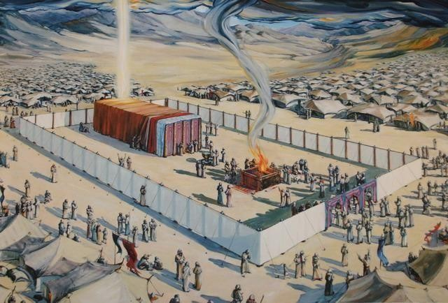
Their Choice
Randolph Dunn

Their Choice

Noah was a righteous man who obeyed God. By faith, he built an ark saving mankind from annihilation. After the ark was completed Noah and his family entered the ark and God caused the animals that breathed air to come into the ark. After God closed the door, He opened the fountains of the deep and the windows of heaven to flood the earth. After days and months, the waters abated. Then Noah, his family and the animals came out of the ark.
Noah immediately built an altar, offered a sacrifice and worshipped God. This offering pleased God “The LORD smelled the pleasing aroma and said in his heart: ‘Never again will I curse the ground because of man, even though every inclination of his heart is evil from childhood. And never again will I destroy all living creatures, as I have done. As long as the earth endures, seedtime and harvest, cold and heat, summer and winter, day and night will never cease.’” (Genesis 8:21-22) God also gave some instructions or commands (Genesis 9:3-7):
- Everything that lives and moves will be food for you • Just as I gave you the green plants, I now give you everything,
- But you must not eat meat that has its lifeblood still in it.
- And for your lifeblood I will surely demand an accounting. I will demand an accounting from every animal. And from each man, too, I will demand an accounting for the life of his fellow man.
- Whoever sheds the blood of man, by man shall his blood be shed; for in the image of God has God made man.
- As for you, be fruitful and increase in number; multiply on the earth and increase upon it. God then established a covenant with Noah and every living creature.
Sin knocked at the door again as Ham showed disrespect for his father whereupon he was cursed to become a slave to his brothers.

In Romans 1:28-32 “Furthermore, since they did not think it worthwhile to retain the knowledge of God, he gave them over to a depraved mind, to do what ought not to be done. They have become filled with every kind of wickedness, evil, greed and depravity. They are full of envy, murder, strife, deceit and malice. They are gossips, slanderers, God-haters, insolent, arrogant and boastful; they invent ways of doing evil; they disobey their parents; they are senseless, faithless, heartless, and ruthless. Although they know God’s righteous decree that those who do such things deserve death, they not only continue to do these very things but also approve of those who practice them.” Note the parallel in Noah’s time and our situation:
  - The people were sinful and we are sinners – Romans 3:23 “for all have sinned and fall short of the glory of
God.”
  - They were about to die and we may also – John 8:24a “I told you that you would die in your sins.”
  - Noah was told what to do to save the righteous and so have we - John 8:24b “if you do not believe that I
[Jesus} am [the Christ, the Son of God], you will indeed die in your sins.”
  - All the people of Noah’s time had a choice to make and we also have a choice – 2
Corinthians 6:2b “I tell you, now is the time of God’s favor, now is the day of salvation.”

Questions
  - Noah was considered righteous because he built an ark and saved mankind.
True
False

  - When is an acceptable time for one’s salvation?
After one has sown their wild oats. When time pressures are not so great There is no time like the present.

  - What happens when people refuse to retain God in their knowledge? it is never too late to accept God's call
Time will mellow the heart creating a desire for knowledge of Him God gives them over to their desires

  - Following Noah’s worship to God, God promised to never again destroy all living creatures by water.
True
False

  - Those who do not believe Jesus is the Christ will die in their sins
True
False
Answer to Questions
- False
- There is no time like the present
- God gives them over to their desires
- True
- True

