Preparing For Man's Redemption
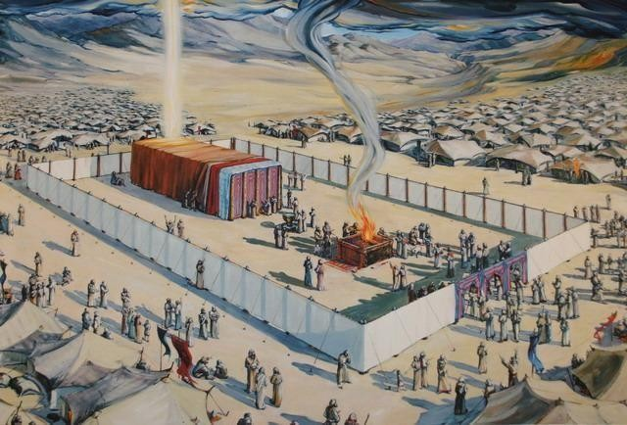

Prophets of the Old Covenant
Randolph Dunn

Prophets of the Old Covenant

God spoke directly to Adam, Noah, Abraham, Isaac and Jacob during the era many refer to as the Patriarchal
Age. During the establishment of the nation of Israel, He spoke to Moses, Joshua and then their judges. While Samuel was judge, the people rebelled demanding a king. During the reign of the kings, God delivered His message through men we refer to as prophets. All prophets delivered God’s message to the Children of Israel but not all delivered prophecies about the coming Messiah. Over hundreds of years and by many different prophets more than 50 prophecies are recorded, all of which were fulfilled in Jesus. A few prophesies are listed below followed by their New Testament fulfillment.

Malachi 3:1 “Watch out! I'm sending my messenger, and he will prepare the way before me. Then suddenly the LORD you are looking for will come to his Temple. He is the messenger of the covenant whom you desire.
Watch out! He is coming!" says the LORD of the Heavenly Armies.
Matthew 2:2 After Jesus had been born in Bethlehem of Judea in the days of King Herod, wise men from the east arrived in Jerusalem and asked, "Where is the one who was born king of the Jews? We saw his star in the east and have come to worship him."

Genesis 49:10 The scepter shall not depart from Judah, nor the ruler's staff from between his feet, until tribute comes to him; and to him shall be the obedience of the peoples.
Luke 3:23- 38 - The genealogy of Jesus is tracing His lineage back through David all the way to Adam.

Jeremiah 23:5 "Behold, the days are coming, declares the LORD, when I will raise up for David a righteous Branch, and he shall reign as king and deal wisely, and shall execute justice and righteousness in the land. Matthew 1:1 This is a record of the life of Jesus the Messiah, the son of David, the son of Abraham.

Isaiah 7:13 -4 And he said, "Hear then, O house of David! Is it too little for you to weary men, that you weary my God also? Therefore, the Lord himself will give you a sign. Behold, the virgin shall conceive and bear a son, and shall call his name Immanuel.
Matthew 1:18 Now the birth of Jesus the Messiah happened in this way. When his mother Mary was engaged to Joseph, before they lived together, she was discovered to be pregnant by the Holy
Spirit.

Micah 5:2 But you, O Bethlehem Ephrathah, who are too little to be among the clans of Judah, from you shall come forth for me one who is to be ruler in Israel, whose coming forth is from of old, from ancient days. Matthew 1:1 This is a record of the life of Jesus the Messiah, the son of David, [Bethlehem] the son of Abraham.

Zechariah 9:9 Rejoice greatly, O daughter of Zion! Shout aloud, O daughter of Jerusalem! Behold, your king is coming to you; righteous and having salvation is he, humble and mounted on a donkey, on a colt, the foal of a donkey.
Matthew 21:6-7 And the disciples went, and did even as Jesus appointed them, and brought the ass, and the colt, and put on them their garments; and he sat thereon.

Isaiah 53:5 But he was wounded for our transgressions, he was bruised for our iniquities; the chastisement of our peace was upon him; and with his stripes we are healed
Matthew 27:26 Then released he unto them Barabbas; but Jesus he scourged and delivered to be crucified.

Isaiah 53:7 He was oppressed, and he was afflicted, yet he opened not his mouth; like a lamb that is led to the slaughter, and like a sheep that before its shearers is silent, so he opened not his mouth. Matthew 27:12-14 While Jesus was being accused by the high priests and elders, he made no reply. Then Pilate asked him, "Don't you hear how many charges they're bringing against you?" But Jesus did not reply at all, so that the governor was very surprised.

Isaiah 53:9 And they made his grave with the wicked and with a rich man in his death, although he had done no violence, and there was no deceit in his mouth.
Matthew 27:57-59 - Later that evening, a rich man arrived from Arimathea. His name was Joseph, and he had become a disciple of Jesus. He went to Pilate and asked for the body of Jesus, and Pilate ordered it to be done. So. Joseph took the body and wrapped it in a clean linen cloth. Then he placed it in his own new tomb, which he had cut out of the rock. After rolling a large stone across the door of the tomb, he left.

Questions
- God spoke directly with Adam, Noah, Abraham, and David.
True False

- There are no prophecies about a redeemer
True False

- Isaiah was the only prophet to prophecy about a Messiah.

True False

- There were over 50 prophecies by many prophets all of which were fulfilled in Jesus of Nazareth.
True False

- God delivered his message through the kings of Israel to His prophets.

True False

Answers to Questions
- True
- False
- False
- True
- False

