Preparing For Man's Redemption
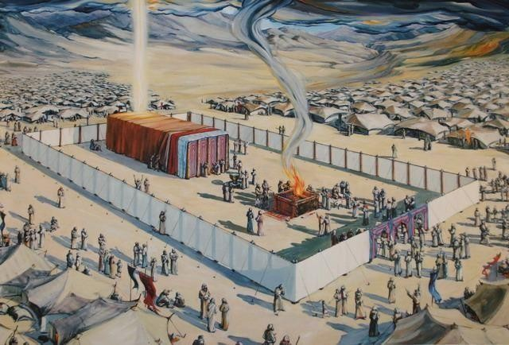
Grievous Sin
Randolph Dunn

Grievous Sin

Because of problems between the herdsmen of Abraham and Lot, his nephew, Abraham allowed Lot to choose his land and Abraham would take another area. Lot chose the better area near the city of Sodom.
"And the LORD said, 'Because the outcry against Sodom and Gomorrah is great, and because their sin is very grave, I will go down now and see whether they have done altogether according to the outcry against it that has come to Me; and if not, I will know'." (Genesis 18:20-21) Before God sent angels to destroy Sodom, He revealed His plans to Abraham who pleaded with God to save Sodom because of righteous people living there.
But there were so few. So God's angels in the form of men appeared at evening entering the city of Sodom. When Lot saw these visitors, he insisted they enter his house under his protection.

The wickedness of Sodom is clearly seen in the following; "Now before they lay down, the men of the city, the men of Sodom, both old and young, all the people from every quarter, surrounded the house. And they called to Lot and said to him, 'Where are the men who came to you tonight? Bring them out to us that we may know them carnally.' So Lot went out to them through the doorway, shut the door behind him, and said, "Please, my brethren, do not do so wickedly! ’See now, I have two daughters who have not known a man; please, let me bring them out to you, and you may do to them as you wish; only do nothing to these men, since this is the reason, they have come under the shadow of my roof.' And they said, 'Stand back!' Then they said, 'This one came in to stay here, and he keeps acting as a judge; now we will deal worse with you than with them.' So, they pressed hard against the man Lot, and came near to break down the door. But the angels reached out their hands and pulled Lot into the house with them, and shut the door." (Genesis 19:4-10)

The angels explained to Lot the purpose of their mission so "When the morning dawned, the angels urged Lot to hurry, saying, ‘Arise, take your wife and your two daughters who are here, lest you be consumed in the punishment of the city.’” ... "‘Hurry, escape there. For I cannot do anything until you arrive there.’ The sun had risen upon the earth when Lot entered Zoar. Then the LORD rained brimstone and fire on Sodom and
Gomorrah from the LORD out of the heavens. So, He overthrew those cities, all the plain, all the inhabitants of the cities, and what grew on the ground." (Genesis 19:15, 23-25)

God removed Adam and Eve from the Garden of Eden because of disobedience, and destroyed by water all people because of the wickedness of man and the evil intent of his heart (mind) except Noah, his family and selected animals. Now He destroyed Sodom by fire because of grievous wickedness. It should be evident that disobedience and wickedness is not tolerated by God and those who practice such will also be destroyed unless they turn from their wickedness and obey the will of God.

Questions
- What sin was so great that God decided to destroy Sodom?
Abortion

Devil worship

Homosexuality

- Lot chose the land east of Jordan because he desired the city life offered in Sodom and Gomorah

the land appeared to be the better land

the Bible does not say

- Disobedience to God caused problems in the Garden of Eden

with the people in Noah's time

All the above

- The destruction of the area around Sodom and Gomorrah only affected the men who attempted to defile the men [angels] visiting Lot.
True

False

- Abraham pleaded with God to save the cities of Sodom and Gomorrah because of righteous people living in these cities.
True

False
Answers to Questions
- Homosexuality
- the land appeared to be the better land
- All the Above
- False
- True

