Preparing For Man's Redemption
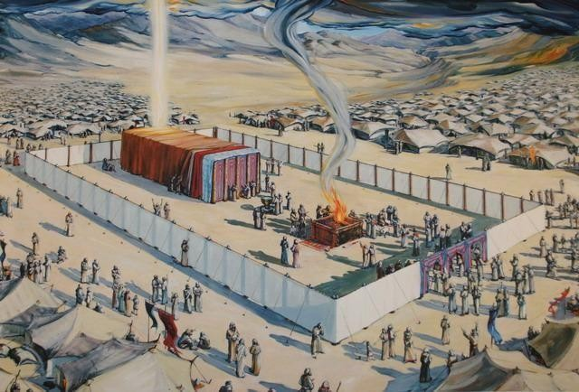

Early Man
Randolph Dunn

Early Man

Adam and Eve
Eve, knowing that God commanded them not to eat of the fruit of the tree of knowledge of good and evil, yielded to her desires, ate of the fruit, and gave some to Adam and he also ate. The devil in the form of a serpent had enticed them to sin. This action of disobedience resulted in them being expelled from Paradise, the Garden of Eden, and suffering other consequences of their sin. The consequences were separation from God, pain, and death.

Their greatest pain may have been when one son, Cain, killed another son, Abel. Sin was present before the murder as Cain's heart was not pure and godly. Both Cain and Able offered sacrifices to God. But Cain became angry because Abel's offering to God was accepted and his offering was rejected.

Cain and Abel
In Hebrews 11:4 we read that Abel's offering was by faith. Now faith is based upon knowledge and love. So Abel's action and attitude pleased God whereas Cain's did not. God said of Cain's offering "if you do what is right, will you not be accepted? But if you do not do what is right, sin is crouching at your door; it desires to have you, but you must master it." (Genesis 4:7)

Therefore, it appears the object Cain offered was not acceptable or his attitude was unacceptable, or both. He may have not offered the best he had, he may have offered something not authorized or he offered exactly what was required but with an attitude other than love of God. Whatever the situation, God was not pleased and Cain knew why. As punishment, the earth would not yield fruits for him and he would become a restless wanderer.

Noah
God told Noah what he must do to save the righteous people from perishing in the impending flood. No doubt these instructions appeared to be unusual but very explicit. Noah may have even questioned how a boat made only from one kind of wood exactly so long, wide and high with only one window and door could possibly save him and his family. However, he began building the ark immediately warning others of the consequences of their rebellious and sinful lifestyle. In Hebrews 11:7 we read "By faith Noah, when warned about things not yet seen, in holy fear built an ark to save his family. By his faith he condemned the world and became heir of the righteousness that comes by faith."

Summary
So far in only six chapters of the first book of the Bible, we have seen three situations where people disobeyed God's commandments, substituting their own desires; one disobeyed because it was pleasing to the eye and something to be desired to make them wise, one disobeyed by presenting an offering, an act of worship, that was not pleasing to God and one group disobeyed as the thoughts and intent of their mind was evil continually. God was displeased in every case, judging their actions against his standard, his Word. A righteous God, their creator, established the consequences He considered appropriate for their action.

Questions
- Cain's offering was not acceptable because it was a grain offering rather than an animal offering Cain was not obedient, thus sinned in his offering best for himself

it is not revealed

- Noah followed God's plan and did not substitute his opinion for God's.
True
False

- Noah’s faith was based upon his feeling about what God wanted someone else's opinion of what God wanted knowledge of what God said He wanted

- God is displeased when those created in His likeness disobey.
True
False

- There are no consequences for rebelling and disobeying God.
True
False

Answers to Questions
- It is not revealed
- True
- knowledge of what God said He wanted
- True
- False

