Preparing For Man's Redemption
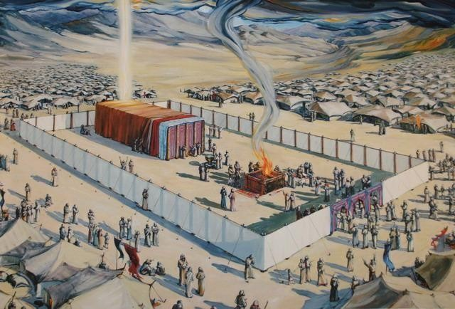

Deliverance
Randolph Dunn

Deliverance

At the appropriate time, Moses’ mother took Moses to Pharaoh's daughter. "Moses was educated in all the wisdom of the Egyptians and was powerful in speech and action. When Moses was forty years old, he decided to visit his fellow Israelites. He saw one of them being mistreated by an Egyptian, so he went to his defense and avenged him by killing the Egyptian. Moses thought that his own people would realize that God was using him to rescue them, but they did not." (Acts 7:22-26)

In fear resulting from his rash action he fled from Pharaoh, going to the land of Midian. He humbled himself as a shepherd for forty years, after which God was ready for him to deliver the descendants of Abraham, Isaac and Jacob from the bondage of physical slavery, a symbol of our slavery to sin. God gave Pharaoh and the Egyptians ten opportunities to choose obedience over destruction. Pharaoh appeared to recognize God's power but with each passing opportunity, it was easier for him to refuse. After the death of his firstborn, he told the Israelites to leave. But he changed his mind and pursued them to bring them back to slavery.

It was at the Red Sea that the Israelites had to make a choice to obey God or return to slavery. It was also there that Pharaoh and his army were buried in the waters of the sea. A new nation, freed from slavery, arose on the other side. This is also like our flight from sin. At the cross of Christ, we must make a decision and bury our sinful master in the waters of baptism in order to arise as a new creation. Paul stated in Romans 6:3-7 "Or don't you know that all of us who were baptized into Christ Jesus were baptized into his death? We were therefore buried with him through baptism into death in order that, just as Christ was raised from the dead through the glory of the Father, we too may live a new life. If we have been united with him like this in his death, we will certainly also be united with him in his resurrection. For we know that our old self was crucified with him so that the body of sin might be done away with, that we should no longer be slaves to sin- because anyone who has died has been freed from sin."

They did not enter into Canaan immediately as their faith was weak. They rejected the report of Joshua and Caleb who trusted in God.

Consequently, they wandered in the wilderness, near their promised land, for forty years, never entering the Promised Land. It wasn't until all males over twenty died (except Joshua and Caleb) that they would be allowed to enter the Promised Land. Moses was prohibited, by God from leading them into Canaan. Instead, it was Joshua, Moses' faithful aide. Once they put their faith in God and obeyed him, they were allowed to enter their Promised Land. We too must have obedient faith and be reconciled to God to enter our Promised Land, Heaven.

Questions
- In attempting to deliver Israel from oppression, Moses attempted to take matters into his own hands rather than waiting upon God.
True False

- God did not give Pharaoh the choice to escape death and destruction.

True False

3. Faith in God allowed the Children of Israel to pass through the waters of the Red Sea to become free from bondage and arrive upon the other shore a new nation.

True False

4. Upon first reaching the Land of Promise, the children of Israel put their faith in the report of Joshua and Caleb with God's guidance

their own ability

5. Moses was permitted to lead the Israelites into the
Land of

Promise
- entered the Promised Land but told Joshua to lead

- see but not enter the Land of Promise

Answers to Questions
- True
- False
- True
- Their own ability
- See but not enter the Land of Promise

