Preparing For Man's Redemption
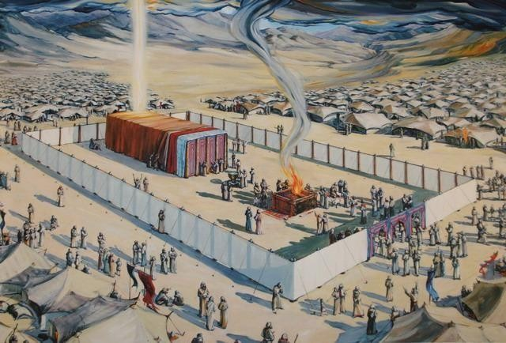

After God's Heart
Randolph Dunn

After God's Heart

After being delivered from Egyptian slavery and receiving a land flowing with milk and honey, Israel was governed by judges whom God selected. But the Israelites wanted to be like all the nations around them. They rejected God and wanted a king. So, God gave them a king - Saul. He ruled by what the people wanted - rule by opinion rather than as an obedient servant of God. Therefore, Samuel, at God's direction, anointed David as king, one who would obey him. Many times, David had to flee from Saul because Saul was hunting him down like a common criminal desiring to kill him. Yet, in spite of this David refused to do anything "against God's anointed".

After Saul's death, David became king. God said of David: "After removing Saul, he made David their king. He testified concerning him: 'I have found David son of Jesse a man after my own heart; he will do everything I want him to do.' From this man's descendants, God has brought to Israel the Savior Jesus, as he promised."
(Acts 13:22-23)

On one occasion David's men were among the flocks of a very wealthy man and while there they dealt honorably with him protecting him, not mistreating his herdsmen or taking anything of his. Later David was nearby, his men were hungry and in need of food so David requested assistance, but Nabal, a surly man known for his mean dealings, refused David's request in a harsh and disrespectful manner. David became very angry, intending to kill him, but he repented, allowing God to exercise his judgment.

But not everything was godly in David's life. Instead of going to battle with his army, he remained at home.
There he saw a lovely woman, lusted for her and sent for her to commit adultery. Learning she was pregnant; David ordered the murder of her husband to cover up his sin. Terrible? Yes! Pleasing to God? No! David desired fleshly satisfaction and yielded to the temptation. He suffered much for this sin. But when confronted by Nathan, the messenger from God, he admitted his wickedness, repented and pleaded for forgiveness. Although forgiven, he still suffered the consequences of his sinful actions.

No doubt his attitude of heart, his remorse and his desire for forgiveness in order to be reconciled to God is why God would say "I have found David the son of Jesse, a man after My own heart, who will do all My will." This is everyone's situation today. We have all sinned, need the proper attitude toward our sin and need to be reconciled to God.

God promised David that one of his descendants would sit on his throne forever, referring to Jesus, the Christ, whose kingdom will have no end. It was Christ, without sin, totally obeying God, willingly giving his life as an atoning sacrifice for us, thus fulfilling God's promise to David and Abraham.

Questions
- David refused to harm Saul, King of Israel, as he had been appointed king by God and to do harm to him would not be respecting God.
True
False

- A person after God’s own heart means one who teaches God's laws and commandments one who is powerful in leading God's people
one who desires to do what is right to correct their sinful acts

- David is an example for us in that he was a powerful king
did not sin, so Jesus who had no sin could be the son of David
was quick to repent of his sins and plead for God's mercy

- God was always pleased with David’s actions.
True
False

- Jesus, a descendant of David, gave His life as the atoning sacrifice for forgiveness of sins.
True

False

Answers to Questions

- True
- One who desires to do what is right to correct their sinful acts
- Was quick to repent of his sins and plead for God’s mercy
- False
- True

