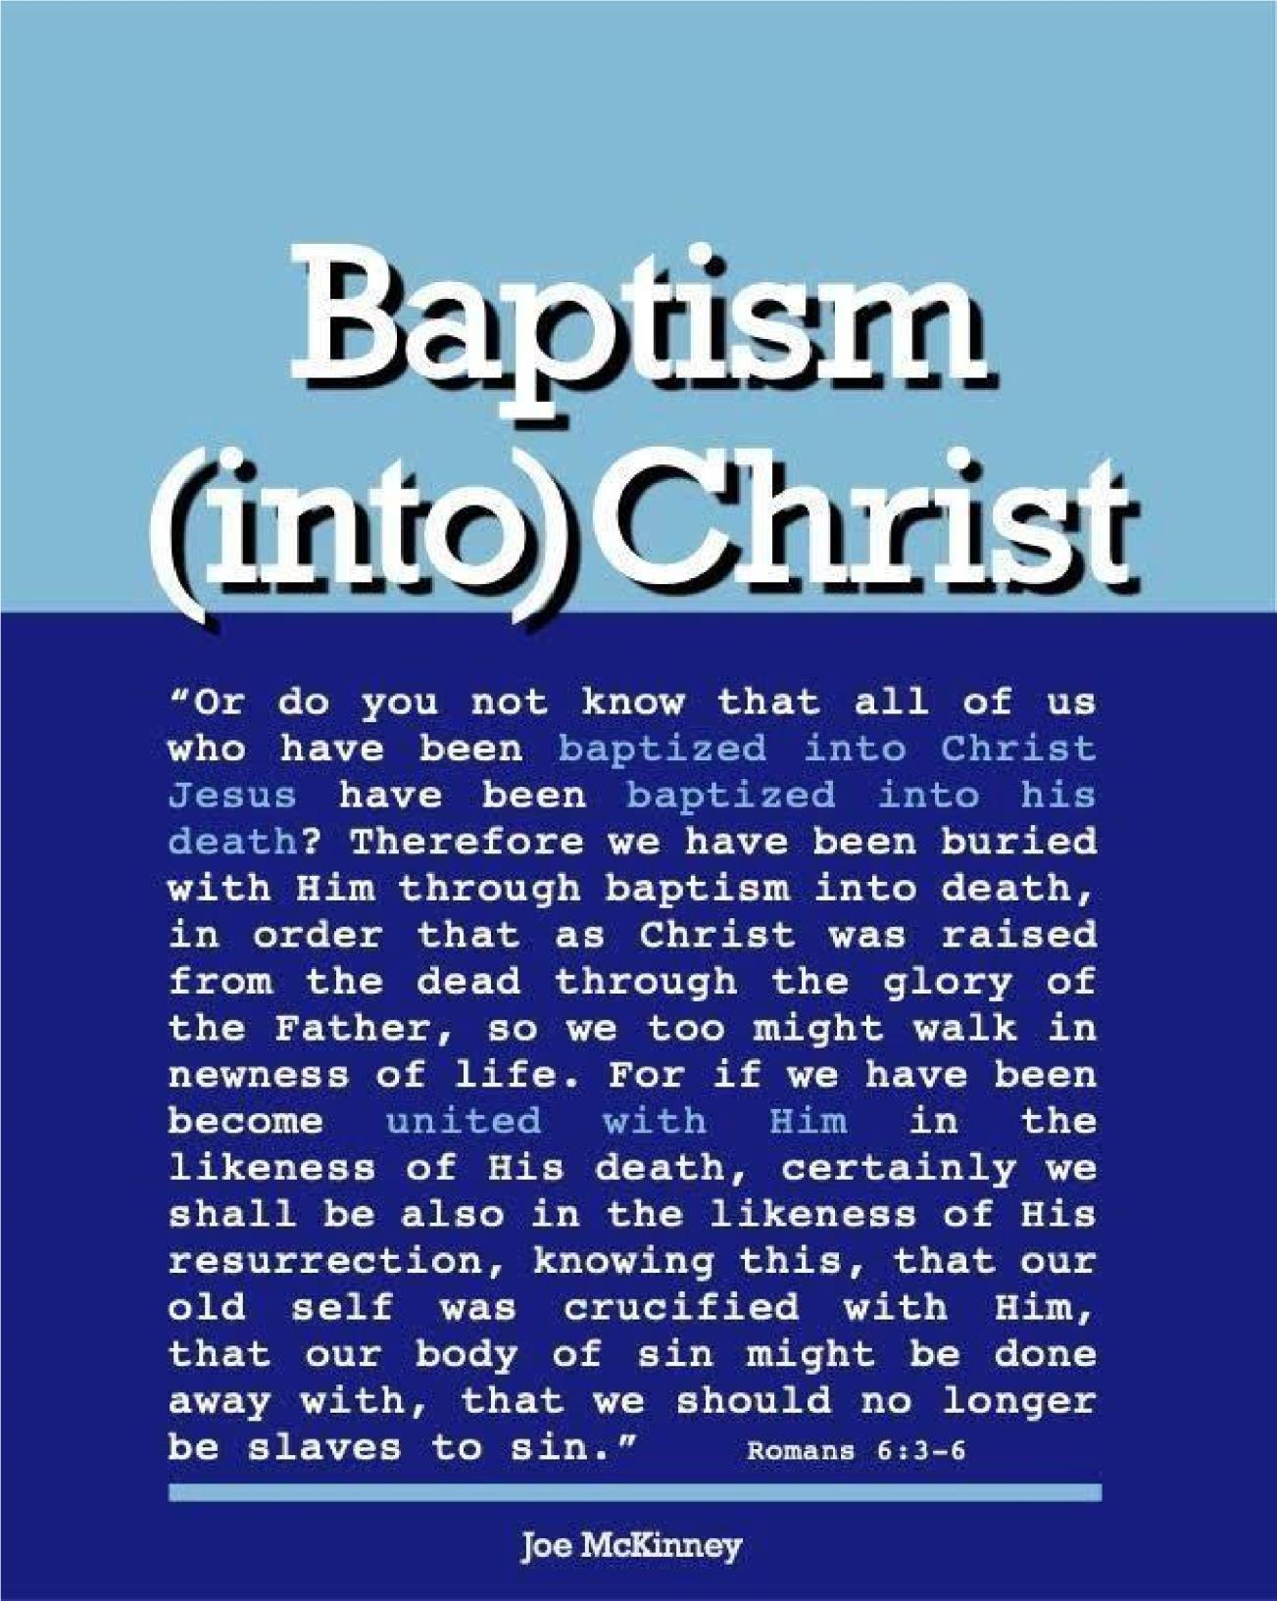

SHOULD BABIES BE BAPTIZED?

SHOULD BABIES BE BAPTIZED?

I believe that babies should not and cannot be baptized and here are the reasons why not.

1. Infant Baptism Is Unbiblical
a. Since baptism is the embodiment of faith and a sinner’s appeal to God for forgiveness, it is
obvious that without faith in Christ as one’s sin sacrifice, there can be no baptism.

Acts 22:16 — An infant is incapable of calling on the name of the Lord.

1 Peter 3:21 — An infant is incapable of appealing to God for a good conscience. Colossians 2:12 — An infant is incapable of having faith in the working of God.
- The scriptures describe those who are to be baptized and the description excludes infants.
Matthew 28:19 — “make disciples of all the nations, baptizing them (Those who became disciples).”

Mark 16:16 — “He who has believed and has been baptized shall be saved.”

Acts 2:41 — “Then those who had received his word were baptized.”

Acts 8:12 — “...when they believed ... they were baptized, men and women alike.”

Acts 8:36-37 — “What prevents me from being baptized?” “...if you believe with all your heart, you may.”

- Simply stated, it was not practiced in the New Testament. The earliest historical references to infant
baptism came 150 years (Origen) to 200 years (Irenaeus) after Pentecost. This prolonged silence
makes it obvious that infant baptism was an innovation of what the apostolic church practiced. Even those who defend the practice of infant baptism have to admit this is so. Consider, for example, L. Berkhof in his Systematic Theology under the heading, “the Scriptural basis for infant baptism.” He writes: “It may be said at the outset that there is no explicit command in the Bible to baptize children and that there is not a single instance in which we are plainly told that children were baptized. But this does not necessarily make infant baptism unbiblical” (p. 632).

2. Some Arguments Given By Those Who Believe In Infant Baptism

a. Martin Luther in his “Large Catechism Part Fourth:
i. “That the Baptism of infants is pleasing to Christ is sufficiently proved from His own work, namely, that God sanctifies many of them who have been thus baptized, and has given them the Holy Ghost; and that there are yet many even today in whom we perceive that they have the Holy Ghost both because of their doctrine and life ... This is indeed the best and strongest proof for the simple-minded and unlearned.” ii. “Further, we say that we are not so much concerned to know whether the person baptized believes or not; for on that account Baptism does not become invalid; but everything depends upon the Word and command of God. When the Word is added to the water, Baptism is valid, even though faith be wanting... For even though a Jew should today come dishonestly and with evil purpose, and we should baptize him in all good faith, we must say that his baptism is nevertheless genuine. For here is the water together with the Word of God, even though he does not receive it as he should.” iii. “Therefore they are presumptuous, clumsy minds that draw such inferences and conclusions as these: Where there is not the true faith, there also can be no true Baptism. Just as if I would infer: If I do not believe, then Christ is nothing; or thus: If I am not obedient, then father, mother, and government are nothing. Gold is none the less gold though a harlot wear it in sin and shame.” b. Catholic:
i. “Some people mistakenly contend that the phrase “Repent and be baptized” and “Believe and be baptized” demonstrate that only those old enough to repent can be baptized. But, consider 2 Thessalonians 3:10, “If anyone was unwilling to work, neither should that one eat.” It says anyone.
Does that mean that we should starve our babies since they don’t work? Of, course not. The verbs “to repent”, “to believe”, and “to work” apply only to the extent that a person is capable of doing so.” ii. “Infants moved by God’s grace can receive His Gift of faith. When Mary brought Jesus to St.
Elizabeth and
St. John the Baptist. Elizabeth replied, “The infant in my womb leaped for joy.”
a. Calvin justified infant baptism on the grounds that there is a seed of faith that is implanted in the children of believing parents because of the covenant promise of God. Thus the Reformed evangelical position: 1) While there is no explicit command, infant baptism is based on the essential unity and continuity of the covenant of grace, 2) The covenant of grace is a single, spiritual covenant made initially with Abraham and fulfilled in Christ, 3) No faith is necessary, 4) Because of covenantal unity, the sign of the new covenant can be given to the children of believers in the NT, just as Abraham gave the sign of the covenant God made with him to his infant sons in the OT, and 5) The sign of the new covenant is baptism which replaces the old covenant sign of circumcision. This accounts for things like “household baptisms,” in which it is assumed that infants were baptized, “covenant children” instead of “privileged children” in 1 Corinthians 7:14, and the “inclusion” of little children in the kingdom of God as opposed to the “likeness” of little children to kingdom citizens in Mark 10:14-16.

A Rebuttal
Nowhere does the Bible mention a single, spiritual “covenant of grace” that somehow spans the ages and connects Abraham to Christ.

While their physical relationship to Abraham entitled them to temporal, physical blessings under the Abrahamic covenant, it did not entitle his descendants to any eternal, spiritual blessings unless they were spiritually like their father Abraham (i.e. they were looking in faith to God). God has never promised spiritual blessings to anyone, at any time, on any other basis than grace. And grace by its very definition not only excludes all human merit; it also excludes physical and natural descent. This is true in both the Old and New Testaments no matter what the covenant.
The children of believers are in a very privileged position. They are the subjects of their parents' prayers, they are exposed to the Word of God and to the testimonies of their parents and other Christians, and they are urged to seek the Lord while he may be found and call upon him while he is near. But nowhere in the NT are we told to baptize them until they give evidence that they come to personal faith in God through Christ Jesus the Savior.
Just because they are children of believers does not mean they have been chosen by God, nor that they have any share in the new covenant. To baptize them as if they did, or in the hope that they will, is unbiblical. To baptize them as a sign that they are “covenant children” who need to respond to the gracious overtures of God is to go back to the types and shadows of the OT, to the days of Abraham and Moses when God was preparing Israel and the world for the emergence of a new nation and people who would all know him, love him, and serve him.
That circumcision was a prophetic type of baptism is seen in Colossians 2:11, 12: “In Him, you were also circumcised with the circumcision made without hands, by putting off the body of the sins of the flesh, by the circumcision of Christ, buried with Him in baptism, in which you also were raised with Him through faith in the working of God, who raised Him from the dead.” The language cannot apply to infants: an infant has no sins to be put off and an infant has no faith in the working of God.
Baptism of unknowing, unbelieving infants is as unbiblical and ineffective to accomplish the biblical purposes for baptism as it is for adults.

E. When Is A Child Old Enough To Be Baptized?
This is an important question, especially for parents and grandparents. There is not really a clear, concise answer in the scriptures for this question. This may imply that it is the wrong question. If so, what should the question then be? A more useful question might be: “What must a child (or any person) know and understand in order to be baptized? Maturity and capacity for understanding spiritual matters do not always depend exactly on the age of the person.

The answer to this question (“What must a person know and understand in order to be baptized?) has answers in the scriptures. These answers can be put in the form of questions that you can ask the child to answer. Here are some questions that a person must be able to answer in order to be ready to be baptized:
- Who is God?
- What is sin?
- What is the result when a person sins?
- What does it mean to be lost?
- What does it mean to be saved?
- Who is Jesus?
- Why was Jesus crucified or why did Jesus have to die?
- What does God promise to do for a person in baptism?
- What does it mean when we say that our sins are washed away by the blood of Jesus?
- What does it mean to say that Jesus died for you?
In addition, these questions of a personal nature may be asked:
- Are you lost?
- Why do you feel guilty before God?
- Why do you want to be baptized?
- Have you repented of your sins? What does that mean?
- Do you believe in Jesus? What does that mean? What does believing in Jesus have to do with his death on the cross?
- Are you ready to commit yourself and your life to Jesus Christ and confess Him as your Lord? What does it mean for Jesus to be the Lord?

NOTES:
- These questions are all to be answered, not with a simple yes or no, but with expressions of the child’s own understanding.
- A child (or adult) may not have to understand theological words like “justification, atonement, reconciliation, propitiation, redemption, regeneration, etc. but they can answer these questions in their own vocabulary in simple terms.
- Be careful of children who are mainly motivated by a desire to please adults.
- Regular participation is Bible reading and prayer, worship, listening to sermons and classes are important to gauge spiritual awareness.
- The child must be able to make a commitment to the Lord in terms of obedience.

Questions
- What does the Bible say about baptism?
make disciples of all nations (people) and baptize them he who has believed and is baptized shall be saved those who received His word were baptized All the above

- Baptism is valid, even though faith is wanting.
True
False

- In the New Covenant baptism is the circumcision of the putting off the body of sins
True
False

- Everyone must be baptized even though they do not believe they have sinned
True
False

Answers to Questions
  - All the above
  - False 3. True
4. False

