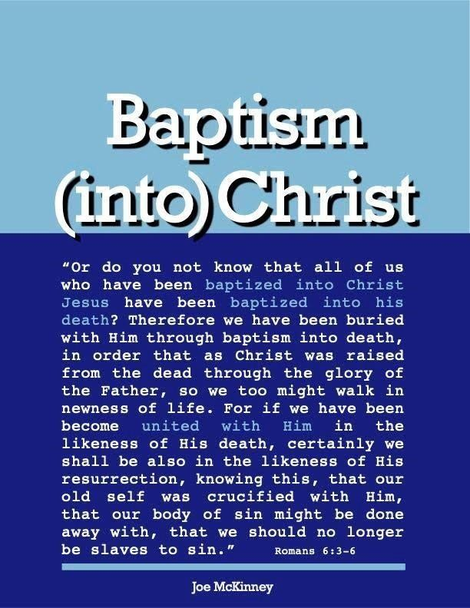

Knowledge Of The Purpose For Baptism

Knowledge of the Purpose
1. In Baptism A Sinner Cries Out To God To Save Him
a. Acts 22: 16 — “And now why do you delay? Arise and be baptized, and wash away your sins, calling on His name.” This passage shows that we are baptized to have our sins washed away and in that action of being baptized, we are calling on the name of the Lord. To call on the name of the Lord means to invoke
Him to action. (See Call on the Name of the Lord page 13.) Question: In baptism, what are we calling on the Lord to do?
Answer: To save us! To wash away our sins!

But what if we don’t feel the need to be saved, because we don’t think Jesus saves or we don’t think we are lost or we don’t really know what we’re doing, or because we think we are already saved?

In this case, how could we be calling on the Lord to save us in baptism? If we didn’t feel the need to be saved, we couldn’t be calling on the Lord to save us! True, scriptural, baptism is an act in which we are asking the Lord to save us from our sins!

This is not to say that for a person’s baptism to be valid, he must say aloud words like: “Lord save me from my sins”. Rather, it means that we are being baptized for that purpose.

b. 1 Peter 3: 21 — “Corresponding to that (eight souls saved by water in Noah’s ark), baptism now saves you — not the removal of dirt from the flesh, but an appeal to god for a good conscience — through the resurrection of Jesus Christ.”

Baptism, according to Peter, is not an outer cleansing of dirt from the physical body. Rather, the baptism that saves us is an “appeal to God for a good conscience.” It is a prayer (an appeal, a petition, a request) to God for Him to cleanse our guilty soul of the guilt of sin. This is the very same thought expressed in Acts 22:16 above.
Notice how various translators render this phrase in 1 Peter 3:21:

“Baptism is...
- an appeal to God for a good conscience” – NASB
- an appeal to God for a good conscience” – RSV, NRSV
- an appeal to God for a good conscience” – ESV
- making you free from the sense of sin before God” – Basic English
- the prayer for a clean conscience before God” – Moffatt (1935)
- an appeal to God from [or for] a clean conscience” – New Living Translation
- [the] demand as before God of a good conscience” – Darby
- the craving of a good conscience after God” – Weymouth
- the asking of a good conscience in God” – Wycliffe New Testament
- the question of a good conscience in regard to God” – Young’s Literal
- the interrogation of a good conscience toward God” – ASV
- [providing you with] the answer of a good and clear conscience (inward cleanness and peace) before God” – Amplified Bible
- asking God for a pure heart” – Easy To Read Version
- making you free from the sense of sin before God” – Bible in Basic English
- the request unto God for a good conscience” – Rotherham (1897)
- the prayer for a good conscience toward God” – Montgomery (1924)
- the craving for a conscience right with God” – Goodspeed (1935) Some other translations or paraphrases render this phrase differently:
- the answer of a good conscience toward God. NKJV, KJV
- the pledge (or response) of a good conscience toward God. NIV
- It means turning to God with a clear conscience. Contemporary English Version
- It means we are saved from the punishment of sin and go to God in prayer with a heart that says we are right. New Life Version

In the New International Version, it is “the pledge of a good conscience toward God,” as if it were because we are already saved and have a good conscience, instead of being “for” or “unto” remission of sins in order to have a good conscience.

But it is rendered by most other translations as an appeal to God for “cleansing” in order to “have ... no more consciousness of sins” (Hebrews 10:2), in accord with Acts 2:38, which speaks of it as “for the remission of sins.” This would make baptism an overt prayer for pardon, without which surely baptism itself would be of no avail.

This seems to not be the easiest phrase to translate. Beasley-Murray makes this comment: “...the disputed phrase can be rendered either as a ‘prayer to God for a good conscience’ or a ‘pledge to God to maintain a good conscience.

On the first interpretation, baptism is declared to be an appeal to God on the part of the baptized, which appeal is answered through the saving act of the risen Christ; this personal dealing between the believer and His Lord makes [baptism] what it is.”

Theological Dictionary of the New Testament (edited by Kittel in Germany, 1935; translated by Bromily in America, 1964): “Prayer to God for a good conscience” (Vol. II, p.688), with the following comment: “In view of v.21, we should expect alla to be followed by a cleansing in the spiritual sense. Thus, the request for a good conscience is to be construed as a prayer for the remission of sins. ... Remission of sins is closely related to baptism from the very outset (Mk.1:4 and par.; Acts 2:38.) This makes a number of other passages fall beautifully into place. For one thing, a “good conscience” (Acts 23:1) is a “conscience void of offence toward God and men” Acts 24:16). For another thing, it harmonizes with what Ananias, sent by the Lord to the believing and penitent Saul of Tarsus, told him yet to do: “arise, and be baptized, and wash away thy sins, calling on the name of the Lord” (Acts 22:16, King James Version; or “calling on his name,” American Standard
Version).”
It is said: “For there is no distinction between the Jew and the Greek: for the same Lord is Lord of all, and is rich unto all that call upon him: for, whosoever shall call upon the name of the Lord shall be saved” (Romans 10:12-13). “Calling upon the name of the Lord” or “calling upon him” or praying to him as Stephen did while being stoned, was “calling upon the Lord, saying, “Lord Jesus, receive my spirit” (Acts 7:59).
Saul of Tarsus was to “be baptized,” “calling upon the name of the Lord,” in order to have his “sins washed away” and thus have a “good conscience toward God.” His baptism itself, being “for” or “unto the remission of sins,” was an overt request for pardon in order to have a “good conscience.”
The Greek word under consideration in 1 Peter 3:21 is the noun eperotema, the verb form of which is eperotao, meaning to ask; also, according to Thayer, “by a usage foreign to the Greeks, to address one with a request or demand; to ask of or demand of one”, citing Matthew 16:1. Arndt & Gingrich likewise cite Matthew 16:1 as an example of meaning to ask someone for something.” KittelBromily trace the change of the word’s meaning to include (in koine Greek of New Testament times) the last mentioned sense, which was taking place at the time of the LXX (about 250 B.C.) Accordingly, Arndt & Gingrich define eperotema as: “1. question; 2. request, appeal, and cite as an example ‘an appeal to God for a clear conscience 1 Peter 2:21’, in harmony with the goodly number of versions cited above, and Kittel.”
Even many scholars who do not wish to concede baptism as being “for,” or “unto remission of sins,” acknowledge that “answer” is not a satisfactory rendering of the Greek verb. But, if not, then the above must be its most likely meaning. It is to me the most satisfactory from every significant angle.
The word “appeal” as used by the NASB, RSV, and others seems to make more sense, meaning that we ask God for a good conscience in the act of baptism. This appears obvious when we read “baptism now saves us.” There is no way for sinners to have a good conscience before being saved. That is what it really means to be saved – to be forgiven of our sins. We are not saved when we “pledge to God to maintain a good conscience.” That would more closely define repentance. On the other hand, when we, in baptism, appeal to God to cleanse our conscience, he does just that - He saves us!

It is not the sinner saying “I promise to never sin again!” that saves him. Rather it is the sinner crying out in the act of baptism “Lord, please, save me!” that saves him. That is the meaning of baptism.

That “appeal” is the better translation and is reinforced by comparing Hebrews 9:13, 14; Romans 6:3-6; Acts 22:16, and 1 Peter 3:21.

Hebrews 9:13, 14 “For if the blood of goats and bulls and the ashes of a heifer sprinkling those who have been defiled, sanctify for the cleansing of the flesh, how much more will the blood of Christ, who through the eternal Spirit offered Himself without blemish to God, cleanse your conscience from dead works to serve the living God?”

Romans 6:3 “Or do you not know that all of us who have been baptized into Christ Jesus have been baptized into his death?”
Acts 22:16 “Arise and be baptized, and wash away your sins, calling on His name.”

1 Peter 3: 21 “… baptism now saves you — not the removal of dirt from the flesh, but an appeal to God for a good conscience — through the resurrection of Jesus Christ.”

From these we see that our conscience is cleansed by the blood of Christ, in baptism we contact his blood (death) and in baptism, we call on the Lord to save us. These three statements fit together perfectly. Salvation is given to us in baptism because it is in baptism that we are appealing (imploring, asking) God to cleanse our conscience by the blood of Christ.

If the person being baptized is unaware of or unbelieving in the truth that God is forgiving his sins (washing away his sins, remitting his sins, cleansing his conscience) in his baptism, then certainly he could not be asking for or appealing for the forgiveness of his sins. Such lack of understanding makes his baptism, not the baptism referred to in 1 Peter 3:21, which baptism “saves” him.

The conclusion is: Salvation (forgiveness of sins), which comes from being united with God in Christ, is given when our trusting hearts appeal to God for a good conscience. We do this when we are baptized. Baptism is faith crying out to God to save, based on the death of Christ on the cross. Baptism is the biblical “sinner’s prayer”, not necessarily spoken but understood and acted out.

c. Colossians 2:12 — “buried with Him in baptism, in which you were also raised up with Him through faith in the working of God, who raised Him from the dead.”

The raising to a new life happens in, through or by means of (Greek dia) our faith in God’s operation or working. We, in effect, are trusting in God to save us in that act of baptism. Note that in baptism it is faith in God’s working. Baptism is God’s work, not ours.

When we are baptized, we believe (trust) that God is working. It is through our faith in His working that He works! For our baptism to be effective we must believe that God is working to raise us to a new life (save us).
Again, that’s what baptism is: crying out to God to save us and trusting that He will, based on the cleansing power of Christ’s blood.

Call On The Name Of The Lord
Word study
To call on the name of the lord means to invoke Him to action. Read each verse in its own context and you will notice how calling on the name of the Lord means to call out to God to save, help, bless, protect, act, etc.

- Kings 18:24 — “Then you call on the name of your gods, and I will call on the name of the LORD; and the
God who answers by fire, He is God.” And all the people answered and said, “That is a good idea.”

- Kings 5:11 But Naaman went away angry and said, “I thought that he would surely come out to me and stand and call on the name of the LORD his God, wave his hand over the spot and cure me of my leprosy.

Psalm 105:1 — “Oh, give thanks to the LORD! Call upon His name; Make known His deeds among the peoples.”

Psalm 116:3-4 — “The cords of death entangled me, the anguish of the grave came over me; I was overcome by distress and sorrow. Then I called upon the name of the LORD: ‘O LORD, I beseech Thee, save my life!”

Psalm 116:13 — (NKJV) “I will take up the cup of salvation, And call upon the name of the LORD.”

Psalm 116:17 — (NKJV) “I will offer to You the sacrifice of thanksgiving, And will call upon the name of the LORD.”

Isaiah 12:4 — “And in that day you will say, ‘give thanks to the Lord, call on His name. Make known His deeds among the peoples; Make them remember that His name is exalted.”

Isaiah 64:7 — “And there is no one who calls on Thy name, who arouses himself to take hold of Thee; for thou hast hidden Thy face from us, and hast delivered us into the power of our iniquities.”

Lamentations 3:55 — “I called on Thy name, O Lord, out of the lowest pit.”

Joel 2:32 — “And it will come about that whoever calls on the name of the LORD will be delivered; For on Mount Zion and in Jerusalem there will be those who escape.”

Zephaniah 3:9 — “For then I will give to the peoples purified lips, that all of them may call on the name of the LORD, to serve Him shoulder to shoulder.”

Zechariah 13:9 — “And I will bring the third part through the fire, refine them as silver is refined, and test them as gold is tested. They will call on My name, and I will answer them. I will say, ‘They are My people,’ And they will say, 'The LORD is my God.'”

Acts 2:21 — “And it shall come to pass that whoever calls on the name of the LORD shall be saved.”

Acts 9:14 — “And here he has authority from the chief priests to bind all who call on Thy name.”

Acts 9:21 — “...Is this not he who in Jerusalem destroyed those who called on this name, and who had come here for the purpose of bringing them bound before the chief priests?”

Acts 22:16 — “And now why do you delay? Arise, and be baptized, and wash away your sins, calling on His name.”

Romans 10:13 — “for, Everyone who calls on the name of the Lord will be saved.”

1 Corinthians 1:2 — “to the church of God which is at Corinth, to those who have been sanctified in Christ Jesus, saints by calling, with all who in every place call upon the name of our Lord Jesus Christ, their Lord and ours.”

Questions
- Through the act of baptism, one realizes he is a sinful man, recognizes Jesus is Lord and Savior, and pleads to God to wash away his sin by the blood of Christ.
True

False

- Baptism only washes away the dirt from the body
True

False

Baptism is just a tradition as one is saved when they believe Jesus is the ChristTrue
3.
False

- One’s conscience is cleansed when God answers their appeal for forgiveness through their act of baptism.
True

False

- Salvation comes from being united with God in Christ.
True

False

- To call on the name of the Lord means to invoke Him to some type of action.
True

False

Answers to Questions
- True
- False
- False
- True
- True
- True

