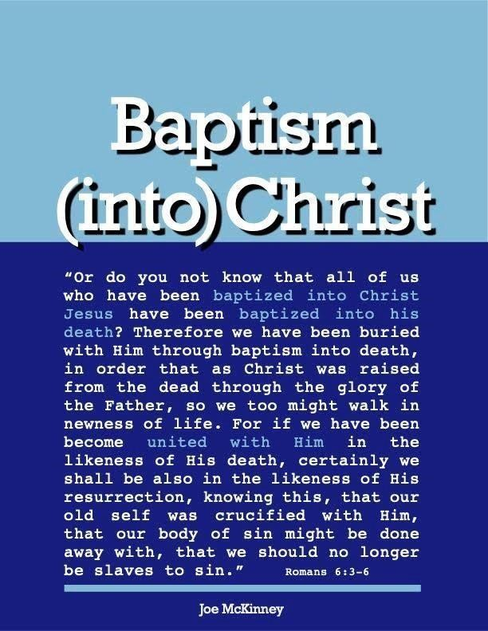

DOCTRINE OF JUSTIFICATION

DOCTRINE OF JUSTIFICATION

The doctrine of justification by faith demands that a person understand and believe that his sins are being forgiven when he is baptized. It is important, therefore, for us to know what justification means.

To help us understand this word, think about the super-religious, do-gooder, self-righteous hypocrite, pillar of the church, and the dirty, rotten, no-good, traitorous, wicked, extortioner, sinner at his side.
“And He also told this parable to certain ones who trusted in themselves that they were righteous, and viewed others with contempt: ‘Two men went up into the temple to pray, one a Pharisee, and the other a tax-gatherer. The Pharisee stood and was praying thus to himself, “God, I thank Thee that I am not like other people; swindlers, unjust, adulterers, or even like this tax-gatherer. I fast twice a week; I pay tithes of all that I get.” But the tax-gatherer, standing some distance away, was even unwilling to lift up his eyes to heaven, but was beating his breast, saying, “God, be merciful to me, the sinner!” ‘I tell you, this man went down to his house justified rather than the other; for everyone who exalts himself shall be humbled, but he who humbles himself shall be exalted.’” (Luke 18:9-14) a. What does it mean to be justified? What is justification?

Justification is a legal term. Justification, defined in Young's Analytical Concordance, means “A judicial sentence, declaration of right, to make or declare right.” Vine's Dictionary of New Testament Words says that justify “denotes the act of pronouncing righteous, justification, acquittal.”

The person who is justified is declared or pronounced to be righteous. (The same Greek word translated “just” 33 times in the New Testament is translated “righteous” 41 times). Declaring a person justified is the same thing as pronouncing a man righteous.

Perhaps knowing that “just” and “righteous” are two ways to translate the very same Greek word will help us understand that to be justified does not mean to be made “just-as-if-I” had never sinned. Just having no sin does not make us acceptable in God’s eyes. We must have our sins “subtracted” and also Christ’s righteousness “added”. Justification is when the criminal is not only declared innocent of the crimes, he committed but also declared to be a righteous person.

There is a difference between “being righteous” and “being declared righteous”. We are declared to be righteous the moment we are saved. We spend our lives becoming righteous as we grow spiritually into the image of Christ. Justification is exclusively a work of God in which He imputes to us the righteousness of Christ.

There are two kinds of righteousness: imputed (attributed, ascribed or reckoned) righteousness and earned righteousness. Consider Philippians 3:3-9: “for we are the true circumcision, who worship in the Spirit of God and glory in Christ Jesus and put no confidence in the flesh, although I myself might have confidence even in the flesh. If anyone else has a mind to put confidence in the flesh, I far more: circumcised the eighth day, of the nation of Israel, of the tribe of Benjamin, a Hebrew of Hebrews; as to the Law, a Pharisee; as to zeal, a persecutor of the church; as to the righteousness which is in the Law, found blameless. But whatever things were gain to me, those things I have counted as loss for the sake of Christ. More than that, I count all things to be loss in view of the surpassing value of knowing Christ Jesus my Lord, for whom I have suffered the loss of all things, and count them but rubbish so that I may gain Christ, and may be found in Him, not having a righteousness of my own derived from the Law, but that which is through faith in Christ, the righteousness which comes from God on the basis of faith, (This is imputed righteousness).”

b. We are justified (saved, counted as righteous) by faith.

“For we maintain that a man is justified by faith apart from works of the Law.” (Romans 3:28)

“knowing that a man is not justified by the works of Law but through faith in Christ Jesus, even we have believed in Christ Jesus, that we may be justified by faith in Christ, and not by the works of the Law; since by the works of the Law shall no flesh be justified.” (Galatians 2:16)

“Now that no one is justified by the Law before God is evident for, ‘The Righteous Man Shall Live By Faith.’”
(Galatians 3:11)

“For we also once were foolish ourselves, disobedient, deceived, enslaved to various lusts and pleasures, spending our life in malice and envy, hateful, hating one another. But when the kindness of God our Savior and His love for mankind appeared, He saved us, not on the basis of deeds which we have done in righteousness, but according to His mercy, by the washing of regeneration and renewing by the Holy Spirit, whom He poured out upon us richly through Jesus Christ our Savior, that being justified by His grace we might be made heirs according to the hope of eternal life.” (Titus 3:3-7)

“But God, being rich in mercy, because of His great love with which He loved us, even when we were dead in our transgressions, made us alive together with Christ (by grace you have been saved), and raised us up with Him, and seated us with Him in the heavenly places, in Christ Jesus, in order that in the ages to come He might show the surpassing riches of His grace in kindness toward us in Christ Jesus. For by grace you have been saved through faith; and that not of yourselves, it is the gift of
God; not as a result of works, that no one should boast. For we are His workmanship, created in Christ Jesus for good works, which God prepared beforehand, that we should walk in them.” (Ephesians 2:4-10)

c. Some conclusions based on these passages:
- God’s motive for saving us is His mercy, kindness, love and grace
- Our actions did not move God to grace. God’s grace moved us to take a step toward Him.
- God saves sinners who do not deserve to be saved. Grace is unmerited and unearned favor.
- We are saved by grace through faith.
- Salvation is by Christ’s meritorious work, not ours.
- Wrath was owed but grace was bestowed.
- We do not save ourselves from our sins, rather God saves us.
- Salvation is a gift from God.
- Salvation is through faith.
- Living (obedient) faith is the means by which we receive God’s grace.
- Human response is required for salvation. To be saved we must trust in Jesus as our sin sacrifice.
- All our righteous deeds are excluded as the means to salvation.
- Christ's perfect obedience merited the salvation that is given to us.
- We are not saved because we are good enough but on the merits of Christ’s work.
- Saving faith trusts in and depends upon God’s saving work in Christ.

Baptism, which now saves us (1 Peter 3:21), to be effective, must be classified as faith. It must be an expression of our faith in Christ as our sin - sacrifice! Otherwise, being saved by baptism would mean that we are justified by works of law and not by faith.

Questions
  - God declares a person righteous following their resurrection from the cleansing waters of baptism that leads to eternal life
True False

  - Man earns righteousness by doing good things for others.
True False

  - Being righteous and being declared righteous are the same.

True False

- Man is justified
On the basis of deeds done in righteousness

By God's mercy by the washing of regeneration and renewing by the Holy Spirit

- For by grace you have been saved through faith; and that not of yourselves, it is the gift of God; not as a result of works.

True False

Answers to Questions

- True
- False
- False
- By God’s mercy by the washing of regeneration and renewing of the Holy Spirit
- True

