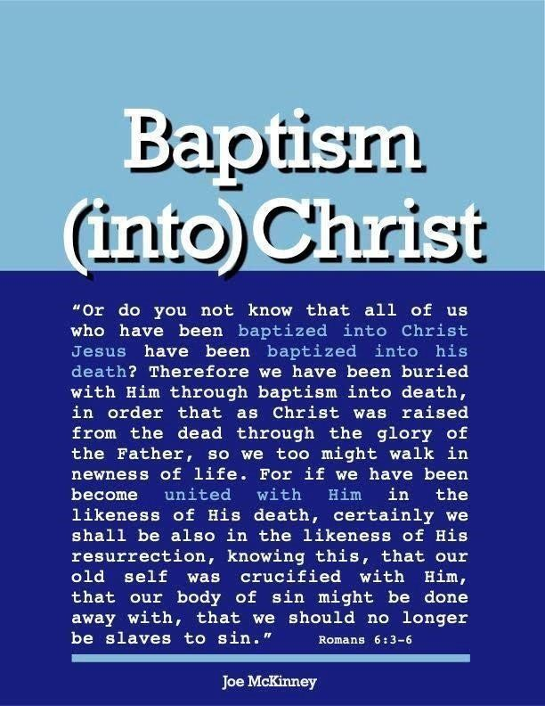
ARE THERE PREREQUISITES THAT MUST BE MET IN ORDER FOR SOMEONE TO BE BAPTIZED?

ARE THERE PREREQUISITES THAT MUST BE MET IN ORDER FOR SOMEONE TO BE BAPTIZED?

Yes, there are prerequisites for baptism. This is obvious from the account of Philip and the Ethiopian treasurer in Acts 8. After being taught Jesus, beginning from Isaiah 53, the eunuch asked, “Look, here is water, why can’t I be baptized?” Philip’s answer showed a prerequisite: “If you believe with all your heart, you may.” It is logical that if he did not believe, he could not be baptized.
The “great commission” recorded in Matthew 28:19 also makes it obvious that there are prerequisites for baptism: “Go and make disciples of all nations, baptizing them in the name of the Father, the Son, and the Holy Spirit”. Who are we to baptize? We are to only baptize disciples – those people who decide to follow Jesus and learn from Him. Those who do not decide to follow Jesus (repent) are not to be baptized.
The simplest and most concise way to express the prerequisites for baptism might be simply that we must believe and repent in order to baptized; that is, if we understand what this mean. However, in that simplicity, it may be easy to get the cart before the horse and in doing so we could ignore (or fail to emphasize) the centrality of the gospel of Jesus Christ.
There is an important, even essential, connection between the Cross of Christ, faith (as trust and belief), repentance, discipleship, the Lordship of Jesus, baptism and redemption. Consider the following:
- In Order To Be Baptized, One Must Recognize That He Is A Sinner Who Needs A Savior.
  - Timothy 1:15 “It is a trustworthy statement, deserving full acceptance, that Christ Jesus came into the world to save sinners, among whom I am foremost of all.”
Many people do not feel the need for a savior because they do not feel lost. Whether it comes through hearing a moving sermon; maybe a friend who shares with you the truth; maybe by reading a tract; whichever, in some way, one must come to understand that "all have sinned and fall short of the glory of God" (Romans 3:23). As the prophet Isaiah had said, long ago: our sins have hidden God's face from us so that He will not hear." (Isaiah 59:2). Our own sin separates us from God! “The wages of sin is death” we read in Romans 6:23. This is a spiritual death, which is a separation from God for those who are lost.
"But what about my good works?" someone may say. The answer returns: "For by grace you have been saved through faith, and that not of yourselves; it is the gift of God, not of works, lest anyone should boast" (Ephesians 2:8, 9). "But my sins are small" others say, but "For whoever shall keep the whole law, and yet stumble in one point, he is guilty of all" (James 2:10).
Human pride and self-sufficiency are the greatest barriers to salvation. He who refuses to admit that he is a sinner in need of forgiveness is lost and cannot be baptized in order to be saved. Sinners need salvation.
- In Order To Be Baptized, One Must Recognize That Jesus Is The Only Hope Of Salvation.

There is no other way. By his death on the cross, Jesus is able to save, set free, and ransom sinners. In
John
14:6, Jesus declared: says, "I am the way, the truth, and the life: No man comes to the Father except through Me." The only way we can get to God is through Christ. We also read in Acts 4:12, "Nor is there salvation in any other, for there is no other name under heaven given among men by which we must be saved." We cannot be saved by relying on Mohammed, Buddha, Judaism, Hindu gods or any other religion. Neither can we devise our own system of "Christianity" as is being done today and expect it to save us. Only Jesus Christ can specify the conditions for our salvation because He paid our price and is our only savior. There is no other way. What Jesus did for sinners was necessary to bring divine mercy to condemned sinners.
- What Was It, Then, That Jesus Did To Save Sinners?
  - Jesus became a man. Before Jesus came, He was God (John 1:1) and was on equality with God (Phil. 2: 6). But man's Savior must be human as well as divine; otherwise, he could not bear man's sins. He emptied himself … coming in the likeness of men." (Phil. 2:7).
  - Christ became our sin-bearer. “But he was pierced for our transgressions, he was crushed for our iniquities; the punishment that brought us peace was upon him, and by his wounds, we are healed ... and the Lord has laid on him the iniquity of us all” (Isaiah. 53:5, 6). “He made Him who knew no sin to be sin for us." (II Cor. 5:21). "Who Himself bore our sins in His own body on the tree" (1Pet. 2:24). None other could be man's sin bearer.
  - Christ became our sin offering. "God presented him as a sacrifice of atonement, through faith in his blood" (Rom. 3:25). "Christ died for our sins” (I Cor. 15:3). “Who gave himself for our sins" (Galatians. 1:4).
  - He was raised for us. “But now hath Christ been raised from the dead, the first fruits of them that sleep. For since by man came, death by man (Christ in the flesh) came also the resurrection of the dead. For as in
Adam all die, so also in Christ shall all be made alive." (I Cor. 15. 20-22). “He was "raised for our justification."
(Rom. 4: 25)
  - He is at the right hand of God interceding for us. “Therefore, he is able to save completely those who come to God through him, because he always lives to intercede for them" (Hebrews 7:25). "We have one who speaks to the Father in our defense–Jesus Christ, the Righteous One” (1 John 2:1). “Christ Jesus, who died– more than that, who was raised to life–is at the right hand of God and is also interceding for us (Romans 8:24).
  - Christ did many other things for the benefit of man, but it was by means of his death that he redeemed us. For example, he left us the incomparable Sermon on the Mount, but this teaching is not redemptive. The gospel that saves is the good news of Christ's death for our sins (I Cor. 15:3, 4). The source of our salvation is the blood of Christ.
  - What Jesus did for us is called “the gospel”, meaning “good news!” In Mark 16:15, 16 Jesus said “go and preach the gospel to every creature. He who believes [this gospel] and is baptized will be saved but he who does not believe [this gospel] will be condemned” We must believe this gospel and be baptized to be saved. If we do not believe [this] gospel we will not want to nor can be baptized.
Questions
  - Who offers forgiveness of sins and eternal lie?
Allah

Hindu Gods

Buddha

Christ

Jehovah of old Testament

  - A person drowning in sin cannot be saved unless he is willing to take hold of the saving rope of salvation.
True

False

  - What is the Gospel – the Good News of Jesus? God became man - Jesus of Nazareth

Christ became our sin-bearer

Christ became the sin offering by His death
God raised Christ from death back to LIFE
Christ returned to Heaven to intercede for us

All the above

  - One shows their belief that the crucified Jesus Christ is their Lord and Savior by their commitment to Him
True

False

  - Repentance
Feeling really sorry

Leads to salvation

Causes one to change from their selfish sinful life to God's way of life

Same as salvation

Answers to Questions
  - Christ
  - True
  - All the above
  - True
  - Causes one to change from their selfish sinful life to God’s way of life

