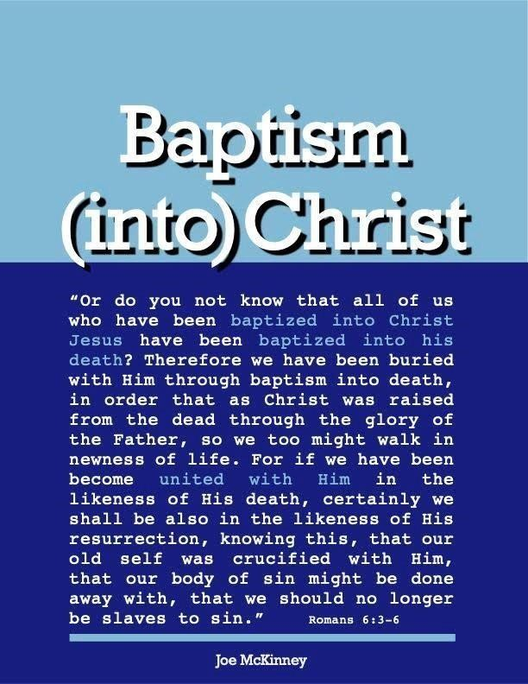
WHAT BLESSINGS DOES A PERSON RECEIVE WHEN HE IS BAPTIZED BIBLICALLY?
WHAT BLESSINGS DOES A PERSON RECEIVE WHEN HE IS BAPTIZED BIBLICALLY?

A person is saved when he is scripturally baptized. There are several aspects or ways of expressing this gift of salvation in the New Testament:

- Salvation — Mark 16:15-16
“And He said to them, “Go into all the world and preach the gospel to all creation. He who has believed and has been baptized shall be saved; but he who has disbelieved shall be condemned.”
- Forgiveness of sins — Acts 2:38
“And Peter said to them, “Repent, and let each of you be baptized in the name of Jesus Christ for the forgiveness of your sins; and you shall receive the gift of the Holy Spirit.”
- Receive the gift of the Holy Spirit — Acts 2:38 above
- Sins washed away — Acts 22:16
“And now why do you delay? Arise and be baptized, and wash away your sins, calling on His name.”
- Cleansing – Eph. 5:25-27
“... Christ also loved the church and gave Himself for her, that He might sanctify her, having cleansed her by the washing of water with the word, that He might present to Himself the church in all her glory, having no spot or wrinkle or any such thing; but that she should be holy and blameless.”
- Sanctification — Eph. 5:26 above
- A good conscience — 1 Peter 3:21
“And corresponding to that, baptism now saves you—not the removal of dirt from the flesh, but an appeal to God for a good conscience—through the resurrection of Jesus Christ.”
- Puts off the body of sin — Col. 2:11, 12
“In Him you were also circumcised with a circumcision made without hands, in the removal of the body of the flesh by the circumcision of Christ; having been buried with Him in baptism in which you were also raised up with Him through faith in the working of God, who raised Him from the dead.”
- Raised with Christ — Col. 2:12 above 10. Born again — John 3:3-5
“Jesus answered and said to him, ‘Truly, truly, I say to you, unless one is born again, he cannot see the kingdom of God.’ Nicodemus said to Him, ‘How can a man be born when he is old? He cannot enter a second time into his mother’s womb and be born, can he?’ Jesus answered, ‘Truly, truly, I say to you, unless one is born of water and the Spirit, he cannot enter into the kingdom of God.’”
- Baptized into the death of Christ - Romans 6:3-6
“Or do you not know that all of us who have been baptized into Christ Jesus have been baptized into his death? Therefore, we have been buried with Him through baptism into death, in order that as Christ was raised from the dead through the glory of the Father, so we too might walk in newness of life. For if we have been become united with Him in the likeness of His death, certainly we shall be also in the likeness of His resurrection, knowing this, that our old self was crucified with Him, that our body of sin might be done away with, that we should no longer be slaves to sin.”
- Become a child of God — Gal. 3:26, 27
“For you are all sons of God through faith in Christ Jesus. For all of you who were baptized into Christ have clothed yourselves with Christ.”
- Be clothed with Christ — Gal. 3:27 above
- Enter into Christ — Gal. 3:27 and Romans 6:3 above

NOTE 1 - The phrase “in Christ” or “into Christ” is very significant! When we enter into Christ, we then are found “in Christ” and it is “in Christ” that all spiritual blessings are given to us (Eph. 1:3, “Blessed be the God and
Father of our Lord Jesus Christ, who has blessed us with every spiritual blessing in the heavenly places in Christ”).

Rom. 3:24 — “being justified as a gift by His grace through the redemption which is in Christ Jesus.”

Rom. 6:11— “Even so consider yourselves to be dead to sin, but alive to God in Christ Jesus.”

Rom. 6:23 — “For the wages of sin is death, but the free gift of God is eternal life in Christ Jesus our Lord.”

Rom. 8:1 — “There is therefore now no condemnation for those who are in Christ Jesus.”

Rom. 12:5 — “So we, who are many, are one body in Christ, and individually members one of one another.”

2 Cor. 5:17 — “...Therefore if any man is in Christ, he is a new creature; the old things passed away; behold, new things have come.”

2 Cor. 5:21 — “He made Him who knew no sin to be sin on our behalf, that we might become the righteousness of God in Him.”

Gal. 3:28 — “There is neither Jew nor Greek, there is neither slave nor free man, there is neither male nor female; for you are all one in Christ Jesus.”

Eph. 1:7 — “In Him we have redemption through His blood, the forgiveness of our trespasses, according to the riches of His grace.”

Eph. 1:11 — “In Him also we have obtained an inheritance.”

Eph. 2:6 — “and raised us up with Him, and seated us with Him in the heavenly places in Christ Jesus.”

Eph. 2:7 — “in order that in the ages to come He might show the surpassing riches of His grace in kindness toward us in Christ Jesus.”

Eph. 2:13 — “but now in Christ Jesus you who formerly were far off have been brought near by the blood of Christ.”

Eph. 3:6 — “that the Gentiles are fellow heirs and fellow members of the body, and fellow partakers of the promise in Christ Jesus through the gospel.”

Eph. 3:12 — “in whom we have boldness and confident access through faith in Him.”

Phil. 3:9 — “and may be found in Him, not having a righteousness of my own derived from the Law, but that which is through faith in Christ, the righteousness which comes from God on the basis of faith.”

Col. 2:10 — “and in Him you have been made complete, and He is the head over all rule and authority.”

- Thess. 4:16 — “...For the Lord Himself will descend from heaven with a shout, with the voice of an archangel, and with the trumpet of God; and the dead in Christ will rise first.”

- Tim. 1:1 — “Paul, an apostle of Jesus Christ by the will of God, according to the promise of life in Christ Jesus.”

2 Tim 1:9 — “who has saved us and called us with a holy calling, not according to our works, but according to His own purpose and grace which was given us in Christ Jesus from all eternity.”

2 Tim 2:10 — “For this reason I endure all things for the sake of those who are chosen, that they also may obtain the salvation which is in Christ Jesus and with-it eternal glory.”

1 John 3:5 — “And you know that He appeared in order to take away sins; and in Him there is no sin.”
1 John 5:11 — “And the witness is this, that God has given us eternal life, and this life is in His Son.”
NOTE 2. These questions are often asked: “Do I have to be baptized in order to be saved?” It might be easier to reply if we asked:
“Do I have to be born of the water and the Spirit in order to be saved?”
“Do I have to have my sins washed away in order to be saved?”
“Do I have to be a child of God in order to be saved?”
“Do I have to be ‘in Christ’ to be saved?”
The answer to all these questions is the same – (“yes!”) - Since it is in Christ that all these blessings are bestowed and we are “baptized into Christ”; that is, we come into Christ in the act of being baptized. Baptism is obviously necessary for a sinner to be saved! It is good to remember that the act of baptism is not a work man does whereby he earns salvation. Instead, it is, as we will see in the next section of this study, “an appeal to God for a good conscience – through the resurrection of Jesus Christ.”
Questions
- Who are those that will be condemned?
No one as Jesus saves everybody Those who disobey, do not obey Christ and His message of redemption

- Who will not see the Kingdom of God?

Jews The blind

Those who are not born again

- The penitent believer who is baptized into Christ Jesus has been baptized into His death.
True False

- All in Christ have been blessed with all spiritual blessings

True False

5. What does one have to do to be
saved Be baptized into

Christ's death
Be born ofthe water and Spirit Have theit sins washed away

Be a child of God Be in Christ All the above

Answers to Questions
- Those who disobey, do not obey Christ and His message of redemption
- Those who are not born again
- True
- True
- All the above

