Time After Christ Returned to Heaven
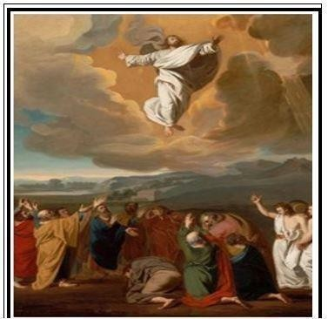
Our Choice
Randolph Dunn

Our Choice
The question "What must I do?” was first asked of Peter when Christ established his church as recorded in Acts 2 which you are encouraged to read in its entirety.
"When the day of Pentecost came, they were all together in one place. Suddenly a sound like the blowing of a violent wind came from heaven (vv. 1-2a) ... When they heard this sound, a crowd came together in bewilderment (vs. 6a) ... Then Peter stood up with the Eleven, raised his voice and addressed the crowd (vs. 14a) ... 'Men of Israel, listen to this: Jesus of Nazareth was a man accredited by God to you by miracles, wonders and signs, which God did among you through him, as you yourselves know. This man was handed over to you by God's set purpose and foreknowledge; and you, with the help of wicked men, put him to death by nailing him to the cross. But God raised him from the dead, freeing him from the agony of death, because it was impossible for death to keep its hold on him.' (Vv. 22-24) ... 'Therefore, let all Israel be assured of this: God has made this Jesus, whom you crucified, both Lord and Christ.' When the people heard this, they were cut to the heart and said to Peter and the other apostles, 'Brothers, what shall we do?' Peter replied, 'Repent and be baptized, every one of you, in the name of Jesus Christ for the forgiveness of your sins. And you will receive the gift of the Holy Spirit.' (Vv. 36-39) ... Those who accepted his message were baptized, and about three thousand were added to their number that day." (vs. 41) ... They devoted themselves to the apostles' teaching and to the fellowship, to the breaking of bread and to prayer. (Vv. 42-43)
We all have the same choice. Will we accept Christ's message of reconciliation or reject it? Some rejected the message but about 3,000 accepted it and did the following:
- They heard the Gospel message - Christ had been crucified, Resurrected, and ascended back to the Father.
- They were convicted of the sin.
- They asked, "what shall we do?"
- Those who accepted the Gospel message:
  - Repented
  - Were immersed in the name of Jesus Christ for the forgiveness of sins
  - Received gift of the Holy Spirit
- About 3000 added to their number, Jesus' disciples. • They devoted themselves to a. Apostles' teaching
- Fellowship
- Breaking of bread
- Prayer

It should be noted that everyone who heard made a decision. They either accepted or rejected the message of reconciliation.
There are many ways one can hear the Message of Reconciliation - someone could personally show them the message directly from the Bible, they could learn from reading the Bible or verifying from the Bible the truth of lessons on the World Wide Web, Internet.
There does not appear to be a requirement that a disciple or follower of Christ do the immersing, baptizing, as long as it is based upon a saving faith, by immersion in water in the name of Jesus and for the forgiveness of sins.

Questions
- What is the Message of Reconciliation?
Christ's death
Christ's return to Heaven
Christ's burial
Christ resurrection
All the above
None of the above

- What did everyone who heard do?
Accepted Christ's message delivered by Peter
Rejected Christ's message
Made a decision

- Those accepting the message received the gift of the Holy Spirit
Repented were immersed, baptized all the above
none of the above

- Those who accepted devoted themselves to learning more about Jesus and His teachings associating with others who had accepted the message of Christ breaking bread with
others who accepted Christ's message prayer
All the above none of the above

- Is the Gospel available to all mankind?
True
False

Answer to Questions
- All the above
- Made a decision
- All the above
- All the above
- True

