Christ's Message of Redemption
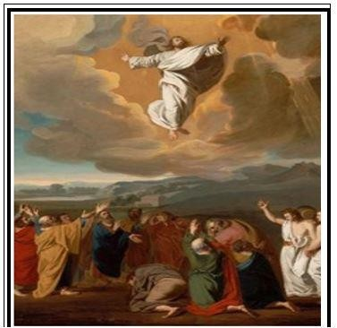

Functions - Within the Spiritual Body
Randolph Dunn
Functions - Within the Spiritual Body
All who have obeyed from the heart the message of reconciliation have put on Christ and have
- died to sin
- been buried or immersed in water (baptism)
- been raised a new being
- been added to the Body of Christ and are in Him, in Christ

As disciples of Christ, we constitute a spiritual body and just like the human body there are many functions the body must perform if it is to grow. All activity must be functioning in unity for the body to be effective and efficient, therefore all parts of the body do not do the same thing. "For as in one body we have many members, and all the members do not have the same function so we, though many, are one body in Christ, and individually members one of another." (Romans 12:4-5)
Paul, while in prison, provided insight into spiritual gifts when he wrote "I, therefore, the prisoner of the Lord, beseech you to walk worthy of the calling with which you were called, with all lowliness and gentleness, with longsuffering, bearing with one another in love, endeavoring to keep the unity of the Spirit in the bond of peace. There is one body and one Spirit, just as you were called in one hope of your calling; one Lord, one faith, one baptism; one God and Father of all, who is above all, and through all, and in you all. But to each one of us grace was given according to the measure of Christ's gift." (Ephesians 4:1-6)
"And He Himself gave some to be apostles, some prophets, some evangelists, and some pastors and teachers, for the equipping of the saints for the work of ministry [serving (rd)], for the edifying of the body of Christ, till we all come to the unity of the faith and of the knowledge of the Son of God, to a perfect man, to the measure of the stature of the fullness of Christ; that we should no longer be children, tossed to and fro and carried about with every wind of doctrine, by the trickery of men, in the cunning craftiness of deceitful plotting, but, speaking the truth in love, may grow up in all things into Him who is the head — Christ — from whom the whole body, joined and knit together by what every joint supplies, according to the effective working by which every part does its share, causes growth of the body for the edifying of itself in love." (Ephesians 4:9-16)
Perhaps the most crucial functions are never seen while others are always seen.
The spiritual body's functions listed below are from Romans 12:6-8:
- Prophecy, let us prophesy in proportion to our faith
- Service or ministry, let us use it in our serving or ministering
- He who teaches, in teaching
- He who exhorts, in exhortation
- He who gives or contributes, with liberality
- He who leads, with diligence
- Perform acts of mercy with cheerfulness

In performing these activities, we must continue to live a life pleasing to God. Romans 12 tells us how we are to live before God:
- Be genuine in Love.
- Hate what is evil, hold fast to what is good.
- Love one another with brotherly affection.
- Outdo one another in showing honor.
- Never lag in zeal, be aglow [fervent] with the Spirit, and serve the Lord.
- Rejoice in your hope, be patient in tribulation, and be constant in prayer.
- Contribute to the needs of the saints, practice hospitality [take care of needs].
- Speak well of those who persecute you; bless and do not curse them.
- Rejoice with those who rejoice, weep with those who weep • Live in harmony with one another; do not be haughty.
- Associate with the lowly.
- Never be conceited.
- Repay no one evil for evil, but take thought for what is noble in the sight of all.
- If possible, so far as it depends upon you, live peaceably with all.
- Beloved, never avenge yourselves, but leave it to the wrath of God.
- Do good things to your enemy for by so doing you will heap burning coals on his head.

From Ephesians 4:11-13 we see that in order to prepare His people for works of service to build up the body so it could mature and reach unity in the faith and in the knowledge of the Son of God He gave some to be: ° apostles
° prophets
° evangelists
° teaching pastors, shepherds, bishops or overseeing watchmen

Therefore, in the Body of Christ, we do not all perform the same functions but become servants, doing whatever needs to be done and give honor to everyone not just to those who have a more public function.
Questions
- God is the one who adds those who have put on Christ to the church Christ established.
True False

- The body of Christ has many functions to perform therefore each individual Christian must do every function.

True False

- The functions of apostles, prophets, evangelists, overseeing watchmen [or teaching pastors] are to
assign tasks or functions to every Christian

prepare Chrisstians for works of service to mature them

- In order to reach unity in the church we must grow in knowledge of the Word and do the works of the Body, the Church.

True False

5. Christians are servants of God, therefore we can select what we want to do rather than do what our Master needs to have done.

True False

Answers to Questions
- True
- False
- Prepare Christians for works of service to mature them
- True
- False

