Journey Through The Bible

Stephen

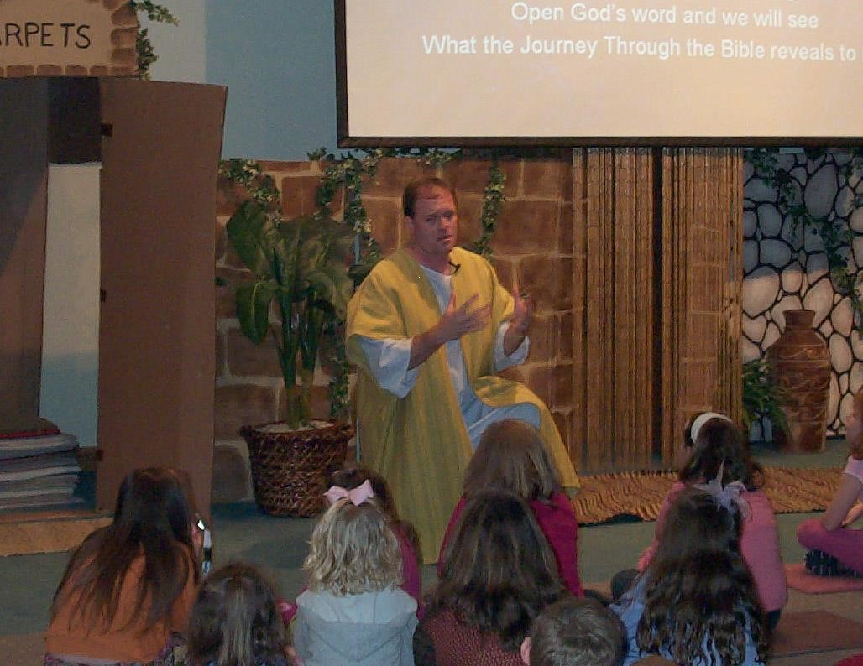

My name is Stephen. I was a member of the Church of Christ in Jerusalem. Many people were becoming Christians. Some people thought that some of the women whose husbands had died were not being helped. I was chosen along with six other men who wanted to do right to do this good work. God gave me power to do miracles, after the apostles laid hands on us.

There were some men who were arguing with me. They told the people that I said bad things about Moses and God. They took me to special people, who knew the law, to decide if I had done wrong. The high priest asked me if these things were true and he let me speak.

I told them about God’s dealing with His people from the time of Abraham, Isaac, Jacob, and Joseph down to Moses. I told these men that God had sent leaders to help them, but many times they would not obey them. I told them the truth. I told them they are stubborn and bad. You do not do what God tells you to do. They were so angry with me that they were grinding their teeth.

I looked up to heaven and saw Jesus standing at God’s right hand. I told what I saw. They screamed and put their hands over their ears. All at once they ran at me and threw me out of the city. They threw rocks at me as I prayed to God.

I knelt down and asked God to forgive them, and then I died. If you would like to know more about me, open your Bibles to the book of Acts. Now I would like to ask you some questions. (Prepare several questions to ask them about your character.)
Scripture reading: Acts 6:1 – 7:60

Memory Verse: Hebrews 10:23
Let us hold fast the confession of our hope

