Journey Through The Bible
Saul (Paul)

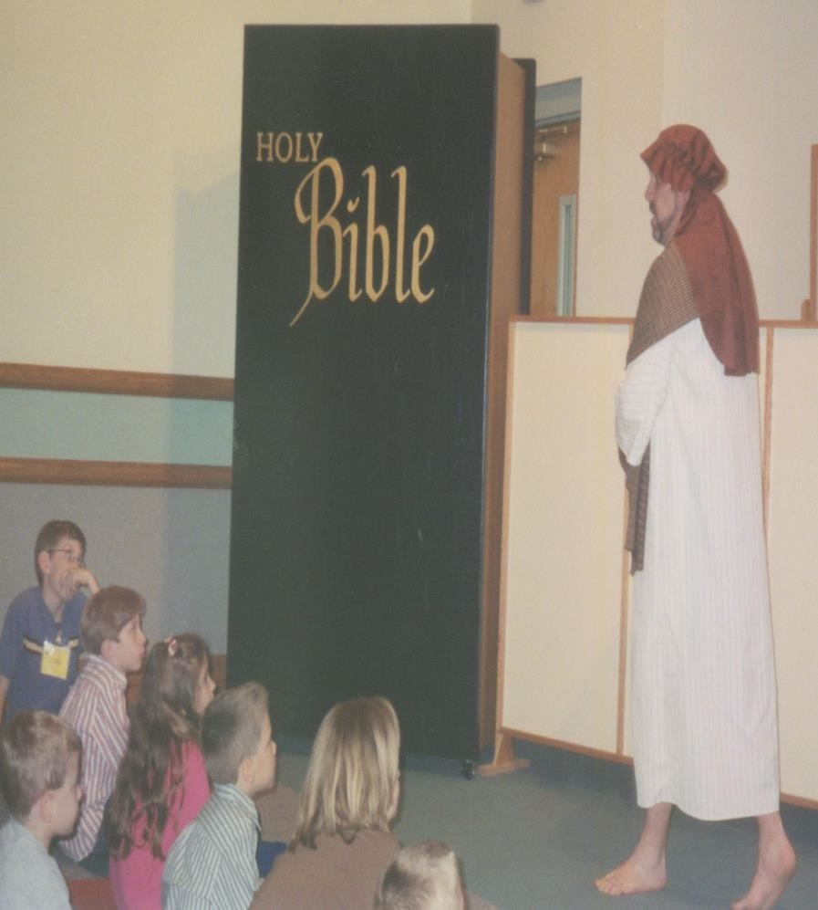
Acts 9:1-19

My name is Paul, though I was born Saul, in the city of Tarsus into a proud, strict family. I am a Jew, but I am also a Roman citizen.
Because I believed that the followers of Jesus Christ would destroy the religion of the Jews, I watched with approval when Stephen, a faithful servant of Christ, was being stoned to death.
Stephen was preaching about Jesus to some of those who had taken part in His crucifixion. When he condemned them for their evil deeds, the mob rushed upon him and ground their teeth at him. Stephen said, "Look, I see the heavens opened and the Son of Man standing at the right hand of God!"
The people in the mob covered their ears and with a loud shout, they all rushed together against Stephen. They dragged him out of the city and began to stone him: they laid their coats at my feet. While they were stoning Stephen, he prayed, "Lord Jesus, receive my spirit." Then he knelt down and cried out in a loud voice, "Lord, do not hold this sin against them." When he had said this, he died. At that time, I approved of their killing him.
While good men buried Stephen and cried for him, I began to persecute, that is doing much harm, the church, entering house after house, dragging off both men and women and committing them to prison.
I continued to breathe threats and murder against the disciples of the Lord. I went to the high priest and asked for permission to go to other cities to find Christians and bring them bound to Jerusalem.
As I was going along near Damascus, suddenly a light from heaven flashed around me. I fell to the ground and heard a voice say, "Saul, Saul, why do you persecute me?" I asked, "Who are you. Lord?" The reply was, "I am Jesus, whom you are persecuting. Get up and enter the city, and you will be told what you are to do." The men who were traveling with me stood speechless, because they heard the voice but saw no one.
I got up from the ground, and though my eyes were open, I could see nothing; so they led me by the hand and brought me into Damascus. For three days I was without sight, and did not eat or drink.
I was taken to the street called Straight and stayed in the house of a man called Judas. I spent much time praying and had a vision in which a man named Ananias came in and laid his hands on me so that I might regain my sight.
Ananias came to the house of Judas and laid his hands on me and said, "Brother Saul, the Lord Jesus, who appeared to you on your way here, has sent me so that you may regain your sight and be filled with the Holy Spirit^
Immediately, something like scales fell from my eyes, and my sight was restored. I got up and was baptized for the forgiveness of my sins. After eating some food, I regained my strength.
I am so very sorry for all the bad things that I ever did. I plan to spend the rest of my life in service to God and my wonderful Savior, Jesus Christ. Memory Verse:
☼ Ask, and it will be given to you; seek, and you will find.

What did this lesson tell me?
☺ You must study and learn what God wants you to do.

Do you know? Answer on back page
? Was Paul doing what God wanted him to do when he hurt God’s people?

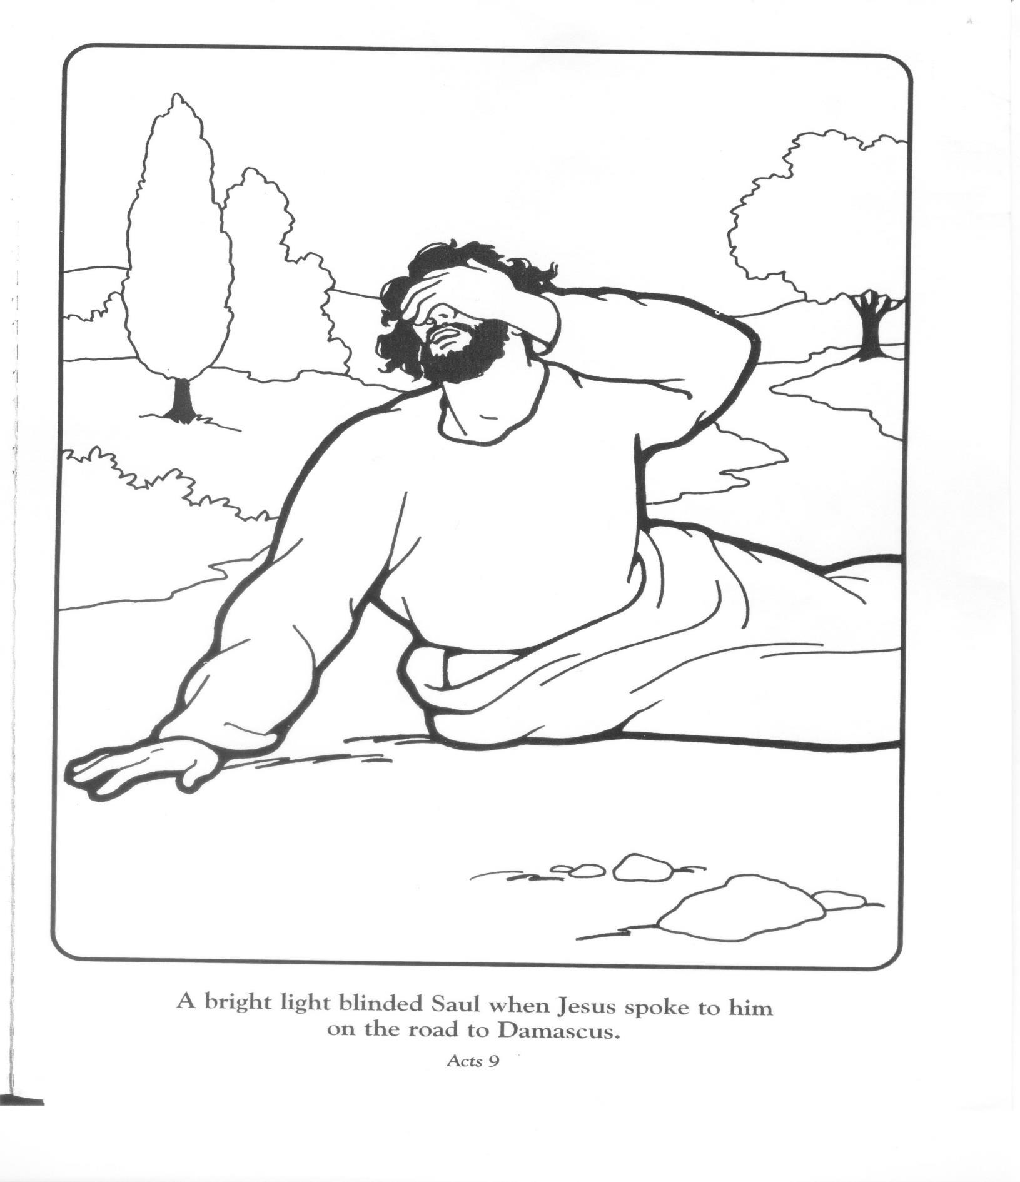
? Answer to do you know. ● No, he thought he was but he did not please God.

