Lessons From The Cross
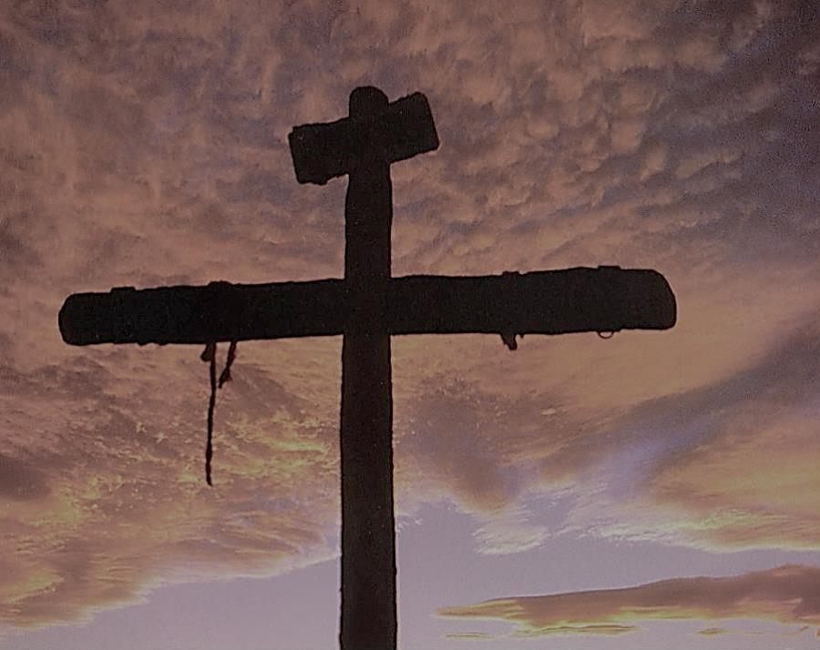

Steve Flatt

Publisher’s Statement

BibleWay Publishing’s objective is to make Bible lessons available to anyone interested in learning more about God and His will.

We recommend that you study your Bible to determine the Biblical accuracy of the message presented in this book or other books and lessons. The teachings of preachers, ministers, pastors, priests, and rabbis, in audio, videos, Bible commentaries, and books including those of BibleWay Publishing are the author’s understanding based upon their ability, knowledge, training, and bias they have.

To check the truth of any teaching, read different Bible translations, and consult Bible dictionaries and lexicons to learn the meaning of unfamiliar words or phrases. Also, multiple Greek words can be translated into one word, which can distort the original meaning. Be careful with accepting dictionary definitions, as meanings change over time. Dictionaries provide the meaning of the original and current usage meanings.

May you allow God to guide you in your study of His Holy Word?

BibleWay Publishing grants permission to use and reproduce, for non-commercial purposes, their lessons in their entirety without change or charge. By using BibleWay Publishing books you agree not to alter, add to, or remove any of their content.

Randolph Dunn, Publisher
biblewaypublishing.com
Info.IBKI.English@gmail.com

BibleWay Publishing
BibleWay Publishing (BWP), is the non-profit Bible ministry of Randolph Dunn. Its objective is to make Bible lessons available to anyone interested in learning more about God and His will. This is done primarily through the following websites.
English
biblewaypublishing.com and thebiblewayonline.com
International Bible Knowledge Institute. (IBKI)
Printed IBKI books are available at cost upon request
Topical lessons and digital books (ePub).
Portuguese lessons are linked here
Spanish
elcaminobiblico.com
Instituto Internacional de Conocimiento Bíblico
Asian languages – Simplified Chinese, Malay (Malaysia), Nepali (Nepal), Sinhala (Sri Lanka), and Indian languages – Bengali, Hindi, Kannada, Odia Tamil, Telugu
thebibleway.net
International Bible Knowledge Institute.
College of Preaching
Topical lessons and digital books (ePub) - English
Ukraine
Προγραμματισμένη λύτρωση for Ukrainians or ukrainebibleinstirute.com for others (under development)
By using these books or lessons you agree not to alter, add to, or remove any of their content.
