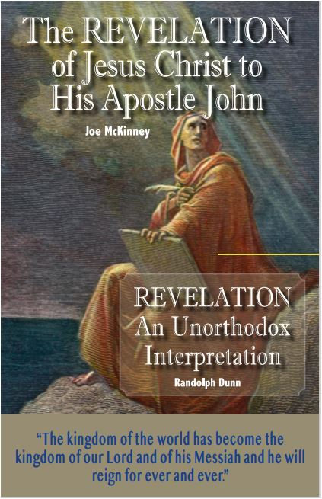

BibleWayPublishing
President's Statement

BibleWay Publishing is a non-profit Bible ministry. Its primary focus is on the websites and digital books of the International Bible Knowledge Institute. The objective of IBKI is to make Bible lessons available to anyone interested in learning more about God and His will. Students are NOT required to attend the Institute to earn a certificate or diploma. These lessons can be studied online or in classrooms, by Zoom, downloaded to digital devices, emailed, printed, or used by individuals, groups, or churches in their evangelistic ministry. IBKI is not an accredited institution.

We recommend that you study your Bible to determine the accuracy of what is stated in these lessons or from any other source. The "commentaries" presented in the International Institute of Biblical Knowledge (IBKI) lessons are the opinions of the authors or compilers. Opinions often find their way into audio, video, and print lessons, as well as Bible commentaries; and, in the teachings of preachers, ministers, pastors, priests, and rabbis.

You should always verify all the comments, opinions, and teachings of these since it is YOUR responsibility to seek, know and do the will of God.

To check the truth of any teaching, read different Bible translations, and consult Bible dictionaries and lexicons to learn the meaning of unfamiliar words or phrases. Be careful with any dictionary definitions, as dictionaries give the meaning of words and phrases from the original language to current usage.

The meaning of words and phrases changes over time. Also, multiple Greek words can be translated into one word, which can distort the original meaning.

May you allow God to guide you in your study of His Holy Word, the Bible.

IBKI grants permission to download and reproduce for non-commercial purposes their lessons in their entirety. Feel free to share but not sell, change, or charge books or lessons.

Randolph Dunn, President

Contact us: info.IBKI.english@gmail.com
Website: thebiblewayonline.com/IBKI-English.html

 International Bible Knowledge Institute
Randolph Dunn, President - Roberto Santiago, Dean
thebiblewayonline.com
Course 1 - God's Message  How Did Everything Get Here?  The Man Who Was God  Christ - God's Mystery  Myths About God  From Life to Death - Mortal Man  Planned Redemption  Messages of the Gospels  Course 2 - Obedience To Christ  Time Before Christ  Time Christ on the Earth  Time After Christ  End of Time on Earth  Time to Decide  From Death Through The Cross To Life  Myths about Forgiveness  Baptism into Christ  Course 3 -A New Life In Christ  A Kingdom Not Made With Hands  Servants In The Kingdom  First Principles of Christ  Widows and Others In Need  Spiritual Milk  Living Liberated  Myth of Misery  Message From The Epistles  Worship God In Spirit and Truth  Studies for Bible Scholars  Outlined Bible  Summarized Bible  Types and Metaphors | Course 4 - Growing In Christ  Jesus of Nazareth  Life Of Christ  United in Christ  Myths about Pain  Body, Soul, Spirit - Where Do They Go?  Marriage and Divorce  God's Sabbath  Creation before Genesis Creation  Hebrews  Course 5 - Maturing In Christ  Lessons From The Cross  God's Rebuilding Process  Greatest Questions Ever Asked  Living For One Another In Christ  Living The Maximum Life  Promises Now and For Evermore  Real Men are Godly Men  Wonderful Words Of Life  Course 6 - Becoming a Bible Scholar  Shadows, Types, and Prophecies  Holy Spirit  Daniel  Revelation Of Jesus Christ  Silence of the Scriptures  Teachings & Practices From AD 100 to AD 1500  Reform or Restore  Compiling and Translating the Bible  Today's Church Practices  Genealogy of Jesus - A Chart

The International Bible Knowledge Institute has links to other languages on thebiblewayonline.com.

