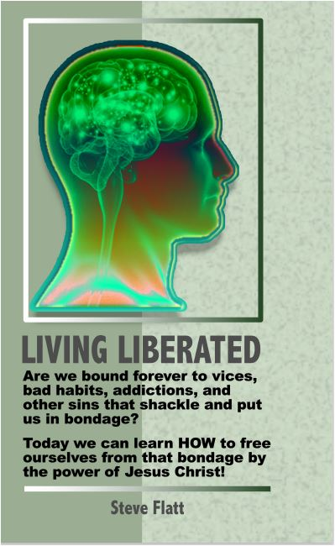Living Liberated

Chapter 1

Freedom from Anger
Did you know that the average man loses his temper six times a week? The average woman only loses her temper three times a week. Women tend to get angrier at people. Men tend to get angrier at things such as flat tires and non-working vending machines. Single people express anger twice as often as married folks, and yet the home is the place where we're most likely to express our anger. Anger is most frequently and intensely expressed toward people that we love, rather than strangers.

We all get angry it is a normal response. God made us with that capacity. Jesus got angry, didn't he? Remember the cleansing of the temple? Three hundred and seventy-five times in the Old Testament, we read that God was angry. Ephesians 4:26 states, "Be angry, and do not sin." In other words, there's a right way and there's a wrong way to get angry. So, some anger isn't wrong.
The issue isn't how do you get rid of all your anger; you're not going to do that. You were made with the capacity to anger at times. The issue is, how can you control your anger so that your anger doesn't control you, so that it doesn't cause you to sin and hurt yourself and other people.

Anger Expressed
- The Monster.
This is the person who just explodes. He or she is a walking time bomb. They have a hair trigger, and when they get angry, everything breaks loose, yelling, stomping, ranting, raving, throwing and cursing. Does that sound like someone you know?
A Biblical example of the monster-type of anger is Cain, Abel's brother. Genesis 4:5, "So Cain was very angry, and his face was downcast." Now listen to verse 8, "Now Cain said to his brother Abel, 'Let's go out to the field.' And while they were in the field, Cain attacked his brother Abel and killed him." You see that's the monster, it's somebody who loses control. Most of the time, those who express monster anger, are immediately sorry and beg for forgiveness, but the damage is done. Does it surprise you that men more than women express their anger in this way?

- The Mute.
The mute is the exact opposite of the monster. The mute is the silent type. They clam up and they hold it in. Sometimes they even pretend that they're not angry. Have you ever been with a mute, and said "You're angry, aren't you?" They reply, "No, I'm not." "Yes, you are." "No, I'm not." "Yes, you are." "No, I'm not!!" They're concealing their feeling, letting it simmer. I call it the crock pot version of anger. It smolders all day.

- _____ Take matters in you on hand, self-control.
- _____ Resist comparison of self with others. (Gal. 6:4)
- _____ Focus on what God has provided and rejoice. (James 1:17; Eccl. 5:19)
- _____ Remember what's really important. (2 Cor. 4:18)
- _____ All the above
- _____ a, c and d
- _____ b, c and d
- _____ a, b and d
  - Which of the following are biblical principles?
- _____ Earn money slowly. (Prov. 13:11; 6:6-9)
- _____ Save regularly. (Prov. 21:21)
- _____ Give generously. (Matt. 6:19-21; Luke 6:38)
- _____ Budget responsibility. (Luke 14:25-33)
- _____ Desire to be debt free. (Prov. 22:7)
- _____ All the above
- _____ None of the above
- _____ b, c and d

President’s Statement

You are encouraged to study your Bible so you can determine if a Bible lesson is someone’s opinion. Sometimes opinions creep into audio, video and printed books and lessons as well as Bible commentaries; also, in the teachings of preachers, ministers, pastors, priests or rabbis. The comments (opinions) presented in BibleWay books and lessons are those of the author or compiler. It is YOUR responsibility to seek, know and do God's will.

In verifying, you may wish to read different Bible translations – ESV, NIV, NASU, RSV, KJV. Also use Strong’s Greek and Hebrew Dictionary, Thayer’s Greek-English Lexicon and Vine’s Expository Dictionary for meaning of words or phrases you do not know. Be careful with dictionary meaning as they change over time and dictionaries provide ancient and current meaning of words and phrases.
Several Greek words may be translated into one word in English and may distort the original meaning. For instance, the Greek words de and kai” were translated as “and” in English. In Greek De is used to separate two nouns whereas kai connected two nouns.
Let God speak to you from His Holy Word as recorded in the Bible.

BibleWay Publishing grants permission to download and reproduce for
non-commercial purposes lessons in their entirety without change or charge.
Randolph Dunn, Publisher - Roberto Santiago Editor
Contact us at info.BiblewayPublishing@gmail.com
IBKI Website: thebiblewayonline.com


Randolph Dunn, President
Roberto Santiago, Dean
The International Bible Knowledge Institute is not an accredited institution.
Course One - The Message
How Did Everything Get Here?
The Man Who Was God
Christ - God's Mystery
Myths About God

Course Two - Obedience To His Message
Time Before Christ
Time Christ on the Earth
Time After Christ
Time to Decide
From Death Through The Cross To Life

Course Three -A New Spiritual Life In Christ
Baptism into Christ
From Life to Death - Mortal Man
A Kingdom Not Made With Hands
Servants In The Kingdom
Message From The Epistles
Worship God In Spirit and Truth

Course Four - Maturing In Christ
Jesus of Nazareth
Life Of Christ
United in Christ
Spiritual Milk
Living Liberated
Body, Soul, Spirit - Where Do They Go When You Die?
Revelation Of Jesus Christ

