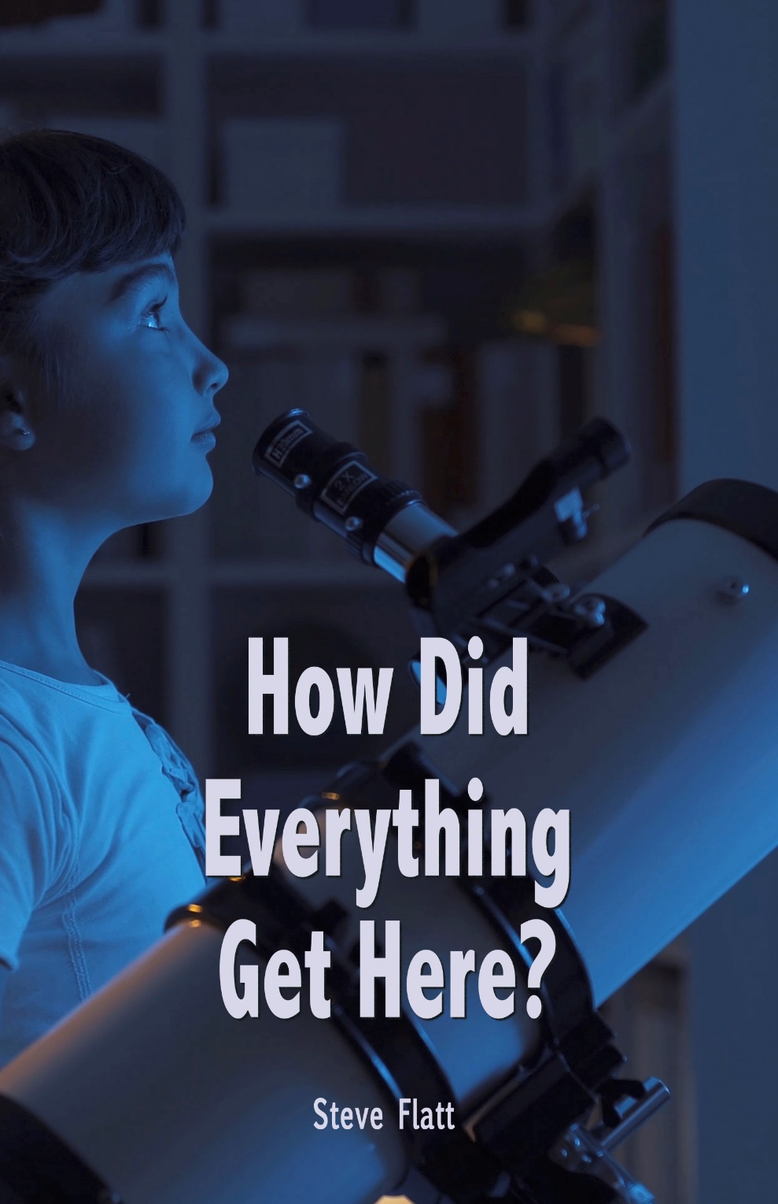

Presidents Statement
International Bible Knowledge Institute

President's Statement

We recommend that you study your Bible to determine the accuracy of what is stated in these lessons or from any other source. The "commentaries" presented in the International Institute of Biblical Knowledge (IBKI) lessons are the opinions of the authors or compilers. Opinions often find their way into audio, video, and print lessons, as well as Bible commentaries; and, in the teachings of preachers, ministers, pastors, priests or rabbis.

You should always verify all the comments, opinions and teachings of these since it is YOUR responsibility to seek, know and do the will of God.

To check the truth of any teaching, read different Bible translations, consult Bible dictionaries and lexicons to learn the meaning of unfamiliar words or phrases. Be careful with any dictionary definitions, as dictionaries give the meaning of words and phrases from the original language to current usage.

The meaning of words and phrases also changes over time. Also, multiple Greek words can be translated into one word, which can distort the original meaning.

May you allow God to guide you as you study His Holy Word found only in the Bible.

IBKI grants permission to download and reproduce for non-commercial purposes the lessons in their entirety. Feel free to share but not sale, change or charge.

Randolph Dunn, President

Roberto Santiago, Dean

Contact with us: info.IBKI.english@gmail.com

Website: biblewaypublishing.com/IBKI-English.html

Introduction Page

Contents

How Did Everything Get Here?

Creation or A Big Bang?
How did everything begin? Where did everything come from? The first things a human being becomes aware of are things around him, the external world. When a baby comes into this world, he or she is more aware of people and things than he is about himself. It's more of an awareness of the externals than of the internals. As time goes on, they begin to realize that there are questions about where all these things came from. A relatively young child might begin asking questions about origin and those questions are simple at first. A child may say, "Where did the stars in the sky come from?" A simple question usually gets a simple answer. If the parent is a believer in God, a Christian, the answer might be, "God put them there." If the parent is an atheist, a non-believer, the answer might be, "a long time ago there was just a huge explosion and things just landed in space."

As they grow older the questions become more sophisticated, not just “how did the stars get there” or “how did the moon get there”. How do we explain galaxies that are trillions of light years away? How do we explain the complexity of the human body, the human brain, the kidney or the eye? How do we explain all of the laws and properties of physics that hold all these things together? Where did all that come from? More sophisticated questions demand more sophisticated and reasonable answers. We want logically formulated answers that will withstand questioning and probing. It's also right that we should ask about origin, demand an answer that is accurate with all known data and sensible in the face of questioning by us and by critics. It is an insult to our intelligence to accept an answer that is untrue or that is poorly formulated.

We begin to see that the source of everything that is, is a source that's supernatural, a source that is of supreme power and intellect and a source that has a morality and an ethic. By definition that source is named God. Here's what Paul said in Romans 1:20, "For since the creation of the world, God's invisible qualities, His eternal power and divine nature have been clearly seen, being understood from what has been made so that men are without excuse." Paul was right. If you can't look around and see what has been made and realize that the tremendous amount of evidence there for that supernatural, all-powerful, all-intelligent, all-moral God, what could possibly prove it to you?

Where did everything come from? Everything came from the Almighty God of heaven and earth, who loved us and created us and everything we see.

Natural Law or Supernatural Force?
When asked the question about origin, the Christian's insight is that this world had to have a supernatural beginning. The very beginning of the Bible, God's Word, says "In the beginning, God created the heavens and the earth." (Genesis 1) That same thing is verified over and over again in the scripture. "He wraps himself in light as with a garment, He stretches out the heavens like a tent, and lays the beams of His upper chambers on their waters. He makes the clouds His chariot and He rides on the wings of the wind. He makes winds his messengers, flames of fire His servants. He set the earth on its foundation." (Psalm 104) Who created everything there is? God did - God the Father, Son and Holy Spirit.

Also, Colossians 1:16, states "For by Him all things were created, things in heaven and on earth, visible and invisible, whether thrones or powers or rulers or authorities, all things were created by Him and for Him. He is before all things and in Him all things hold together." Those are the answers for the Christian. How did everything get here? There was a supernatural force.

But for those who would hold to the premise that everything came about through natural forces, they find themselves in a position that knows no defense.

There are two basic things in this universe. There is matter and there is energy. The problem is that neither matter nor energy have in and of themselves any creative force. Matter does not create other matter. A piece of wood does not naturally create another piece of wood. Matter and energy are continually being used up. How many times have you heard scientists tell us that this universe of ours is running down? We are told that our sun, which is a star in the Milky Way galaxy, is about at middle age. Supposedly, a billion years from now our sun will eventually use all its energy. It's winding down. If our universe is composed of matter and energy, where did those things come from? By natural law, they did not create themselves. Where did they come from? By natural law, they are winding down and are going to be spent up. Who created the great storehouse of energy in the first place? Natural science knows no answer.

Current scientific theory holds that light, whenever it was created, came from non-living matter. That's an interesting assumption, isn't it? In a book published not that long ago called “Issues and Evolution”, it states that very thing, "The assumption that all life comes from non-living matter must be made by the modern scientist if he believes that the question, 'What is life?' belongs in the natural sciences." The point is those who propose that there was no supernatural cause must propose that life came from something not alive. But, that flies in the face of modern science. Have you ever heard of the theory of spontaneous generation, a theory that was popular in the 19th century that life did indeed come from non-living matter? The ancients used to believe that worms actually came from horse hairs that were dipped in water. Ah, but along came a noted scientist by the name of Louis Pasteur. You may have heard of him, he was big in milk. Pasteur through a number of experiments verified the conclusion that life cannot come from nonliving matter. Do you see the point? Do you see that those who say that this world and this universe somehow just have always been?

Science has to repudiate itself to hold a non-creationist's view. As we look at this question, "Where did everything come from?" When reduced to a choice, either there was a supernatural creative force, or there was just natural law. There's really no choice to be made. There had to be a supernatural force.

Is it here by design or is it here by accident?
Consider the fact that our world is filled with millions of living things, any one of which is more complex and sophisticated than any man-made object. In other words, there must have been a great deal of intelligence associated with that supernatural force that put everything here. Our body is composed of literally hundreds of millions of cells. Did you know that each tiny cell has an electrical system that's more complex than the telephone system of a city of 30,000 people? Isn't that amazing? The question is, "Is there any man-made object that we would account for apart from intelligent design and production?" Imagine the telephone system in a city the size of New York City. Think about all the switches, all the intricate wiring, the satellite up-link. Think about all that went into that. Imagine somebody telling you that nobody designed that. Nobody drew any pictures, there weren't any plans, nobody manufactured that entire scenario, but it just simply happened. The biggest fool in the world wouldn't believe that. Basic rationality says that if we see something that complex, we assume design and intelligence. Since it is ridiculous to think that any man-made device was made without design and production, how much more ludicrous is it to assume that there was no design in these non-man-made objects, any one of which is more complex? The human brain, the human body, the kidney - the greatest filtering system in the world. One scientist set forth in a recent journal that the chance of one protein molecule falling together in place at random - the chance of that was 1 x 2.02 x 10 raised to the 239th power. Is it by chance or was it design? The believer accepts passages like Psalm 19:1 when David wrote, "The heavens are declaring the glory of God and the firmament proclaims His handiwork." There was indeed a design and it was magnificent.

Supernatural or Natural?
It was supernatural. Design or accident? It had to have been design. But what about the nature of that Creator? I'm finding more and more people in our world are willing to accept the fact that there had to be a Creator, but more and more are also assuming that Creator was some cosmic force, some huge glob of energy out there in the universe, not a personal God. To that we need to take a look at our universe. Sometimes we see exceptions to it, but the human creatures who inhabit this world have an innate sense of morality. Isn't it amazing that as you span the civilizations that inhabited this world over the centuries that there is a remarkable consistency of what we call good and what we call bad. If you go back to the Egyptians or the American Indians or to the Incas or the Babylonians, civilizations that had no contact with each other, and by and large their statutory code was remarkably similar. It was always illegal to murder, it was always illegal to steal, it was always illegal to lie. There were sexual norms in each of those civilizations. There was, it seems, within the hearts of those people an innate sense of right and wrong. Similar across the world. Why is it that we universally call a man like Hitler or Saddam Hussein evil? What would evil mean if we were not created by a moral Creator? Evil would just be my preference as opposed to yours, and our preferences would be as numerous as there are people on the face of this earth, but that's not the case.
We are given a sense of morality. Moral sense does not come from a non-moral source. If we've come from rock, dirt and matter, where did we get conscience or morality?

We begin to see that the source of everything that is, is a source that's supernatural, a source that is of supreme power and intellect and a source that has a morality and an ethic, and by definition, that source is named God. Here's what Paul said in Romans 1:20, "For since the creation of the world, God's invisible qualities, His eternal power and divine nature have been clearly seen, being understood from what has been made so that men are without excuse." Paul was right. If you can't look around and see what has been made and realize that the tremendous amount of evidence there for that supernatural, all-powerful, all-intelligent, all-moral God, what could possibly prove it to you?
Where did everything come from? From the Almighty God of heaven and earth, who loved us and created us and everything we see.
Amazing Grace Lesson # 1001 Steve Flatt
Questions
- Can eternal power and divine nature be clearly understood by what God has made?
Yes ___ No ___

- How were things created?
- ___ Unknown
- ___ A big bang
- ___ created by and eternal power
- ___ None of the above

- Which of the two things in the universe were created?
a. ___ Matter
b. ___ Energy
c. ___ neither
4. Creation was by accident.
True ___ False ___

- Since survival of the fittest exists in the animal world, then there is no inherent morality in humanity?
True ___ False ___

