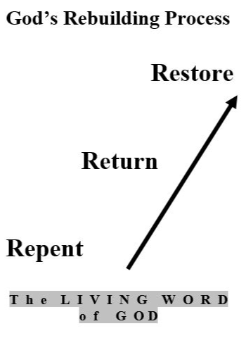

Steve Flatt

God’s Rebuilding Process

Repent, Return and Rebuild
You are encouraged to study your Bible to prove the truth presented in these lessons or any other lesson. The comments presented herein are those of the compiler. You should verify them and anything else taught by others; e.g., a pastor, preacher, priest, some Bible scholar, commentator, or BibleWay Publishing as it is YOUR responsibility to seek, know and do God's will.
In verifying you may wish to read different Bible translations – ESV, NIV, NASU, RSV, KJV. Also use Strong’s Greek and Hebrew Dictionary, Thayer’s Greek-English Lexicon and Vines Expository Dictionary for meaning of words or phrases you do not know. Be careful with definitions as all dictionaries give both current and old meaning of words and phrases.
The meaning of words and phrases change over time. Also, several Greek words may be translated into one word in English and may distort the original meaning. For instance, the Greek words de and kai” were translated as “and” in English. De is used to separate two nouns whereas kai connects two nouns
Let God speak to you from His Holy Word as recorded in the Bible.


Adapted from an Amazing Grace lesson by Steve Flatt
BibleWay Publishing grants permission to reproduce for
non-commercial purposes lessons in their entirety without change or charge.
Randolph Dunn, Publisher - Roberto Santiago Editor
Website: thebiblewayonline.com
Contact us at info.BiblewayPublishing@gmail.com
December 2006

