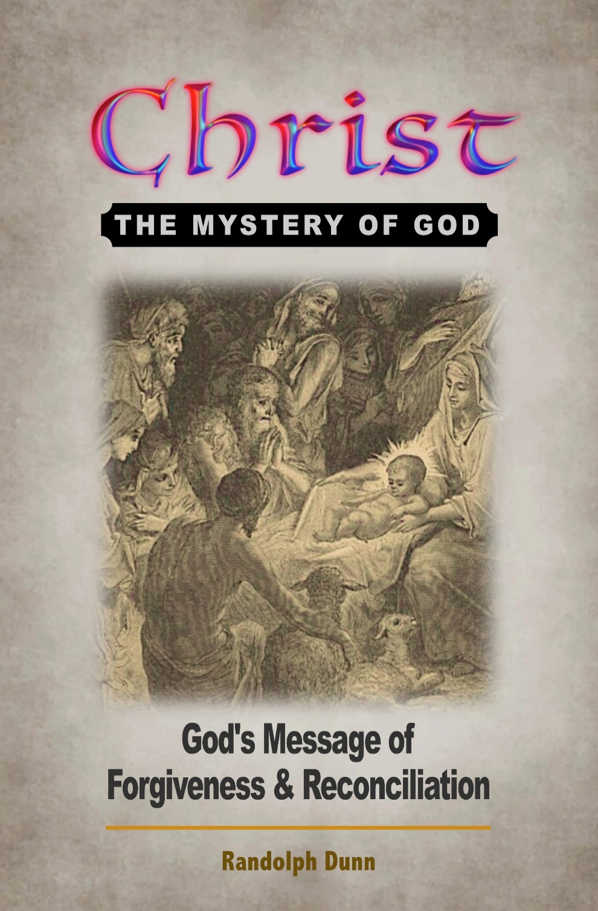

You are encouraged to study your Bible so you can determine if a Bible lesson is someone’s opinion. Sometimes opinions can creep into commentaries, audio, video and print; also, teachings of pastors, ministers, priests or rabbis, even BibleWay books and lessons. The comments presented herein are those of the compiler. It is YOUR responsibility to seek, know and do God's will.
In verifying, you may wish to read different Bible translations – ESV, NIV, NASU, RSV, KJV. Also use Strong’s Greek and Hebrew Dictionary, Thayer’s Greek-English Lexicon and Vines Expository Dictionary for meaning of words or phrases you do not know. Be careful with dictionary meaning as they change over time and dictionaries provide ancient and current meaning of words and phrases.
Several Greek words may be translated into one word in English and may distort the original meaning. For instance, the Greek words de and kai” were translated as “and” in English. In Greek De is used to separate two nouns whereas kai connected two nouns.
Let God speak to you from His Holy Word as recorded in the Bible.


BibleWay Publishing grants permission to download and reproduce for
non-commercial purposes lessons in their entirety without change or charge.
Randolph Dunn, Publisher - Roberto Santiago, Editor
Website: thebiblewayonline.com
Contact us at info.BiblewayPublishing@gmail.com
July 2021
There is no tuition or fees for any IBKI studies or services. There may be a charge for printed books and lessons.

Elective Lessons
Planned Redemption
Creation Before the Genesis Creation
Myths About Forgiveness
What Shall We Do?
Myths About Misery
First Principles
Holy Spirit
Silence of the Scriptures
Marriage and Divorce
The End of Time on Earth
Myths About Happiness
Myths About Pain
Daniel
Types and Metaphors

Additional Lessons
Shadows, Types and Prophecies Revealed
Compiling and Translation the Bible
Teaching and Practices After A. D. 100
Today’s Church practices Are They Tradition or Scripture?
God’s Sabbath
Lessons from the Cross of Christ
God’s Rebuilding Process
Greatest Questions Ever Asked
Living for One Another in Christ
Living the Maximum Life
Promises For Now and For Evermore
Real Men Are Godly Men
Wonderful Words of Eternal Life

Interested books but not required for the award
Outlined Bible
Summarized Bible


Randolph Dunn, President
Roberto Santiago, Dean
The International Bible Knowledge Institute is not an accredited institution.

There is no tuition or fees for any IBKI studies or services. There may be a charge for printed books and lessons

Course One - The Message
How Did Everything Get Here?
The Man Who Was God
Christ - God's Mystery
Myths About God

Course Two - Obedience To His Message
Time Before Christ
Time Christ on the Earth
Time After Christ
Time to Decide
From Death Through The Cross To Life

Course Three -A New Spiritual Life In Christ
Baptism into Christ
From Life to Death - Mortal Man
A Kingdom Not Made With Hands
Servants In The Kingdom
Message From The Epistles
Worship God In Spirit and Truth

Course Four - Maturing In Christ
Jesus of Nazareth
Life Of Christ
United in Christ
Spiritual Milk
Living Liberated
Body, Soul, Spirit - Where Do They Go When You Die?
Revelation Of Jesus Christ

