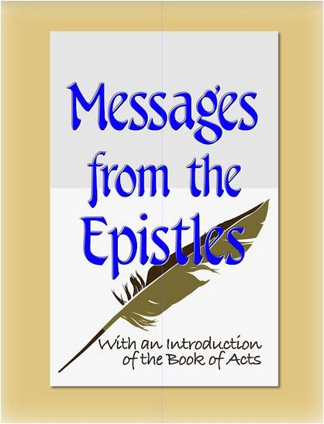
Randolph Dunn
International Bible Knowledge Institute

President's Statement

BibleWay Publishing is a non-profit Bible ministry. Its primary focus is on the websites and digital books of the International Bible Knowledge Institute. The objective of IBKI is to make Bible lessons available to anyone interested in learning more about God and His will. Students are NOT required to attend the Institute to earn a certificate or diploma. These lessons can be studied online or in classrooms, by Zoom, downloaded to digital devices, emailed, printed, or used by individuals, groups, or churches in their evangelistic ministry. IBKI is not an accredited institution.

We recommend that you study your Bible to determine the accuracy of what is stated in these lessons or from any other source. The "commentaries" presented in the International Institute of Biblical Knowledge (IBKI) lessons are the opinions of the authors or compilers. Opinions often find their way into audio, video, and print lessons, as well as Bible commentaries; and, in the teachings of preachers, ministers, pastors, priests, and rabbis.

You should always verify all the comments, opinions, and teachings of these since it is YOUR responsibility to seek, know and do the will of God.

To check the truth of any teaching, read different Bible translations, and consult Bible dictionaries and lexicons to learn the meaning of unfamiliar words or phrases. Be careful with any dictionary definitions, as dictionaries give the meaning of words and phrases from the original language to current usage.

The meaning of words and phrases changes over time. Also, multiple Greek words can be translated into one word, which can distort the original meaning.

May you allow God to guide you in your study of His Holy Word, the Bible.

IBKI grants permission to download and reproduce for non-commercial purposes their lessons in their entirety. Feel free to share but not sell, change, or charge books or lessons.

Randolph Dunn

IBKI President

For more information contact Innocent M. Ezekiel at ntaonitsha@gmail.com
Website: thebiblewayonline.com/Info.IBKI.English.html

